

Faculty of Applied Sciences  
Bachelor of Science in Computing

**COMP490 Final Year Project  
Final Report**Academic Year 2022/23

|  |  |
| --- | --- |
| Spaced practice with study progress tracking for children | |
|  |  |
| Project number: | 21 |
| Student ID: | P-19-0833-2 |
| Student Name: | Daniel Ruan |
|  |  |
| Supervisor: | Philip Lei |
| Assessor: | Wilson Ho |
|  |  |
| Submission Date: | 2023/04/19 |

Declaration of Originality

I, Daniel Ruan, declare that this report and the work reported herein was composed by and originated entirely from me. This report has not been submitted in any form for another degree or diploma at any university or other institute of tertiary education. Information derived from the published and unpublished work of others has been acknowledged in the text and a list of references is given in the bibliography.



2023/04/19

Abstract

Spacing learning activities across various time intervals has been proven to enhance children's retention and learning. While numerous studies have explored ideal intervals for revision and practice, the impact of individual differences among children remains uncertain. A fixed optimum standard may not be equally effective for individual children. This project aims to discuss and propose a practical and effective solution to this challenge. Furthermore, this project aims to integrate spaced learning with primary school education to foster children's interest in both natural sciences and humanities. Incorporating general education into primary school curricula has been a long-standing goal for educators worldwide, as a lack of early interest in a particular subject often puts students at a disadvantage in their future higher education pursuits. By reviewing existing research and determining an appropriate spaced practice algorithm, this project aims to design and develop a tool for children to learn and practice general knowledge in a more engaging manner.

Acknowledgement

I would like to express my sincere gratitude to everyone who has supported and guided me throughout the course of my final year project.

First and foremost, I extend my deepest appreciation to my project supervisor, Philip Lei, for their unwavering guidance, invaluable advice, and continuous encouragement throughout the entire project. Their expertise, dedication, and patience have played a significant role in driving my progress and success.

I am also grateful to all the faculty members and staff at Macao Polytechnic University, who have provided me with an excellent academic environment and resources to facilitate my learning and project development.

Special thanks go to my fellow classmates and friends, who have been a constant source of motivation, support, and camaraderie during this journey. Their insightful suggestions, constructive feedback, and willingness to lend a helping hand have been instrumental in overcoming the challenges I faced during the project.

Finally, I would like to express my heartfelt gratitude to my family, whose unwavering love, support, and understanding have served as the foundation upon which I have built my academic pursuits. Their faith in my abilities and constant encouragement have inspired me to strive for excellence and achieve my goals.

I am truly grateful for the guidance, assistance, and encouragement I have received from everyone who has contributed to the successful completion of this project.

Table of Contents

1 Introduction 12

1.1 Objectives 12

1.2 Risk Assessment 13

1.3 Summary 16

2 Background and Related Work 17

2.1 Forgetting Curve 17

2.1.1 Characteristics 18

2.1.2 Approximate equation 19

2.1.3 Prevent Forgetting 20

2.2 Spacing Learning 22

2.2.1 Spacing Effect 22

2.2.2 Theory of Spaced Learning 22

2.2.3 Spaced Learning in Neurological Evidence 23

2.2.4 Individual Differences of Children’s Spacing Learning 24

2.2.5 Influencing Factors of Children’s Spacing Learning 25

2.3 Leitner boxes System 26

2.3.1 Research of Leitner system 28

2.3.2 Improvement of Leitner system 29

2.3.3 Related works and Application 29

3 Design Approach 31

3.1 Subject Design 31

3.2 Algorithm Design 33

3.2.1 Massing or Spacing 33

3.2.2 Optimum Spaced Lag 34

3.2.3 Basic mathematical model 35

3.2.4 Balancing daily workloads 38

3.3 User Interface Design 40

3.3.1 Responsive Design 40

3.3.2 Visual Memory and Vocabulary Aid 41

3.4 System Design 42

3.4.1 Data Modelling 43

3.4.2 Dynamic Modelling 46

3.4.3 Software Architecture 49

4 Implementation 50

4.1 Technology Selection 50

4.1.1 Back-end 50

4.1.2 Front-end 51

4.2 Backend Implementation 55

4.2.1 Setup the Server-side 55

4.2.2 Database 56

4.2.3 Authentication System 57

4.3 Frontend Implementation 61

4.3.1 Frontend Structure 61

4.3.2 Data Transmission 61

4.3.3 Responsive Design in Tailwind CSS 63

4.4 Algorithm Implementation 66

4.4.1 Building a Markov model 66

4.4.2 Review algorithm 68

4.4.3 Recommendation algorithm 69

5 Results and Discussion 71

5.1 Project Outcome 73

5.1.1 Account Registration 73

5.1.2 Navigation Bar 76

5.1.3 Book List 77

5.1.4 User Profile 83

5.1.5 Exercise List 84

5.1.6 Question List 87

5.1.7 Multiple choice question 87

5.1.8 User Achievement Showcase 94

5.2 Testing & Evaluation 95

5.2.1 User Acceptance Testing 95

5.2.2 Limitations 97

6 Conclusion and Further Work 99

References 100

Appendix A. Project Management 106

Appendix B. Reflection 107

Table of Figures

Figure 1 Probability impact matrix before proposed solution 10

Figure 2 Probability impact matrix before proposed solution 16

Figure 3 Probability impact matrix after proposed solution 16

Figure 4 Typical forgetting curve 18

Figure 5 Forgetting Curve with Spaced practice 21

Figure 6 Transition scheme for review of words 27

Figure 7 The Leitner calendar for a learning cycle of 64 days, after which the system repeats itself 28

Figure 9 Original Leitner System's Review Workload Statistics Chart 37

Figure 10 Total Workload Statistics Chart after Adding Review Work and New Practices 38

Figure 11 Total Workload Statistics Chart Obtained through the First Balancing Method 39

Figure 12 Total Workload Statistics Chart Obtained through the Second Balancing Method 40

Figure 13 Entity-Relationship (ER) diagram 43

Figure 14 • Question Deck Status Control Diagram 47

Figure 15 Activity Diagram 48

Figure 16 System Structure Summary 49

Figure 17 The extending features of the project 49

Figure 18 JWT Authentication Workflow 58

Figure 19 Structure of JSON Web Token 59

Figure 20 Desktop Style 65

Figure 21 Mobile Phone Style 65

Figure 22 Light Mode 72

Figure 23 Dark Mode 72

Figure 24 Mobile Phone Screen Interface 73

Figure 25 Registration Interface 74

Figure 26 Login Interface 75

Figure 27 Error Alert 76

Figure 28 Book List 77

Figure 29 PDF reader 78

Figure 30 Photo reader(thumbnail) 79

Figure 31 Photo reader(detail) 79

Figure 32 Photo reader (mobile) 80

Figure 33 Study Task Form (Empty form) 81

Figure 34 Study Plan Form (After entering information) 82

Figure 35 Successful task creation 82

Figure 36 Amend personal information form && Reset password 83

Figure 37 Task tracking list 84

Figure 38 Exercise record table 85

Figure 39 Create question decks 86

Figure 40 Successful creation of new exercise task 86

Figure 41 Exercise List 87

Figure 42 Multiple Choice Question 89

Figure 43 Multiple Choice Question (wrong answer) 89

Figure 44 Multiple Choice Question (true answer) 90

Figure 45 Successful Submission Alert 91

Figure 46 Question hints 92

Figure 47 Presentation of results 93

Figure 48 Reconfirm 93

Figure 49 After the page jump 94

Figure 50 User Achievement Showcase 95

Figure 51 Gantt chart 106

Figure 1 Probability impact matrix before proposed solution

|  |  |  |  |  |
| --- | --- | --- | --- | --- |
| Probability | High |  | Risk 2 |  |
| Medium |  | Risk 4 | Risk 3 |
| Low |  | Risk 1 |  |
|  | | Low | Medium | High |
| Impact | | |

List of Tables

Table 1Table of prioritized risk (Notes: Priority 1 is the highest risk) 12

Table 2 Table of Priority Risk 16

Table 3 Entity's Attribute Table 46

Table 4 Entity's Relationship Table 47

Table 5 Quiz results after learning with conventional methods 97

Table 6 Quiz results after using spaced practice 98

Table 7 Program plan 107

Table 1Table of prioritized risk (Notes: Priority 1 is the highest risk)

|  |  |
| --- | --- |
| Priority | Risk identifier and Description |
| 1 | Risk 3: The software cannot support different devices |
| 2 | Risk 4: Users are unwilling to use the product |
| 3 | Risk 2: Insufficient test users’ investigations |
| 4 | Risk 1: Computer breakdown or development environment issues |

# Introduction

As evidenced in research in educational psychology, the spaced practice has been proven to be a more effective strategy than cramming, and to improve retention and possibly deepen understanding. In addition to the above advantages, spaced practice allows students to allocate their study plan reasonably, reduces the learning load in a short period, and reduces the pressure on students during the learning process. Because of these benefits, it makes the learning process more effective.

A recent educational study[1] found that spaced practice significantly improves ordinary people's ability to retain knowledge in long-term memory. Therefore, spaced practice is adapted to education for young children. Although there are several studies[2][3] and discoveries of ideal intervals for revision and practice, it is not nearly enough. Since the growth and development progresses at a different pace for each child, there are significant discrepancies in their memory and IQ, and a fixed optimum standard may not work as well as the best among all children. A study tool for children also needs to consider the study progress of individual items and arrange suitable frequency for the distributed practice. In addition, the tool is required to precisely control the complexity of the learning process so that it is not extremely simple or arduous for children to learn, as such exercises tend to make students bored or frustrated and hinder their motivation in study.

Most of the current software for children's learning and applications already used research results such as the Ebbinghaus Forgetting Curve[4] and used it as a reference time for the next revision exercise, whereas a majority of them simply repeated the child's mistakes from the previous practice every day, without creating a personalized revision plan for each child. Tedious repetition is hardly used to achieve optimal study results for all children. Therefore, a feasible and effective solution to this problem is going to be discussed and proposed in this project.

## Objectives

* Review the literature on spaced practice and study progress tracking.
* Study the characteristics of learning for children and find those characteristics that facilitate increasing and improving their long-term retention of knowledge.
* Investigate how to organize suitable practice exercises with moderate difficulty for children.
* Design an algorithm to dynamically combine spaced practice and workload with each child's characteristics and parental expectations.
* Design a method to generate practice exercises for the next learning session by judging the level of student mastery, and the exercises include a suitable mix of reviewed topics, weak topics, and new topics.
* Track the study progress by automatically grading the exercises.
* (Optional) Collect results of exercises and statistics to produce a learning report.
* Implement the above functions in a user-friendly study tool for children.

## Risk Assessment

This project may encounter four risks, and the priorities of these risks are listed in Table 2. Figure 1 and Figure 2 are two probability impact matrices. Figure 1 shows the probability impact for the risks before solutions are taken, and Figure 2 shows the probability impact for the risks after the solutions are taken.

**Risk 1: Computer breakdown or development environment issues**

If a computer failure occurs during the development process, the entire project may be halted. This will seriously impact the progress of the project.

Solution: Leverage online code repositories such as GitHub and regular backups to ensure that development progress is not disrupted even if the computer fails.

**Risk 2: Insufficient test users’ investigations**

After the initial development, some user testing was needed to demonstrate the usefulness of the software and the effectiveness of the algorithms. Therefore, enough test users are required to test the interrupted learning tool for children. However, it is not easy to acquire test volunteers to trust, so one of the risks is that there are not enough testers in the survey and testing process, which can lead to insufficient surveys and statistics to generate sufficiently objective experimental results.

The solution: open source the software for free during the testing phase, upload it to GitHub for all to download and actively promote it through social media. In addition to all of this, primary school teachers and children's educators can be contacted via email and distributed to school-age children through these approaches.

**Risk 3: The software cannot support different devices**

The software may be used by users on different versions of Windows computers, such as Win7, Win10, and Win11. However, many software programs are no longer compatible with Win7, with the result that most people with Win7 computers are unable to use the software properly.

Solution: The software needs to be backward compatible with Win7 computers. Therefore, the software needs to be optimized for Win7, for example, addressing common problems such as prompting for Win7 or above or not having permission to open. This can be achieved by recording some of the system information in advance and writing it into the registry in advance via the "child_process" module of node. Of course, there may be more than one optimization problem with Win7, so it is necessary to compile a manual to solve common problems that users encounter when using the software.

**Risk 4: Users are unwilling to use the product**

The user interface of the project is poorly user-friendly, such as a poorly designed interactive interface or inappropriate colour schemes for the project theme, and these issues are off-putting to the user, which may ultimately lead to the user dismissing the application.

Solution: There are some widespread design principles to be followed during the design phase, and the authors consider the eight golden rules to be design principles. As the primary users of this project are primary school children, it is important to fully cater for the group characteristics of children at this stage, so the interactive interface for children is simple to comprehend, easy to operate and conducive to the complete as well as effective completion of interactive tasks by kids. During the product development process, arrangements were made for some tests related to the user interface and to find some users with children to perform the first phase of testing and use, to try to find out what might be unfriendly to children users and to make improvements. Concurrently, it is planned to arrange tests related to the user interface during the product development process and get some users who have a professional knowledge of children's education to test and use it in the primary stage to attempt to identify areas that may not be friendly to the ordinary user and to improve them.

|  |  |
| --- | --- |
| Priority | Risk identifier and Description |
| 1 | Risk 3: The software cannot support different devices |
| 2 | Risk 4: Users are unwilling to use the product |
| 3 | Risk 2: Insufficient test users’ investigations |
| 4 | Risk 1: Computer breakdown or development environment issues |

Table 2 Table of Priority Risk

There are four associated risks, as shown in Table 2. The risk that the software cannot support different devices has the highest priority as this risk directly prevents users using the software on Windows 7 operating system. The second priority risk is the reluctance of users to use the product, as the main users of the software are primary school children, whose physical characteristics, such as immaturity of movement, limited cognitive range, inattention and low self-control, determine the specificity of the child user group. In order to avoid the risk, adequate research and studies must be carried out during the project design process. The last two priorities are inadequate research of test users and computer failures or problems with the development environment. Neither of these are fatal, but they still have considerable consequences. However, the probability of these risks occurring is very low if awareness and prevention are done well.

|  |  |  |  |  |
| --- | --- | --- | --- | --- |
| **Probability** | High |  | Risk 2 |  |
| Medium |  | Risk 4 | Risk 3 |
| Low |  | Risk 1 |  |
|  |  | Low | Medium | High |
|  |  | **Impact** | | |

Figure 2 Probability impact matrix before proposed solution

|  |  |  |  |  |
| --- | --- | --- | --- | --- |
| **Probability** | High |  |  |  |
| Medium |  |  |  |
| Low | Risk 1, Risk 3 | Risk 2, Risk 4 |  |
|  |  | Low | Medium | High |
|  |  | **Impact** | | |

Figure 3 Probability impact matrix after proposed solution

## Summary

A preliminary introduction to the project has thus been completed in Chapter 1. Chapter 2 will illustrate the background theory and summarise the relevant research findings. Chapter 3 will publish the completed work including the design and partially completed implementation of this project. Chapter 4 will list the ongoing work elements and blueprint plans for future work. A short summary of the entire Final Year Project Progress Report is presented in the final chapter.

# Background and Related Work

Research[4] on human memory preservation dates back more than a century (Ebbinghaus, 1885/1964). The breadth of this vast body of work is the result of psychologists' interest in the cognitive, biological and developmental mechanisms of memory, but more importantly, it is the result of the scientific community's efforts to improve and optimize human learning. Scientists have studied the conditions and methods that best facilitate learners' acquisition, retention, classification and updating of new information; indeed, much of what we know about the mechanisms of memory has been elucidated by studying the effectiveness - or ineffectiveness - of the results of various types of learning environments and pedagogical approaches. In the meanwhile, developments and research[5] in molecular biology and neurology have enabled biological scientists to study and verify the mechanisms of memory production at the microscopic molecular level.

This chapter is a review of previous theories and research outcomes, with a focus on the forgetting curve and spaced learning. In the first section, the work of the German psychologist Hermann Ebbinghaus is presented, and subsequent research on the forgetting curve is presented; in the second chapter, the theory of spaced learning, recent research developments and related work are illustrated and highlighted.

## Forgetting Curve

German psychologist Hermann Ebbinghaus sought to learn more about why the forget things in our minds, and how to prevent it. His research[4] produced the Forgetting Curve - a visual representation of the way that information learned evaporates over time.

The forgetting curve assumes a decline in memory retention over time. The curve below illustrates how information is lost over time when there is no attempt to retain it. A related concept is the strength of memory, which refers to how long a memory lasts in the brain. The stronger the memory, the longer a person will be able to recall it. A typical forgetting curve graph claims to show that unless humans make a conscious effort to review learned material, their memory for newly learned knowledge tends to halve within days or weeks.

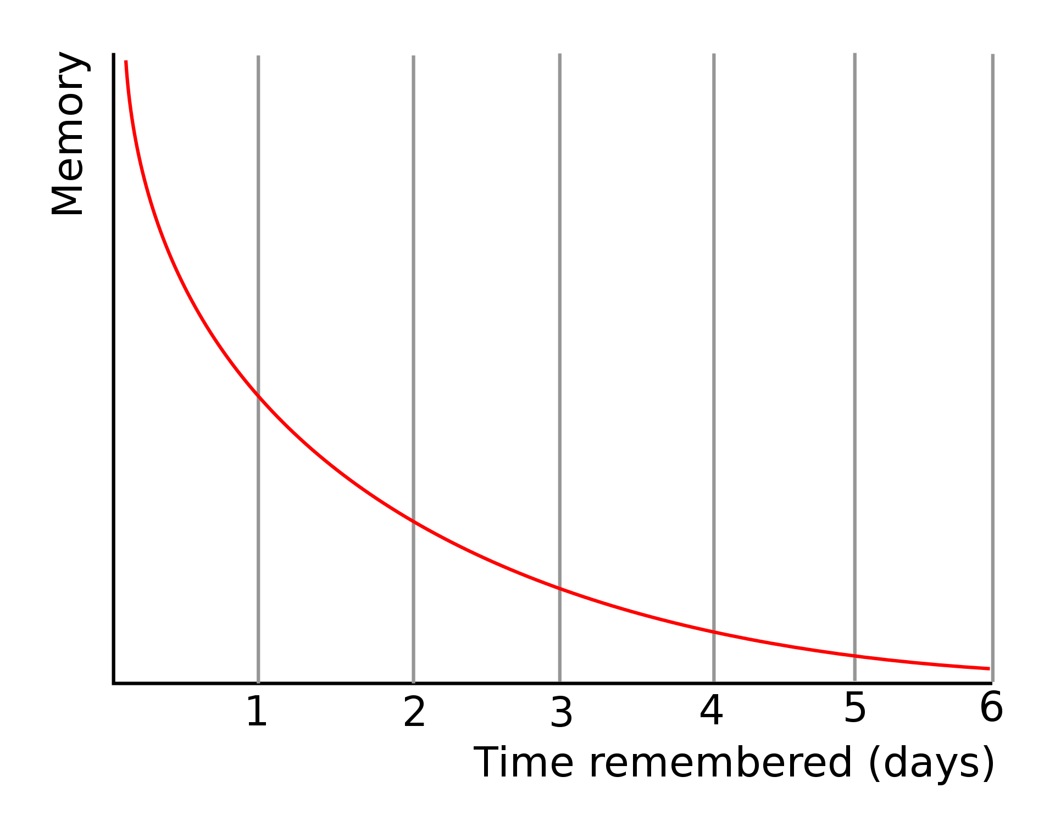

Figure 4 Typical forgetting curve

### Characteristics

Ebbinghaus conducted experiments on his ability to recall syllables with a string of meaningless syllables, which he endeavoured to retrieve after various lengths of time. Both his experience and the results illuminate several pivotal aspects of memory:

* Memories diminish with time.

If people learn new knowledge without attempting to review the knowledge, they retain increasingly less of the knowledge as time goes on.

* The most significant reduction in retention occurred shortly after the learning.

It is demonstrated the dramatic drop at the beginning of the forgetting curve. If there is no review or reinforcement of human learning, the human tendency to retain information plummets. For example, people are likely to leave a networking seminar or conference full of new facts and figures, only to discover a couple of hours later that they barely remember them.

* Meaningful information is more likely to be remembered.

What doesn't matter (such as the meaningless syllables that Ebbinghaus tried to learn) best corresponds to the forgetting curve. Therefore, for example, if people are listening to a lecture on a subject they don't comprehend or have little interest in, they may forget it more quickly than if they find the subject fascinating.

* The presentation of things impacts on learning.

The identical set of information may be remembered more or less, according to the way it is presented. People may find it easier to recall information that is logically structured and clearly illustrated. But they are likely to forget that disorganized, scrawled shopping list!

* How the senses influence how well the memory functions.

Ebbinghaus thought[4] that physiological factors, such as stress and sleep, worked wonders in the extent to which the information people retain. Many people have a vicious cycle of experience - they are stressed, which causes more stress by making it more hard for them to remember. There is also strong evidence that sleep assists our brains in categorising and storing information.

### Approximate equation

* Ebbinghaus's forgetting curve equation

Hermann Ebbinghaus performed many studies on memory and forgetting in the 1880s. He subjected himself to memory tests and continued to record the results, then analysed the data mathematically and finally published his findings in 1885. Hermann Ebbinghaus plotted these results on a graph creating what is now known as the "forgetting curve". He investigated the rate of forgetting, but not the effect of spaced practice on the increase in retrievability of memories.

Ebbinghaus' thesis also includes an equation that approximates his forgetting curve[4]:

In this equation, represents the 'savings' expressed as a percentage, and represents the time in minutes, calculated from one minute before the end of the study. The constants and are 1.25 and 1.84 respectively. time saved is defined as the relative amount of time saved in the second learning trial as a result of the first learning. a saving of 100% indicates that all items were still known at the first trial. A saving of 75% means that the time required to relearn the missed items is 25% of the original learning session (learning all items). The "savings" are therefore similar to the retention rate.

* Other memory equations

After the publication of Ebbinghaus' forgetting curve, more and more scholars became interested in the relationship between forgetting and memory, and it is still a very popular research topic today, with many experts in different fields analysing forgetting curves from different perspectives. a 1995 study on long-term memory proposed a simple memory equation[6].

R is retrievability (a measure of how easy it is to retrieve a piece of information from memory), S is the stability of the memory (which determines how quickly R declines over time in the absence of training, testing or other recall), and t is time.

In a study[7] conducted in 2016 on Optimal Scheduling for spaced practice, S. Reddy, et al. analyzed data for different hypotheses after making multiple. They tested various formulas on empirical evidence from Mnemosyne (a popular flashcard software tool) to determine which one would be the most appropriate. From their observations, they employed the following exponential forgetting curve.

$$Px_{recall, z}\left(t\right)=e^{-\frac{ * t}{kz}}$$

where θ is the global difficulty, t is the time since last reviewed and kz is the current deck for a word z.

### Prevent Forgetting

Hermann Ebbinghaus illustrated a variety of solutions[4] to combat forgetfulness in his papers, two of which are well known:

* Overlearn

Over-learning is the exercise of exercising a newly acquired skill to a greater extent than it was originally acquired. The phrase is also frequently employed to designate the pedagogical theory that this exercise form results in automaticity or other salutogenic consequences.

The first strategy Ebbinghaus explored was 'overlearning' - that is, putting in more effort than usual when you learn something. He found that doing so improved memory and slowed the sharp decline on the forgetting curve. He observed that recall of learned material decreased over time (see forgetting curve). Ebbinghaus realized that nonsense syllable lists became more difficult to remember over time, and some groups required more revision time to recapture 100% of the memory. He defined over-learning as the frequency with which material is repeated after which it is possible to recall it with 100% precision.

• Spaced practice

Hermann Ebbinghaus laid the foundations for the study of spaced practice by suggesting that the loss of information over time follows the forgetting curve, although forgetting could be reset through repetition based on active recall.

Regularly reviewing and refreshing information prevents the forgetting curve from shaping up. While forgetting starts again after each review, it is slower than before. For this reason, each new curve shown in Figure 5 is flatter than the previous one.

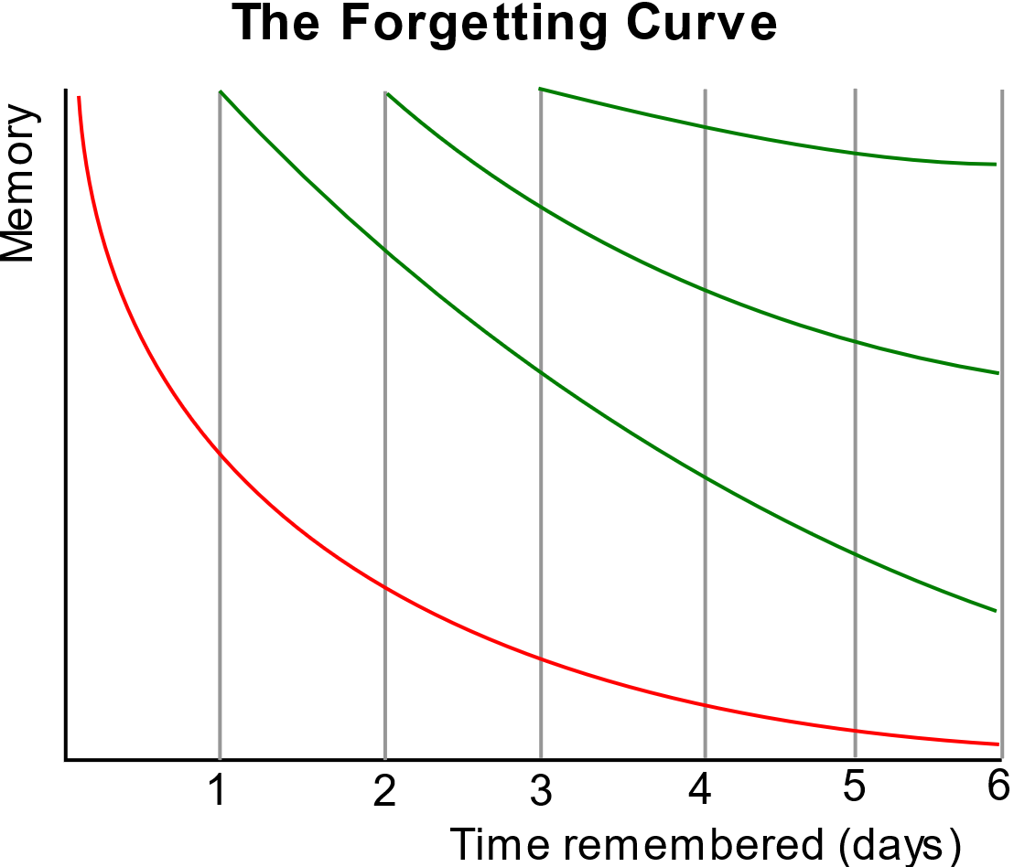

Figure 5 Forgetting Curve with Spaced practice

In the next subsection, the author will elaborate on spaced practice and spaced learning, explain the relevant principles and describe several families of algorithms for scheduling spaced practice.

## Spacing Learning

### Spacing Effect

The spacing effect refers to the finding that learners’ repeated exposure to information is more durable in long-term memory if learning events are distributed across time rather than occurring in immediate succession. The spacing effect was first observed over 100 years ago[4], and to date, more than 1,000 published experiments have demonstrated a spacing effect in memory[8][9][10].

In a typical study of the spacing effect, participants are presented with some learning events in immediate succession (i.e., a massed schedule) and other learning events distributed across time (i.e., a spaced schedule). Memory for information learned via a massed schedule is then examined in relation to the material learned via a spaced schedule. The consistent finding across studies is that participants have higher performance on the spaced schedule than the massed schedule.

The vast majority of studies on the spacing effect have been conducted with adult samples, often with undergraduates in a psychology-laboratory setting[11]. However, the implementation of this phenomenon has gained traction with the developmental science and educational psychology research communities, with a growing body of work now being conducted with young students in formal schooling[12][13].

Importantly, the spacing effect has been observed across developmental periods, with benefits of spaced learning observed in young children[14][15] and even infants[16][17]. There is no doubt about the benefits of spaced learning for kindergarteners, first and second graders. Although, a small number of negative results exist, the majority of studies on the effects of spacing on these young learners have observed positive results from spacing practice[18][12].

### Theory of Spaced Learning

A number of theoretical accounts have emerged to explain the spacing effect. Deficient processing theories[19][20] propose that participants demonstrate poor memory for massed repetitions because one presentation or the other is not fully “processed” or attended to. That is, these theories maintain that presentations are encoded to a lesser degree when they occur in immediate succession. Encoding variability theories[21][22] propose that repetition improves memory to the extent that a repeated item is encoded differently at each presentation. Because spaced schedules influence the degree to which each presentation varies from another, this type of schedule results in more extensive differential encoding, and thus several alternative routes by which to access the memory trace. Consolidation theories[23] propose that, in spaced learning, the consolidation in memory of the first presentation of information – which occurs during the interval between presentations – is inherited by the second presentation to create a new, higher-level consolidation in memory.

Although these theories are still discussed to date, there is currently a predominant theory: study-phase retrieval theory. According to study-phase retrieval theory, the spacing of learning events across time allows learners time to forget information between learning events[24]. For spaced learning schedules, the second presentation of an item is assumed to initiate active retrieval of the first presentation (presumably forgotten, thus learners must engage in effort retrieving the presentation), and so on with each subsequent presentation. According to study-phase retrieval theory, the benefit of spaced practice comes from this active retrieval; it is the mechanism of cognitive effort required to retrieve forgotten information. Because the forgetting of information makes retrieval more difficult, it is forgetting that increases the potency of encoding on successive presentation[25][26]. This increased difficulty prompts learners to engage in deeper retrieval, and it strengthens the memory traces of both the prior and current learning presentations; in turn, future forgetting of the information is slowed. Alternatively, if repetitions are massed, retrieval of the first presentation is so trivial that little cognitive effort is involved. There is much evidence that the spacing effect is best explained by study-phase retrieval theory, rather than by one of the three alternative classes of theories[10][27].

### Spaced Learning in Neurological Evidence

In the field of Neuroscience and Molecular Biology, the baseline scientific logic of the effects of spaced learning has been studied by a variety of scientists and there has been very positive research and progress so far, with multiple papers from neurological disciplines and biology confirming the benefits of spacing for long-term memory. The results of a study by Scharf in 2002 and a report by Hernandez and Abel in 2008 both suggest that a repetitive stimulus separated by a time without stimulation could cause intracellular signalling mechanisms to activate genes that kick-start the manufacture of proteins. Such proteins can then enhance synaptic sensitivity, provoking long-term potentiation (LTP) and LTP encoding. The validity of spaced practice in generating long-term memory has been proven experimentally in many kinds of populations on time scales of a few minutes.

### Individual Differences of Children’s Spacing Learning

For kindergarteners, and first-graders, benefits of the spacing effect have been observed across a variety of domains and tasks. Spaced schedules have been demonstrated to enhance children’s rote memory for simple items, such as the free and cued recall and recognition of pictures[10][28]. Children can also benefit from spaced schedules when learning more complex instructional content, such as science concepts[29] and trivia facts[30]. In addition to benefiting children’s acquisition of simple and complex knowledge, spaced learning schedules facilitate the transfer and generalization of concepts to new learning situations. In a number of recent studies, children’s categorization and generalization of novel information[29] were supported by spaced learning more so than massed learning. Finally, there is evidence that spaced learning facilitates acquisition of specific motor skills in preschoolers[31] and infants[16]. Thus, spaced learning has been applied, and found to be advantageous, across diverse spheres of children’s learning.

Other research has found that spaced learning deters category learning in some instances. For example, Folarin found[18] that spaced practice impaired first graders’ retention of common categories (e.g., four-legged animals, clothing, vegetables, etc.), with performance decreasing as spaced intervals increased. In some cases, spaced learning has not been advantageous for category learning but nor has it been harmful: Deák and Narasimham[32] found no difference in the benefits of massed learning or spaced learning when preschoolers were trained on new instances of well-known object categories. It remains unclear why children display poor category-learning performance in these spaced learning studies and high performance in others.

Currently, it is extremely difficult to predict, a priori, whether a spaced learning task will be effective or ineffective for the instruction of children. One glaring problem is that researchers have assumed that the effects of spaced learning are mediated by the task, rather than by the child. However, there appears to be no consistent structures across task protocols affecting children’s performance one way or the other. For example, across studies, children’s positive or negative response to spaced learning is not driven by the number of repetitions of items during learning[10]. Thus, it does not appear as though task demands can explain the differing results.

One possible explanation for why such conflicting result is observed across different studies with different samples of children is that the individual differences in the basic cognitive processes underlying spaced learning are what drive its efficacy. Indeed, it is possible – even likely– that identifying the ideal level of “desirable difficulty” in children’s learning might hinge on the cognitive abilities that they bring to and utilize during the task. In the next section, the author hypothesizes which cognitive abilities might be the most important in children’s spaced learning.

### Influencing Factors of Children’s Spacing Learning

* Children’s Age

One individual difference that might reasonably play a role in children’s discrepant learning from spaced schedules is age. Age is often used as a proxy for general maturation and can be a mediating factor in children’s performance in general learning tasks[33]. However, based on the existing literature on young children’s spaced learning, it is unlikely that maturation is the key mechanism for the variation in children’s performance for a number of reasons. First, spacing effects are observed across the lifespan from infancy[16] to older adulthood[34]. Second, many studies that have tested specifically for age effects have found no such effects[10] including studies which directly compared the performance of preschool-aged children with that of adults[28][10].

Only two studies on children’s spaced learning have observed age effects; however, they are extremely conflicting in the differences they exhibit across two different developmental periods. Toppino and DiGeorge[35] only observed benefits of spaced schedules for adults and older children, but not for preschoolers, while Vlach and Johnson[36] observed that infants at 20 months could learn from spaced schedules, but not infants at 16 months. Provisionally, these results might suggest that younger learners benefit less from a distributed schedule. However, age ranges across the studies were extremely disparate (infants vs. preschoolers and adults). Thus, it is difficult to argue that “younger learners” do not demonstrate a spacing effect while “older learners” do; these age effects are extremely conflicting and therefore these differences may be the result of other factors. If age was the driving factor of children’s learning from spaced schedules, it would follow that researchers would have observed consistent age differences in the spacing effect across studies. Thus, the available literature would suggest that there is no reliable effect of general maturation in the elicitation of a spacing effect, and we would not expect to see children’s age relate to a spacing effect in the current study.

* Attention Abilities

Another factor that affects children's spaced learning ability is attention. The causes of attention are complex and it is difficult to summarize them in a simple answer, but what is well known, nonetheless, is that attention is the competence to select and fixate on relevant stimuli. Attention is a type of cognitive process that provides it with the possibility of orienting ourselves to relevant stimuli and thus reacting to it[37]. This cognitive ability is very important and is an essential function in our daily lives. Fortunately, attention can be enhanced by suitable cognitive training.

It is undeniable that inattention and distractibility are common to most children in the learning process and cause them to be less effective. After prolonged periods of ineffective learning, children develop self-doubts about their own abilities and intelligence, which can lead to low self-esteem or, if the situation worsens, to more serious psychological disorders such as depression[38].

While it is believed that children are distracted due to lack of education and negligence on the part of their supervisors, Neuroanatomy research[39] has found that Attentional Systems are related to three different systems in the brain: the Alert System, Orientation System and Execution These systems are inextricably linked to many structures and physiological tissues in the brain, and the underdevelopment of the child's brain is the greatest internal physiological factor affecting attention in children.

## Leitner boxes System

There has been much research into the workings of the human brain and memory patterns. It is clear from these studies that a particular learning strategy called spaced practice is beneficial for learning words. As the name implies, words are repeated at intervals to enable more words memorising in long-term memory. Spaced practice contrasts with filler learning, which involves repeating words frequently in a single study session. Numerous studies[40][41][42], have shown that spaced practice is more effective than filler learning. A good way to implement spaced practice is to use something called flashcards. Students write a word on the front of the card and its translation on the back. While exercising with the flashcards, students try to conjure up the transliteration and turn the cards over to inspect the answers given.

Sebastian Leitner was one of the first to develop a good system for learning new items using abstract recognition cards. In his book *So lernt man lernen*[43]*:* from 1972 he came up with a programme of exercises which is extensively used and which has become fashionable once more in the last few years. Despite the fact that in his book Lernkartei he used a large box with numbered parts of variable magnitude indicating when certain words should be repeated, the extensively used Leitner system has a regular schedule, the Leitner calendar, which specifies which cards need to be repeated when and therefore does not require a special box.

In the Leitner calendar, each deck of flashcards will be situated in one of the seven decks of cards. When learning a deck of flashcards, the student is required to verify that each term in the deck knows the translation of that term. If the student knows the translation of the word, the card goes up one deck, otherwise it goes back to the first deck, as shown in Figure 6. Cards that are correctly examined in the last deck are deemed to have been acquired and will drop out of the system. This implies that they will no longer be reviewed.

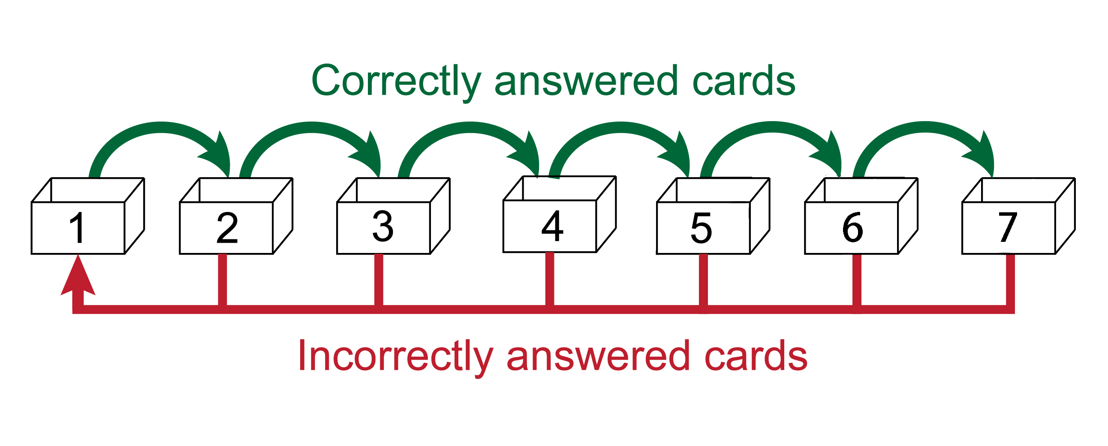

Figure 6 Transition scheme for review of words

Each deck is practised at various intervals. The cards in the lower decks are frequently practiced over and over again, deck 1 or even daily, and the upper decks are duplicated less frequently. The Leitner calendar is illustrated in Figure 7.

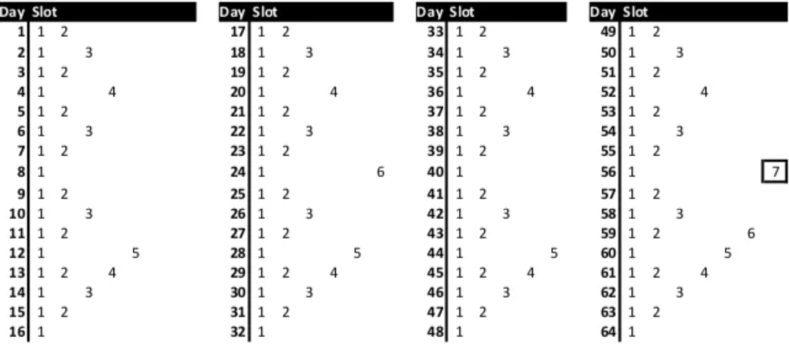

Figure 7 The Leitner calendar for a learning cycle of 64 days, after which the system repeats itself

### Research of Leitner system

There are few studies on the Leitner boxes system, but the practical application of the Leitner boxes system to draw cards is well researched, and there are many studies on draw cards that have demonstrated the effectiveness of interval learning through multiple experiments. At the same time, more and more scholars have begun to focus on the best spaced practice algorithms, and many excellent spaced practice algorithms have emerged as a result of the tireless efforts of many experts and scholars. Many algorithms have become increasingly complex in order to accommodate the many unknown factors in spaced practice learning, such as the learning and cognitive difficulty, the type and type of knowledge, the individual learner's ability and conditions, and many other variables. For example, the MEMORIZE algorithm[44] proposed by Behzad et al. is a simple, scalable online spaced practice algorithm that involves more than 30 different variables in its computation and requires the use of a computer to complete the entire process. In contrast, the Leitner boxes system is a relatively easy to implement spaced practice algorithm that does not require complex calculations to complete, it simply follows the schedule of The Leitner calendar for each day. However, the prevailing view is that the Leitner boxes system is not one of the best spaced practice algorithms, and many scholars consider it to be very tedious and inefficient. In reality, the 64-day learning cycle of the Leitner Box system is extremely long for many users, and the biggest problem for users is that if they are constantly learning new content, the actual workload becomes prohibitive later in the learning cycle and many users struggle to follow along.

### Improvement of Leitner system

Against this background, many scholars and researchers wanted to improve the Leitner system, Anouk Beursgens being one of them. Anouk Beursgens presented an analysis and improvement of the Leitner system in February this year. In his analysis[45] of the Leitner system Anouk decided to adopt the memory recall probability formula (Equation 3) used by S. Reddy et al. in the study *International Conference on Knowledge Discovery and Data Mining* as the memory recall formula to be used in his analysis. probability formula used in his analysis. He then proceeded to model the Leitner system using a discrete inhomogeneous Markov process and made a series of assumptions before embarking on a practical analysis and study, and concluded his research paper with a simplified version of a practical solution to the Leitner system. He proposes to replace the 7 decks in the original system with 5 decks and to compress the learning period from 64 days to 16 days, while making a number of user-friendly scheduling and changes to make the new solution easier to use and implement.

### Related works and Application

The Leitner's system has a massive benefit over the theory proposed before he made it: it is pragmatic. It is a system that could be used by any person and requires minimal introduction. Similar concepts to these have already been carried out in some computer-aided language study and flashcard applications. Most of these software use what are called " e-flashcards ". Study software such as SuperMemo, Anki and Duolingo use an improved algorithm based on the Leitner system.

* SuperMemo

The earliest work on SM-family of algorithms dates back to the 1980s, 100 years after the publication of the Ebbinghaus' forgetting curve, when Dr Piotr Wozniak became interested in spaced practice and began to conduct scientific research on the subject. Dr Piotr Wozniak's design was based on the Leitner system and the first generation of the algorithm was built, and after years of continuous improvement, many different memory models were introduced to improve the algorithm. Among the many different versions of the SM algorithm, the most famous one is the SM-2 algorithm, created for SuperMemo in the late 1980s, forms the basis of the spaced practice methods employed in the program. It is an open-source algorithm, has since become the object of imitation and learning by other spacing learning software. The latest version of SuperMemo algorithm is SM-18, to be released in 2019. Currently, due to the algorithm is not currently open source, only study software such as SuperMemo uses such an SM-18 as the standard for the interval repetition algorithm.

* Anki

Anki is a free and open-source flashcard program using spaced practice, a technique from cognitive science for memorization. The name comes from the Japanese word for "memorization". Anki's current scheduling algorithm is derived from SM-2, it is based on the Leitner system. There are many students who are currently using Anki because they think it is a program that makes it easy to remember things. It's a lot more efficient than traditional study methods. Anki is rapidly gaining importance as a source for many medical students in the USA. A University of Washington School of Medicine study[46] in 2015 discovered that 31% of students who replied to a medical teaching survey indicated that Anki was used as a study tool.

* Duolingo

Duolingo is the most popular language learning application for children today, with over 500 million registered users. The core algorithm used in the app is called spaced practice. And follow the concept of the Leitner system is introduced to provide personalized language lessons at longer intervals for optimal learning, rather than cramming lessons into a short period.

In addition, Duolingo offers users a five-minute language skills quiz to establish each user's beginning level of knowledge of the particular language they desire to learn before they start. For example, if someone signs up to learn French and if they have four years of teaching experience in high school, they are likely to have an even easier time starting a Duolingo course than a user who has never been taught French before. To accurately identify where each user's comprehension of the language begins, the placement test is adjusted as it proceeds based on whether the user has answered the previous problem accurately. In just five minutes, this quiz gives the application a really good indication of where every user ought, to begin with the curriculum.

# Design Approach

In this chapter, the author will discuss the design process of the final year project and provide detailed explanations and descriptions from four dimensions: subject, algorithm, UI, and system.

## Subject Design

The initial selection phase of this final year project was to produce something unconventional, and it required a change from the previous work. In contrast to Hermann Ebbinghaus's use of meaningless information to test the upper limits of human memory, this project aims to investigate how meaningful information can be remembered more easily, especially in the formative years of children's learning. Only by finding scientific and effective ways to reduce rote learning, reduce stress, improve learning efficiency and make learning more enjoyable for children. These are the beginnings of the author's research

Popular science was chosen as the main topic for this project. According to a survey[47] in the United States, one in four books read by students in grades K-12 is non-fiction non-fiction reading. Popular science, the main branch of non-fiction, has a much smaller proportion. According to the US Department of Education's recommendation that US students should spend 50% of their reading time on non-fiction by grade 4, it is clear that the current allocation of time between fiction and non-fiction books for most students and children is not reasonable. The reason for this is also obvious, as non-fiction books have a much more dense intellectual content and children, and even the average person, have a limited ability to understand and process information in non-fiction books. Experts and scholars have stated that 'success as students, citizens and workers depends largely on the ability to read and understand information or non-fiction texts' and therefore students of all ages need to be exposed to these non-fiction books and texts and encouraged to read them. When students are exposed to these non-fiction readings, they not only build their knowledge of nature and society, but also practice key skills such as citing evidence and evaluating arguments.

The top three most popular non-fiction reading topics in the United States in grades K-12 are animals, science, and biographies/autobiographies, which explains why science or, more accurately, popular science was chosen as the core learning content topic for this project. In addition, research has shown that students with better textual comprehension skills also have better critical thinking skills, which can be acquired by students reading popular science books. High comprehension maximizes every minute of reading time. Growth in reading is optimized when students read for longer and at higher levels of comprehension. Research has found that students with better text comprehension also have better reasoning comprehension, or critical thinking. Accurately assessing students' reading comprehension also gives students a good sense of their potential for critical thinking and reading skills. Education professionals encourage students to make an effort to read texts with strong comprehension skills and to read reading materials that have an appropriately challenging reading level.

In order to address the lack of reading of science books by real-life children, this project is intended to develop a children's learning software about providing science content. In order to address the lack of retention of non-fiction knowledge in the brain, it was decided to use active recall and spaced learning methods to improve the efficiency and retention of children's knowledge. The primary distinction between this project and traditional word learning software utilizing spaced learning for memorization is that children are provided with clear, practical information and knowledge, rather than abstract details regarding the 26 different letter combinations. Although each letter combination has a rich linguistic history and undergoes various changes, learning the spelling of new words presents relatively meaningless information. This project, instead, focuses on delivering useful and engaging content to children to foster their learning and understanding. The combinations of letters are often perceived as meaningless information for most people, particularly children, and are similar to what is studied in the forgetting curve experiments involving irregular letter combinations. The author aims to explore research on meaningful information and spaced learning, an area that currently has relatively limited coverage. Since this domain of scholarship remains under-researched, this project aspires to contribute valuable findings to fill this knowledge gap.

Experience has shown that information with realistic meanings is more likely to be remembered and less likely to be forgotten than meaningless information. Scientific studies have also shown that the brain is more neurologically active when it comes to remembering meaningful information than meaningless information. Many memory experts and masters recommend that meaningless information, such as sequences of numbers and letter combinations, be artificially assigned meaningful information to make it easier to remember and recall quickly, for example by making up a story about a letter combination. For example, the letter combination 'family' can be seen as a combination of the initial letters of each word in the sentence 'father and mother, I love you'.

This program offers individual learning goal setting for children and students in addition to the use of spaced learning. In many cases, personalized goals maximize pupils' motivation and the simple act of setting goals has been shown to be a powerful way to promote reading practice. Children who have set reading goals spend more time reading, read more books, and understand texts better, and achieve higher reading scores when they reach their goals. Specific goals with corresponding timetables can increase students' self-discipline in learning and can be more effective.

## Algorithm Design

In this chapter, the author briefly describes the process and methodology of his own research, and identifies useful results and findings from previous literature to inform the author's design. When designing an Algorithm, four sections deserve the most attention, namely Massing or Spacing, Optimum Spaced Lag, Basic mathematical model, and Balancing daily workload

### Massing or Spacing

In a study[48] of inductive learning methods Norehan and Jennifer conducted two experiments on the difference between spaced learning and aggregation learning in inductive learning. A number of images with different shapes and features were prepared and a number of labels were assigned to images with the same features. After several rounds of learning and recitation by the volunteers, the researcher asked the participants to identify the features of the new images. Despite the small sample size and large standard deviation of the data, it is intriguing to observe that for high discrimination learning (where memorized content is clearly distinguishable and not easily confused, such as red and green), aggregation learning proved to be more effective than spaced learning. Conversely, for low discrimination learning (where memorized content is not clearly distinguishable and may be similar yet different, like yellow and orange), spaced learning showed to be more beneficial than aggregated learning.

The above findings mentioned earlier offer valuable insights for the authors in designing repetition algorithms that adhere to the principle of distributing similar questions across various learning steps, while assembling questions with different labels within a single-spaced practice session. Essentially, the author plans to incorporate a random approach within the algorithm so that, under normal circumstances, students do not answer consecutive questions with the same label. This approach aims to enhance the challenge and novelty during the practice process, preventing students from developing thought inertia due to consecutively answering similar questions, which might lead them to neglect the thinking process involved in answering the questions. The rationale behind this approach is that each spaced learning session can be viewed as a miniature aggregated learning process. A single-spaced learning session may comprise several different topics in succession, necessitating children to sustain their concentration to learn efficiently over a period of time.

### Optimum Spaced Lag

It may be assumed that if spaced practice is more productive than a mass of practice, then the benefit will be greater the more interval (between practice repetitions). However, the evidence from research shows that this hypothesis is too over-simplistic.

In one review[49] and study of mechanisms and optimization of spaced learning, Paul et al. studied through molecular biology. Paul made progress in understanding the molecular mechanisms of the spacing effect through a series of biological experiments using predictive models to determine the optimal spacing between learning trials, and in human language study, he found an attractive positive correlation between the length of the trial interval of effective spaced acquisition and the interval of maintenance (i.e. the interval separating the final training episode from the memorization retention test). Between relatively brief holding intervals (approximately 1 minute - 2 hrs), inter-training sessions in the broad range of approximately 1 minute to 3 hours produced larger discourse learnings than inter-training interventions of 2 days or longer. Within the longer retention interval of 1 day, training interventions of 1 day produced more significant learning than very short (<30 s) intervals. A 7-day practice interval was preferable to a 3-day interval for retention at 6-month intervals for discourse acquisition. This association between lengthier training and retentive intervals suggests that longer training periods preferentially result in a long-lived memory train. It is plausible that for a range of minutes against several hours, at least to some extent, longer trace lifetimes are associated with increased transcriptional effects from larger training intakes. However, that explanation may be inadequate when comparing 1-day versus multi-day training interventions.

The results of another study[50] on optimal spacing lag also support the appeal, as Cepeda et al. showed in their study on optimizing distributed practice from 2008 to 2009 that there is no fixed optimal spacing time and that the optimal spacing time depends on the ideal retention time, with the longer the ideal retention time, the longer the interval between practice sessions. A largescale investigation researched 10 various lag periods (the intervals for initial learning and retention practice revisions ranged from 0 to 105 days) and four apparently various retention intervals (7, 35, 70 or 350 days after the retrieval exercise session for the final test. Retention rates for trivia facts (research material) were highest when the time lag was approximately 10% to 20% of the test retention interval. There is, however, no established optimum lag period - it relies on the target retaining interval. A lag period of about 1 day is ideal if you are looking for the maximum score on the exam a week later, but if you want to preserve information for 1 year, then a lag period of about 2 months is perfect.

In summary, the findings suggest that for children with a learning period of over six months, a training interval of seven days results in better test outcomes after the learning process is completed. In contrast, children with a two-week learning period achieve the best results when the training interval is one day. Considering that this project does not include any particularly large learning tasks, and each learning task is composed of an encyclopedia from a specific domain with a relatively limited amount of content, a learning period of around one month seems appropriate. Based on these findings and conclusions, and taking into account the actual situation of the project, the author concludes that the recommended spaced learning dates for designing the interval repetition algorithm in this project are as follows: a learning period of 15-30 days with an optimal interval time of one day.

### Basic mathematical model

A number of completely different spaced practice algorithms have emerged, but many of them are based on extensions and derivatives of the Leitner System. For example, Duolingo used the Half-Life Regression algorithm[51] when it was first launched, which is similar to the Leitner System. After an in-depth study of different spaced practice algorithm models and a comparison of different interval repetition algorithm models, the author decided to use the Leitner System as the basis of the model for this project and to improve on it to make it easier to use.

In subsection 2.3.2, a modified approach to the Leitner system is presented, and the mathematical models used in the analysis of the data that follows this project is derived from the models and methods developed by Anouk Beursgens in his research publications[52]. It is worth noting that Anouk Beursgens' research publications only describe the modeling methods and do not disclose the exact code and details, but after the author contacted Anouk Beursgens, Anouk Beursgens agreed to disclose his code and sent it to the author via email. The subsequent personal research work undertaken by the author resulted from extended learning and research into the numerical analysis model developed by Anouk Beursgens.

In Anouk Beursgens' mathematical modelling of the Leitner system, he decided to use days 1 to 16 of the Leitner calendar as the learning cycles for the model, considering the impact of the actual operational efficiency provided five decks for the model to use. In addition, he believes that the Leitner system is modelled as a Markov process. Time-steps are discretized, that is, one day. The review scenario after a specified number of days is the same as the review scenario from day one, so the Leitner system is modelled as a cyclic Markov process.

In the next step, Anouk Beursgens conducted a preliminary data analysis to identify potential issues with the Leitner system. First, he analysed the impact of the difficulty coefficient in the model. The difficulty coefficient is a parameter within the model, with a mathematical range between 0 and 1, representing the difficulty level of the knowledge children are learning. The more difficult the knowledge, the higher the difficulty coefficient, and the lower the probability that children will successfully recall it the next time. Anouk Beursgens continuously adjusted the model's difficulty coefficient and tested it, eventually finding that a difficulty coefficient of 0.3 closely matched the actual conditions of human memory processes. Ultimately, he decided to use the difficulty coefficient (theta = 0.3) as a model prerequisite and obtained a statistical diagram of the amount of work children did on day 0 to review what they had learned on day 0 after having done so once on day 0 (the workload on day 0 is unit 1).

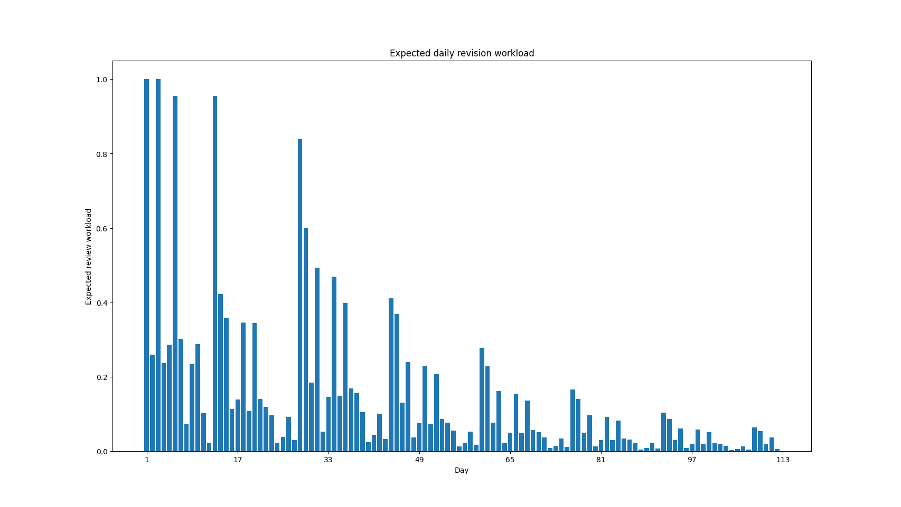

Figure 9 Original Leitner System's Review Workload Statistics Chart

In the figure 8, it can be clearly seen that in the first 16-day repetition cycle the repetition cycle has some peaks close to 1 on days 1, 3, 6 and 13, which is due to the fact that in the Leitner calendar there is more decks to be reviewed on these days and therefore a higher revision workload. In addition, it can be observed in the bar chart above that there is a clear downward trend in the revision workload of the students after the 33rd day, i.e. the end of the 2nd learning cycle, for the 3rd and subsequent rounds. Therefore, in order to simplify the analysis, the authors will only discuss the first two learning cycles in the subsequent analysis.

Figure 8 only illustrates the variation in revision workload after learning something new on day 0. In addition to reviewing old knowledge, users learn new knowledge every day. The authors, therefore, wanted to go further and analyse the trend in the average daily revision workload of the students under the condition of learning something new every day for 16 days. The authors calculated the actual amount of revision work done by the students on day 17 and beyond by following these steps:

1. Calculate the statistics on the amount of review work from day 0 after learning new knowledge in unit 1, as shown in Figure 1
2. calculate the revision workload from day 1, then from day 2, day 3, day 4 to day 15
3. Adding up the 16 statistics for one learning cycle, as shown in Figure 2

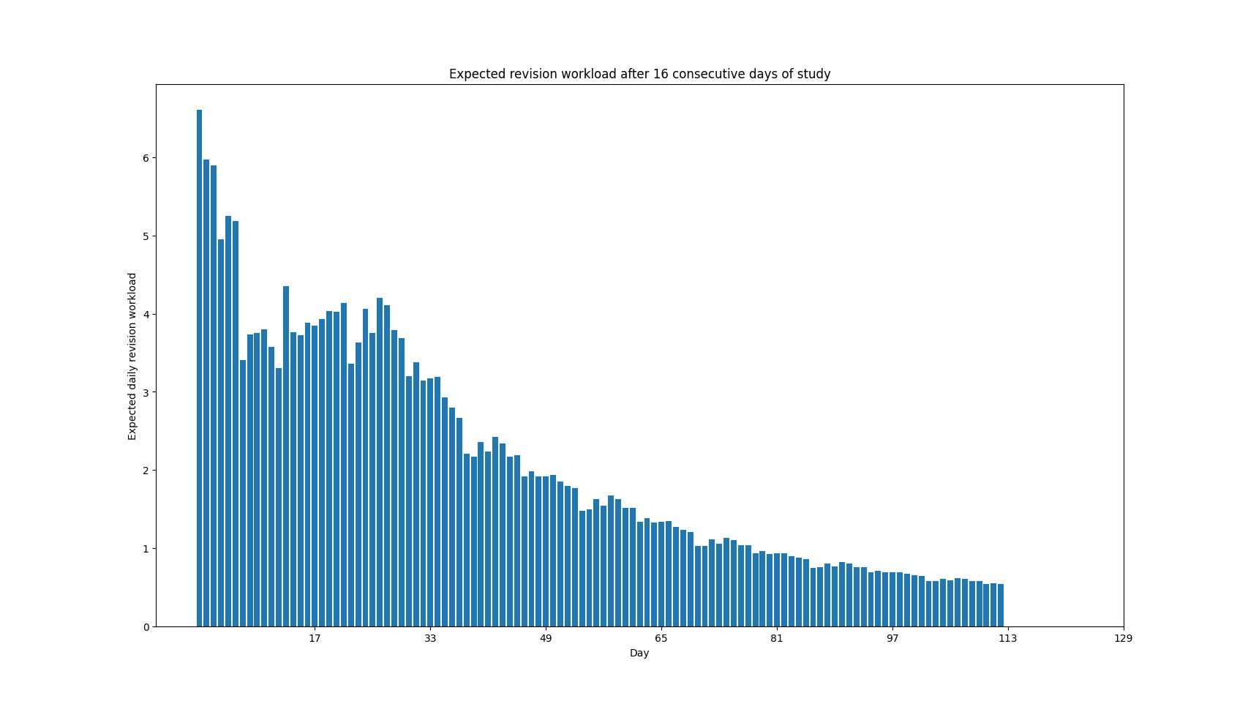

Figure 10 Total Workload Statistics Chart after Adding Review Work and New Practices

Figure 9: The statistics start from day 17. The workload expectation for revision on day 17 was above 6.5 and for the next 5 days, it was above 5. After this, the daily revision expectations fluctuate slightly between 3 and 4.

### Balancing daily workloads

In the last section, the author predicted trends in the average daily revision workload of learners under the condition of learning new knowledge daily for a period of 16 days, in which 2 trends in the data were found.

Trend 1, where the expectation of revision was high and on a decreasing trend from day 1 to day 6 after the end of learning new content. Trend 2, from day 7 (day 23) after finishing new content to the end of a 2-study cycle (day 49), review expectations fluctuate between 3 and 4, with review expectations at a more stable level.

To overcome the issue of excessive revision expectations in the first six days, the author will suggest two solutions. Solution 1, halve the daily workload for the first 6 days and postpone the study plan for 6 days, then complete the remaining workload for the original 6 days during the postponed 6 days. As shown in Figure 10

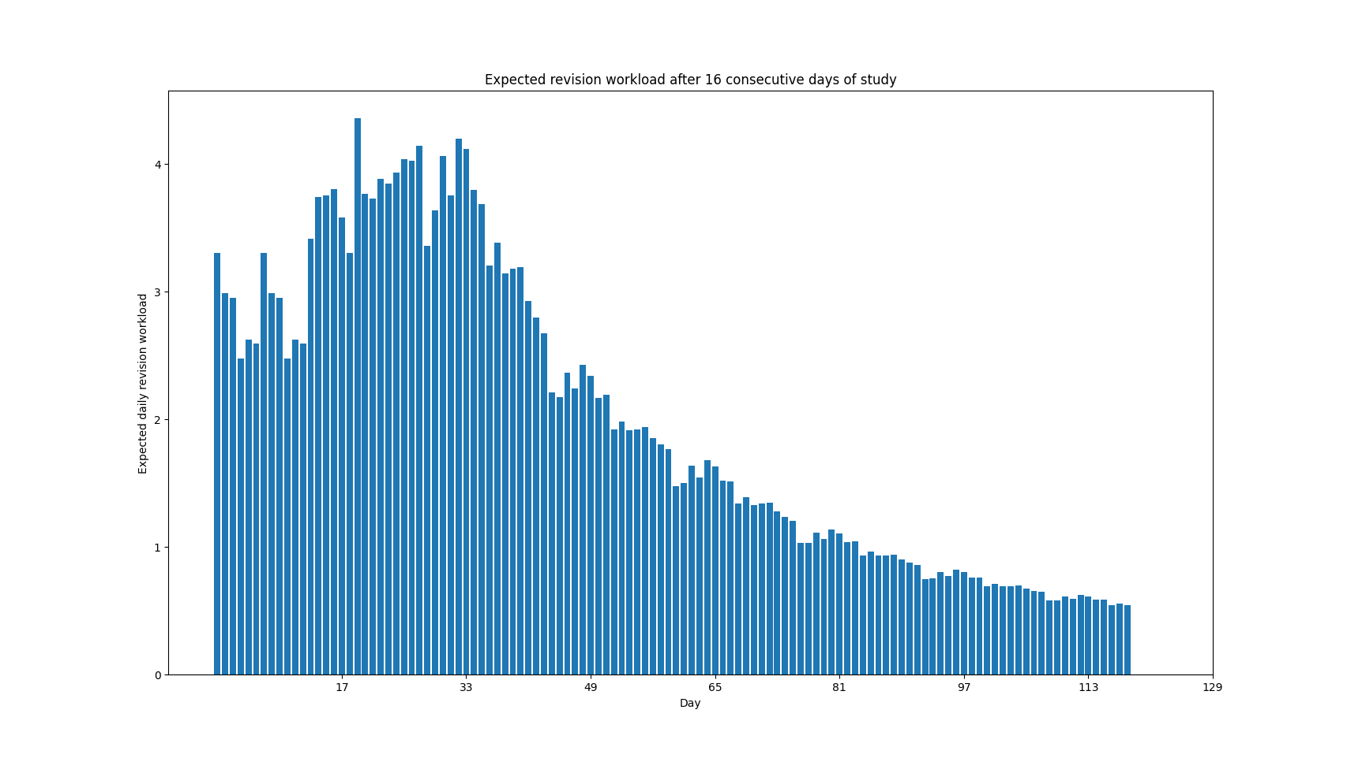

Figure 11 Total Workload Statistics Chart Obtained through the First Balancing Method

Solution 2, spread the daily revision workload from the first 6 days to spread it evenly over days 7 to 12. In other words, distribute the reduced workload from the first 6 days evenly over days 7 to 12. As shown in Figure 11

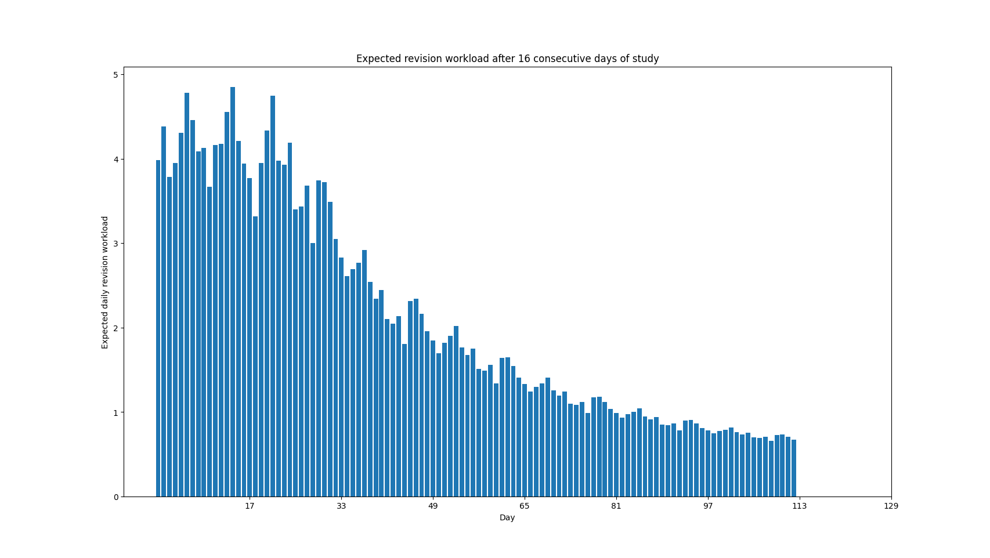

Figure 12 Total Workload Statistics Chart Obtained through the Second Balancing Method

In general, the main issue with the first solution is that it delays the revision cycle, and the main problem with this is that it affects the actual effectiveness of subsequent revision, and learners may face a greater workload and difficulty in subsequent revision due to the six-day delay. The second solution is even more ideal as it avoids delaying the study date and is a better solution to the issue of excessive revision workload in the first 6 days.

## User Interface Design

### Responsive Design

With the rapid spread of smartphones, people are becoming more and more dependent on them in their daily lives. According to the Statista data, the number of smartphone users in the world currently amounts to 6.648 billion, which implies that 83.32% of the world's population has a mobile phone. This amount is a significant increase from 2016, when only 3.668 billion users, or 49.40% of the global population, existed that year.

In the last few years, mobile users have frequently complained of difficulties in reading and using traditional PC website. This is because traditional PC website do not display well on mobile devices. With such a huge number of mobile users, this has forced many developers to make changes and many commercial companies have developed mobile applications to replace PC browser web pages in order to respond to mobile users' habits and provide a better experience for mobile users. Operating systems of smartphone currently consist mainly of Android and iOS. On Android, most of these mobile applications are developed using java and Kotlin as programming languages; on IOS, Swift is used to developing mobile applications, which is a powerful and straightforward programming language created by Apple.

It probably seemed obvious that redeveloping a mobile application using Kotlin for this project might be a better idea, but considering the workload caused by developing an Android mobile application from scratch, the author had to reject this solution. However, to satisfy the requirement of mobile users, original design need to change to adapt the project interface to be suitable the mobile screen. There are currently two design solutions to fulfil the requirements, adaptive web design (AWD) and responsive Design.

Adaptive Web Design (AWD) advocates the creation of several versions of a website to adapt it to the user's devices significantly better, rather than a singular static web page that reloads (and looks) identical on all machines, or a solitary page that rearranges and adapts content in response to the user's machine/screen dimensions / browsers.

Although adaptive web design has advantages, it causes significant problems. The main problem with using adaptive web design is that the web pages have to be rebuilt from scratch to fit the mobile screen size of the mobile user, which generates more work. On the other hand, the various screen sizes of mobile devices cause the same web page to be displayed in different proportions on different screens. There are many types of mobile phones of all brands and models on the market, in many varying screen sizes, and for children, the primary users of this project, the iPad is the most commonly used mobile smart device. Another potential challenge is that creates a massive number of redirect requests, which leads to wasted server bandwidth and resources, thus resulting in slower page loading for the user and ultimately affecting the actual user experience.

### Visual Memory and Vocabulary Aid

Visual Memory in human beings is an essential cognitive tool. With visual memory, people are able to recognize things we have seen in the past, even when exposure is relatively short. Improvement of visual memory is commonly associated with practice effect and experience that comes with age. In a study by Vuontela et al., results suggested that older children were able to recall sequences further back in a series of pictures presented.

Based on the above-mentioned literature, the authors believe that visual stimulation of children is also a very important element in the learning process, and therefore the inclusion of appropriate and relevant pictures in each question is essential for children to learn and recall. The combination of pictures and text can effectively reduce the threshold of understanding abstract knowledge, and the visual stimulation of pictures helps to remove the boredom brought about by text, resulting in children being more enthusiastic about engaging with and learning about the subject, enhancing the enjoyment and pleasure of learning.

An important practical issue in the design of UI is the inability of children to understand the meaning of words for some species, in other words children do not know a particular technical term. As children learn science and read popular science texts, they are bound to encounter words that are unfamiliar or out of the ordinary. A common problem encountered in practice is that children may know the correct answer to a question, but due to their unfamiliarity with the words, they misunderstand the true meaning of the question or option. Therefore, the project is designed to provide a dictionary explanation of the key term in each question, along with relevant pictures to enhance visual stimulation, so that children remember it better and increase the likelihood of successful recall the next time. Children use mouse to hover over a marked term to be provided with the specific meaning of the term directly. The aim of this is to save children's learning time by allowing them to easily access the corresponding explanation within the learning software when they encounter a complex term, rather than having to resort to an external dictionary or word search software. This reduces and saves time in word searching, reduces the uninteresting and impatient learning process, reduces distractions and reduces frustration in the learning process.

## System Design

In this chapter, the author will provide an overview of the work from the perspective of a system designer. Author will begin by discussing data modelling using Entity-Relationship (ER) diagrams and pre-written SQL statements. Following that, author will examine the system's architecture and delve into the technology choices made for each component of the system.

### Data Modelling

To develop a learning logic that truly caters to the requirements of children, the author has meticulously analysed data modelling and created an Entity-Relationship (ER) diagram. This diagram effectively captures the structure of the database, presenting the contents of each table and the relationships between them. In the subsequent paragraphs, the author provides a polished description of these components to illustrate the underlying design.

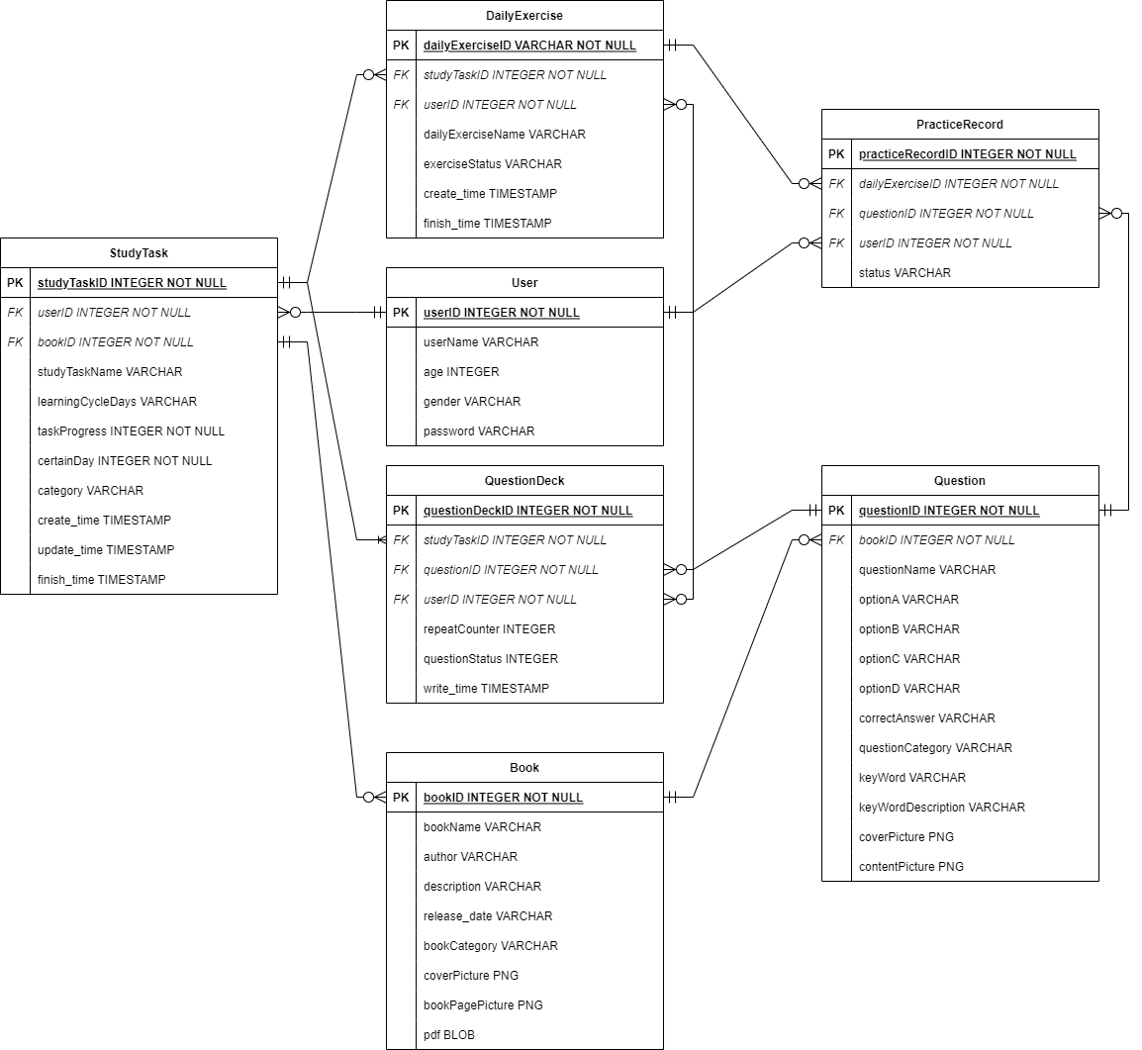

Figure 13 Entity-Relationship (ER) diagram

The following table will show the attributes of each schema and give a basic description for each of them.

|  |  |  |
| --- | --- | --- |
| Table name | Attributes | Description |
| User | User ID, user name, age, gender, password | This table is designed for child users who have successfully registered an account on this spaced learning platform. It contains a limited amount of personal information in addition to usernames and passwords. |
| Book | Book ID, book name, author, description, release date, cover picture, book page picture, book category, pdf | This table records all the encyclopaedias on science learning for children. It includes basic information about each book and uses pictures to store the actual content of each page in every book. |
| Question | Question ID, question name, option A, option B, option C, option D, correct answer, question category, related information, key word, key word description, cover picture, content picture | This table records basic information about each child's practice question, including the topic, options, and answers. The keywords and explanations for each question are correspondingly given to make it easier for children to accomplish the questions. |
| Question Deck | Question deck ID, question status, repeat counter, write time | This table records a child's mastery of a topic. The question status refers to which decks the question is in the Leitner system, and the repeat counter refers to the total number of times the child has done the question. |
| Study Task | Study task ID, study task name, learning cycle days, create time, last update time, finish time, task progress, certain day, category | This table records information about the study task created by the user and includes three related time. |
| Daily Exercise | Daily exercise ID, daily exercise name, exercise status, create time, finish time | This table is designed to record information about the user's daily exercises. The status records whether the user has completed the exercise or not. |
| Practice Record | Practice record ID, status | Instances generated from this table are the results after the user has completed the exercise and submitted it. Each time a user submits an answer, a practice record is generated, and the status of the practice record indicates whether the user's submitted answer is correct or not. |

Table 3 Entity's Attribute Table

Each class has a not null ID number to ensure every instance in the database stays uniquely. It means that once an instance is created from the backend, it will not affect the existing instances. In detail, suppose a user have many study tasks. Meanwhile, a question must belong to a specific book and may be selected to be added to multiple daily exercises. And it is clear that each study task contains numerous daily exercises, with all daily exercises being generated from the question decks of a particular study task. The next table will illustrate the detailed relationships between each table (Entity).

|  |  |  |  |
| --- | --- | --- | --- |
| Entity Name | Relationship | Multiplicity | Entity Name |
| User | has  has  has  has | 0..*  0..*  0..*  0..* | Study Task  Daily Exercise  **Practice Record**  **Question Deck** |
| Book | includes  **behaves as** | 0..*  **0..\*** | **Question**  Study Task |
| Question | **behaves as**  **behaves as** | **0..\***  **0..\*** | **Question Deck**  **Practice Record** |
| **Study Task** | includes  has | **1..\***  **0..\*** | **Question Deck**  **Daily Exercise** |
| **Daily Exercise** | has | **0..\*** | **Practice Record** |
| **Question Deck** | **\** | **\** | **\** |
| **Practice Record** | **\** | **\** | **\** |

Table 4 Entity's Relationship Table

### Dynamic Modelling

The following diagram(Figure 13) shows the state change process of a particular question during a student's learning period. By default, the initial state after a user creates a learning task is "question deck 0". When the question is answered correctly, the state changes to "question deck 2". If the question is answered correctly multiple times afterward, the state changes to "question deck 5". This state indicates that the user has fully mastered the knowledge required for this question, and the state will no longer change. In addition, if the user submits an incorrect answer, the state will change to "question deck 1".

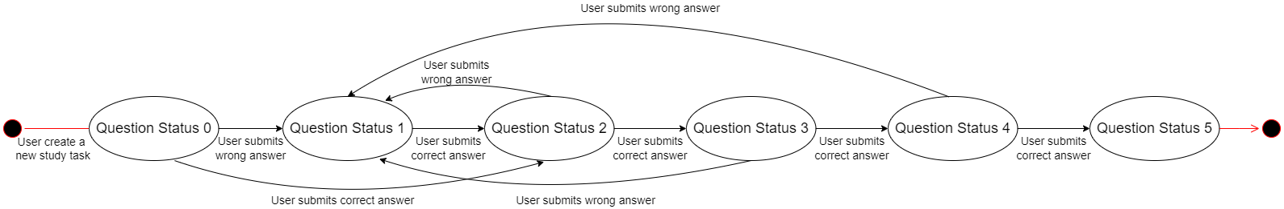

Figure 14 • Question Deck Status Control Diagram

Figure 14 shows the activity diagram of our project, where we can see the activities from two different actors in the system: the user and the server (database). The user first enters the website, and if they are not registered, the system redirects them to the registration page, where they can log in or sign up. Only after the user logs in successfully can they access their personal homepage and edit their personal information, such as age and password. Users can click on the sidebar to enter the encyclopedia list interface and choose the books they are interested in and start reading. In addition, users can create a learning task to deepen their knowledge and perform spaced exercises daily. Users enter the daily exercise list to browse all exercise records and then click on a record to view detailed exercise information and begin their daily practice. After the user selects their answer, the system will judge the user's answer, provide feedback, and upload the exercise record. Once the user completes all exercises, the system will display the results of this exercise session. If the user wishes to continue practicing, the system will automatically generate similar questions to consolidate the knowledge the user has learned. After completing the exercises, the system will collect and analyze the user's learning records and display them in the form of charts on the statistics page. Afterwards, the user can choose to log out and close the web application.

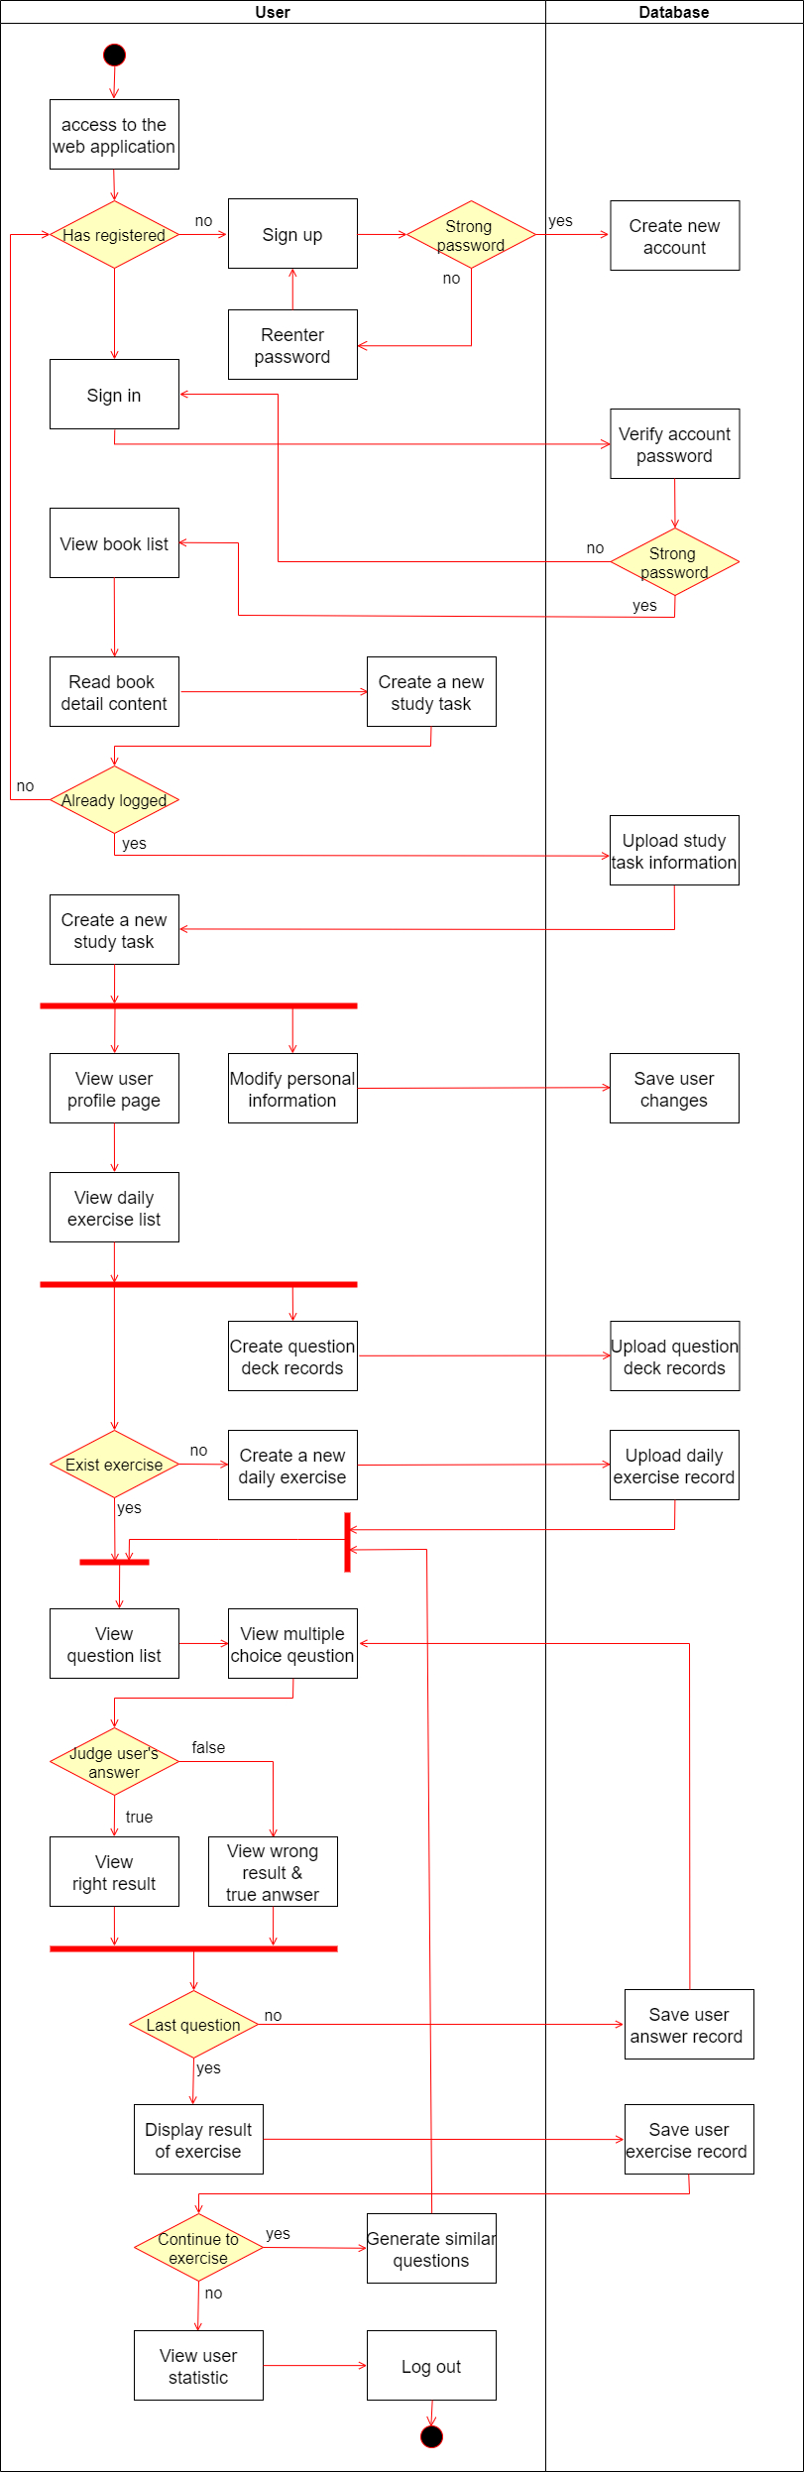

Figure 15 Activity Diagram

### Software Architecture

In the design stage, it is decided to adapt the front-end back-end separation structure to the project. The author decided to design the client-side website with the MVVM model and make the back-end, for the customers, a pure API services provider. The entire system is divided into separate modules.

The following diagram shows the complete structure of the project.

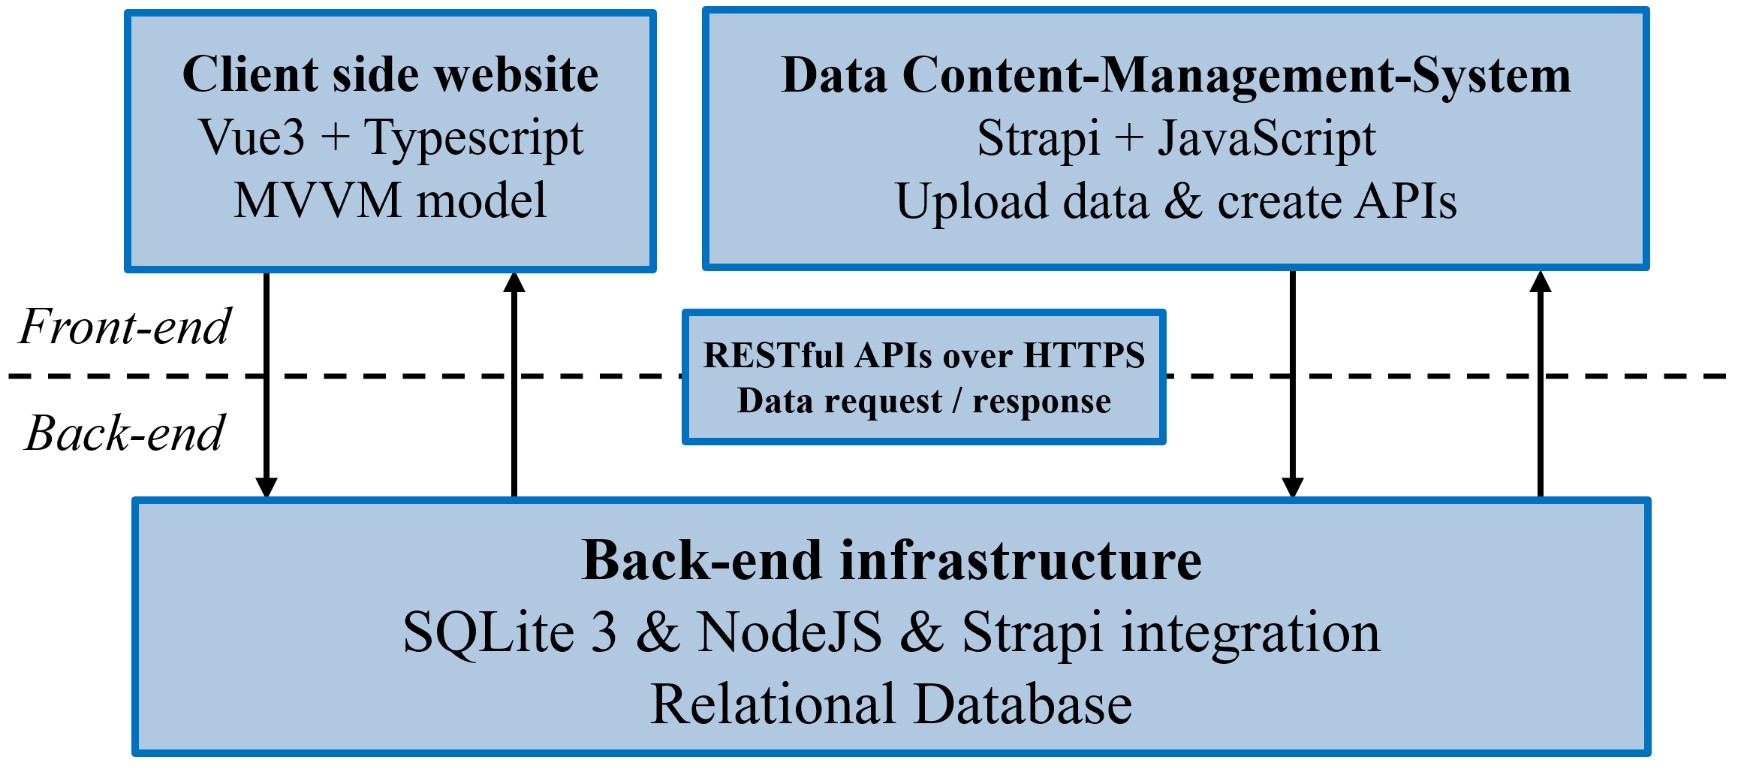

Figure 16 System Structure Summary

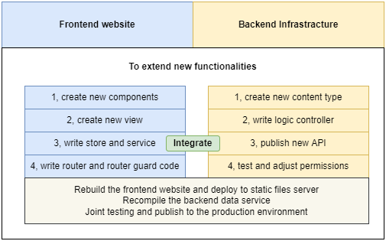

Figure 17 The extending features of the project

# Implementation

In this chapter, the author will discuss the implementation of the project's architecture and main features. Regarding the architecture, this chapter will examine the structure of the system separately. For the implementation of the main features, we will select some critical parts of the project and describe them from four perspectives. They are Technology Selection, back-end, front-end, and algorithm. They are not entirely independent but interact with each other to form and implement a complete final year project.

## Technology Selection

In this first section of the chapter, the author will introduce programming languages, platforms, and tools (including software toolkits or libraries), which are crucial for the development and implementation of the project. Additionally, the author will explain the reasons behind the choice of each software toolkit or library one by one. At the end of this chapter, the author will provide a JSON file containing the package dependencies for this project implementation as a reference.

### Back-end

Author decided to use RESTful API over HTTPS to standardize data requests and responses and use JWT technology to implement account management system.

In the design stage, there are two technical solutions to choose from for the back end: one is to completely design and implement the back-end system independently, using PHP or Python as the programming language and pairing it with MySQL or MariaDB. The other is to learn and try using existing back-end frameworks to meet our needs. In order to make it easy for users to edit data, such as uploading learning materials, the author ultimately chose the second approach and decided to use the Strapi framework.

The software, developed and open-sourced by a French company sharing the same name, offers an open-source headless content management system (CMS). Strapi, a Node.js-based, back-end only CMS, aims to provide developers with the freedom to utilize their favourite tools while simplifying content management for editors.

The following framework features were introduced by Strapi’s official website:

* **Modern Admin Panel:** Elegant, entirely customizable, and a fully extensible admin panel.
* **Secure by Default:** Reusable policies, CORS, CSP, P3P, Xframe, XSS, and more.
* **Plugins Oriented:** Install the auth system, content management, custom plugins, and more, in seconds.
* **Blazing Fast:** Built on top of Node.js, Strapi delivers amazing performance.
* **Front-end Agnostic:** Use any front-end framework (React, Vue, Angular, etc.), mobile apps, or even IoT.
* **Powerful CLI:** Scaffold projects and APIs on the fly.
* **Databases Support:** Works with PostgreSQL, MySQL, MariaDB, and SQLite.

### Front-end

The front-end project is the most important part of the FYP project. There are two different design approaches during the design phase. One is to design a mobile native app developed with Kotlin and Java, and the other is to develop a responsive cross-platform web application using the Vue framework. Although the number of global mobile phone users exceeded 5.3 billion two years ago, it is undeniable that in recent years, more and more child users are using tablets such as iPads as their primary electronic devices. In order to meet the needs of multi-platform users with different devices and reduce redundant development, the author decided to use the second design approach, developing a Vue web application. This web application adopts a responsive design, which can use different layouts in different pages to meet the needs of desktop, tablet, and mobile phone users. The web application can be deployed on a server after development is complete, and users can easily access it by simply entering a specific URL in their browser.

TypeScript is a superset of the JavaScript language that has a single open-source compiler and is developed mainly by Microsoft. The goal of TypeScript is to help catch mistakes early through a type system and to make JavaScript development more efficient. It builds on the successes of JavaScript while improving on its weaknesses.

In program development, a "small change" in a type may result in a lot of code adjustments, and these adjustments may not be indicated by any error before or after the "small change", so the developer has to rely on the naked eye to check, which is difficult and easy to miss.

In addition, TypeScript is suitable for use as a scripting language in the Vue 3 framework, as it can make the code more readable and maintainable.

As a framework implemented in the MVVM model, Vue has a simpler structure than traditional frameworks, with powerful packages for state management, routing, or server-side rendering that have up-to-date support and ensure synchronization across the system. Using Vite and Vue, setting up projects and getting them ready for deployment is very fast.  This, in turn, helps build our application quickly and efficiently.

On the other hand, Vue is light, easy to learn, and easy to write.  Integrating or migrating existing projects to Vue is faster and smoother due to its familiar template syntax and use of components. As the project developer, the author has systematically learned the Vue framework in previous university courses. Therefore, the Vue 3 framework is the best choice for the development and implementation of this project.

In addition to better TypeScript support, Vue 3 also boasts enhanced customization capabilities. Vue 3 offers more options for customization and extension, allowing developers to easily integrate multiple libraries and build more complex applications. This includes the ability to create custom directives, filters, and plugins, making it possible to effectively leverage third-party libraries.

In this project, the author added TypeScript dependencies while creating the Vue 3 project and then included two common libraries for Vue projects: "axios" and "pinia". "Axios" is used to send HTTP requests in both browser and Node.js environments. It offers a concise and easy-to-understand API that can handle various types of HTTP requests (such as GET, POST, PUT, DELETE, etc.). "Axios" makes it easier for the frontend to communicate with the backend server to retrieve or send data. Pinia is a state management library for Vue.js that provides a simple, lightweight, and high-performance state management solution for Vue applications. Compared to Vuex, another popular state management library for Vue, Pinia is easier to use, has a more straightforward API, and provides stronger type inference support when used with TypeScript. "Pinia" allows developers to divide the application state into multiple independent stores, making it easier to manage and maintain the shared state of various components. "Pinia" makes the development process of Vue applications more efficient, more scalable, while maintaining good performance and maintainability.

During the development of this project, the author used Tailwind CSS to enhance the webpage's appearance and design its layout.

Tailwind CSS offers many benefits, significantly reducing development difficulty and time compared to traditional CSS. For example, Tailwind's "Utility-First Fundamentals" feature eliminates the need for constantly editing special CSS files as the project evolves. With Tailwind, you style elements by applying pre-existing classes directly in your HTML. This approach means you no longer need to write separate classes for each different appearance. Instead, you simply write the styles for each tag you need within the relevant HTML. This method is convenient because it saves the trouble of importing and makes modifications and fine-tuning easy.

Tailwind CSS has a significant advantage when it comes to responsive design. Responsive design is a crucial aspect of modern web development, as it ensures that websites and applications adapt well to various screen sizes and devices, such as desktop computers, tablets, and mobile phones. Tailwind CSS makes it easy to create responsive designs by providing utility classes that apply different styles based on breakpoints. These breakpoints are defined by default but can also be customized to suit your project's specific needs. By using these utility classes, developers can quickly adapt their designs to different screen sizes without having to write extensive custom media queries.

This approach not only saves time during development but also helps maintain a clean and consistent codebase, making it easier to manage and maintain the project in the long run. Overall, the responsive design capabilities of Tailwind CSS make it an excellent choice for modern web applications and websites that need to cater to various devices and screen sizes.

During development, the author utilized the extensibility of Vue 3 to add many small plugins to the project, such as "vue3-datepicker", "vue3-pdf-app", and "vue3-photo-preview". By using these components, the web application's interactivity with users can be significantly enhanced, streamlining the development process and allowing the author to focus on developing key features without spending too much time on less important parts.

Lastly, the author would like to clarify that these packages, libraries, and dependencies all have an MIT license, and they are all free-to-use and open-source projects. At the end of this section, the author will list the package dependencies of this project:



## Backend Implementation

In Section 4.2 of this chapter, the author will focus on the development and implementation of the backend project. For this project, although the backend is not the most critical part, it helps store data and provides efficient API interfaces for the frontend to access data, which is crucial for the entire spaced learning project.

### Setup the Server-side

Before setting up a Strapi project, the author installed the Node.js environment using Node.js v16.14.0 and enabled the core package to use yarn package management (v1.22.15). Afterward, following the official Strapi guide, we created a new project by entering:



When finished, some important parts of the project's default structure were as follows:



### Database

To set up the database, the author initially carried out database configuration. For the sake of convenience, SQLite3 was employed in the project's database settings. Moreover, the framework facilitates data migration between two distinct databases, which the author will address later concerning MySQL migration. The configuration file can be found below:



The subsequent step involved creating tables. The Strapi framework employs a JSON-based ORM-like content type system, allowing shaped types to be automatically converted into database tables. This can be achieved by writing type configuration or operating within the admin panel. The author translated ER diagram and pre-written SQLs into the corresponding types. The following code shows an example schema from the project, using "book" as an example:



### Authentication System

The author implemented an authentication system using JWT (JSON Web Tokens), an open, industry-standard RFC 7519 method for securely representing claims between two parties.

JSON Web Token (JWT) provides a compact, URL-safe way to represent claims that are transferred between two parties. The claims in a JWT are encoded as a JSON object, which is used as the payload of a JSON Web Signature (JWS) structure or as the plaintext of a JSON Web Encryption (JWE) structure. This allows the claims to be digitally signed or protected with a Message Authentication Code (MAC) and/or encrypted.

JWT is particularly useful for API authentication and server-to-server authorization. In the context of Single Sign-On (SSO), it enables a service provider to receive trustworthy information from the authentication server.

By sharing a secret key with the Identity Provider, the Service Provider can hash a portion of the received token and compare it to the token's signature. If the result matches the signature, the Service Provider knows that the provided information came from the other entity possessing the key. This ensures a secure and reliable authentication process. The JWT authentication process typically consists of 4 main steps, as illustrated below:

=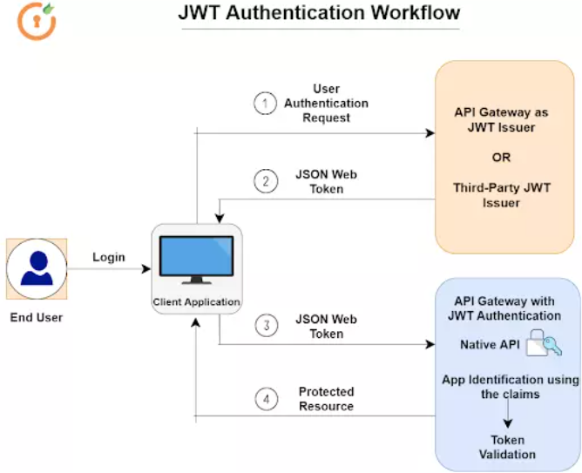

Figure 18 JWT Authentication Workflow

The JWT consists of three parts: header, payload, and signature. and use dot (.) to connect these three parts. the algorithm in the header stands for the algorithm and the default value is HMAC SHA256 (shorthand: HS256), payload is also a JSON object, it is used to transmit data like username or token expiration time, and the signature is a partial taking of security consideration. The JWT data structure is illustrated as follows:

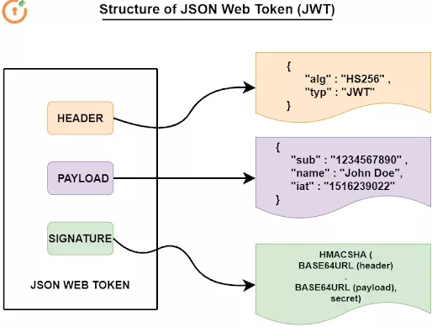

Figure 19 Structure of JSON Web Token

Strapi framework provides a handy way to perform authentication and authorization. In the following code, the program always validates the user when they try to sign in. If successful, the endpoint returns a JWT for the user, which is stored in the browser's local storage and added to the default request header for validation in every future request. When the user re-enters the site, the program consistently executes the recovery method to maintain the user's sign-in status within the expiration time. The attached code is the client-side authentication method in the project.



## Frontend Implementation

In the third section of this chapter, the author will briefly introduce and explain a part of the frontend code implementation process, focusing only on the static implementation of the frontend web pages and data retrieval. Due to space constraints, the author can only choose key pieces of code to describe.

### Frontend Structure

Before diving into the specific implementation process, let me briefly introduce the structure of the frontend project. As this project uses the Vue 3 framework, its project structure is similar to that of traditional Vue projects. The file structure of the project is as follows:



The "views", "components", and "layout" folders contain all the Vue files, which make up the static pages of the web application. The "css" folder contains most of the stylesheets, while the script portions of the project are distributed across the remaining folders. It is worth noting that, in the components section, the author created a large number of small Vue components to improve code maintainability and facilitate reuse. These components are nested together to form a complete larger component. Additionally, the author followed the React project structure, placing some TypeScript files in the "hook" folder, which contains various hook functions.

### Data Transmission

In frontend development, the first challenge encountered is the communication of data between the frontend and backend. The author's solution is to use "Pinia" and "axios" in combination and record these data transfer functions in the "store" folder. "Pinia" and "axios" are two libraries used in frontend development, particularly with Vue.js applications. They work together to handle state management and data communication between the frontend and backend. For each collection type, scripts are created to store functions and temporary data. Next, the author will use the "question" collection as an example to explain how data is transferred between the frontend and backend.

The author first utilized TypeScript's features to strictly enforce the data types of almost every variable. To ensure that the data receiving end of the frontend can effectively store data from the backend database and execute clear and logical operations, the author defined the data types for each variable, as shown in the following code:



The core usage of "Pinia" is to define a specific type of "Store" to maintain the state and logic of certain components. The "Store" is an instance that can be freely read and written, making it more convenient for developers to access the required data from the frontend and avoid conflicts between the backend and frontend. For example, as shown in the code above, the author created a new store to maintain the state of the "order" object. A special instance called "QuestionStore" was predefined to hold all variables and functions. To define a state store, the "defineStore()" function is used, and a unique ID must be provided to ensure the store is successfully mounted onto the root store.

After completing the preparatory work, the author used asynchronous functions and the "axios" tool to fetch question data. These temporary data are then stored in variables and displayed on the web page. The following shows the get function for the question list:



In this code snippet, "axios" is initially used to fetch data from the backend API endpoint. "axios" is a library employed for making HTTP requests in both browser and Node.js environments. It provides a simple and easy-to-understand API that accommodates various types of HTTP requests, such as GET, POST, PUT, DELETE, and others. Upon successfully sending the request, the corresponding temporary data is returned. Subsequently, this data is stored in different variables and displayed on the web page. With this process, the author has successfully completed the frontend-backend data transfer work.

### Responsive Design in Tailwind CSS

In order to ensure a more comfortable user experience, the author aims to achieve responsive design in this project. In simple terms, a responsive layout is a method of displaying web content in various styles on screens of different sizes. When a web page becomes wider or narrower, elements within the web page automatically stretch or shrink to fit the new width of the current screen, without leaving blank spaces or horizontal scroll bars on the edges of the page. As a result, web pages that utilize responsive design tend to be more flexible and easier for users to read and interact with, as they don't need to perform extra tasks (such as manually zooming in or moving the page) to view the page's content.

Tailwind comes with a set of pre-set breakpoint values and corresponding names for the most common screen sizes. When developers want to adjust the display of different elements for these screen sizes, they only need to use the name of the breakpoint size in the class of the tag they want to modify, and then write the required changes after the name. This code displays the detailed dimensions for each size name:



After completing the Tailwind setup, the next step is to use them in the "template" section of the Vue files to achieve responsive design. The author will now provide an example of a card component's code from the profile:



This code snippet is an excellent example of Tailwind CSS's capabilities. Developers don't need to input many values when defining styles for each HTML element in the "class"; instead, they input abstract phrases that Tailwind can convert into CSS stylesheets, making the code more readable.

For instance, in this line of code: "<div class="text-center md:text-right space-y-2">", it means that the text within this "div" is centred by default. However, when the screen width is greater than 768 pixels, the text will align to the right. The following two screenshots will effectively demonstrate this responsive web design:

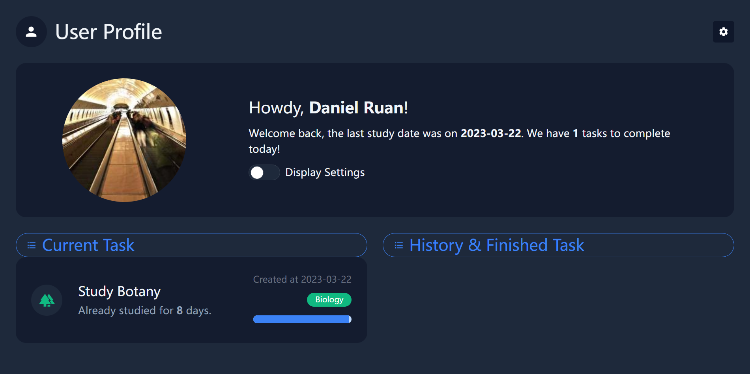

Figure 20 Desktop Style

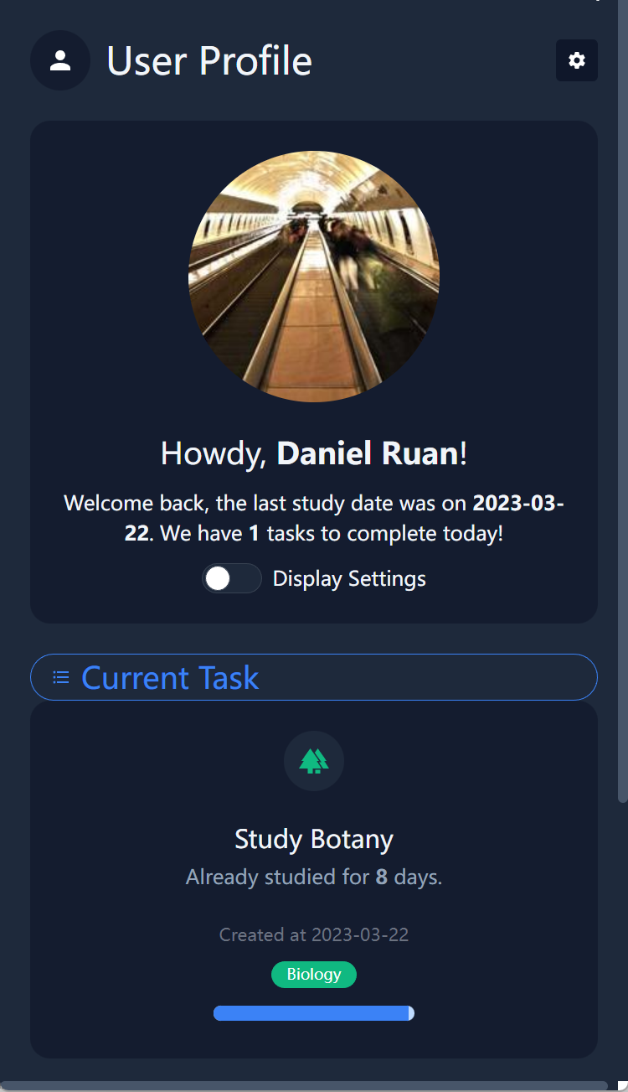

Figure 21 Mobile Phone Style

## Algorithm Implementation

In the final section of Chapter 4, the author will focus on the implementation process of the spaced repetition algorithm, which consists of three parts: building a Markov model, review algorithm, and recommendation algorithm. The implementation process of these three parts is not complicated, but due to the length limitations of the paper, the complete code cannot be fully displayed. The author will show key code snippets and explain each one.

### Building a Markov model

During the design phase, to validate the theoretical effectiveness of the Leitner system as a spaced repetition algorithm, the author referred to a 2022 literature[52] to create a mathematical model. The literature pointed out that the Leitner system can be modeled as a discrete-time inhomogeneous Markov process. Next, the author will show some code snippets and explain step by step how to build this mathematical model to validate the effectiveness of this spaced repetition algorithm from a theoretical perspective.

The author chose the popular Python programming language to model the Leitner system. Python contains packages and modules for mathematical processing, so the author took advantage of this feature and installed and called five libraries or modules in Python.



The first four imports are related to fundamental mathematical libraries in Python, while the last import is a submodule of the Matplotlib library in Python. This submodule provides a MATLAB-style interface for creating a variety of plots and visualizations. After completing the basic imports, the author created several foundational variables to prepare for subsequent calculations.



"nr_of_cards" is used to record the status of a question, with a default starting value of 1 and a maximum value of 6. "theta" represents the difficulty coefficient of the task, and after multiple tests, setting this coefficient to 0.3 was found to be more conducive to analysis. "statevector" serves as an array to store all possible states, and the author enumerates all possible states through multiple nested for loops.



The "transprob()" function is used to calculate the prior probabilities in the transition matrix because a Markov chain requires a transition matrix. The "transmatrix()" function describes this transition matrix and is used to calculate the transition probabilities when the state of a question transitions. Afterward, the author used three functions in combination with the Markov model to analyze and predict the performance of spaced repetition learning among students.



"masterallwords()" predicts the number of days required for a student to master all the knowledge, "nr_of_masteredwords(day)" predicts the total amount of knowledge a student has mastered at a given day, and "nr_of_reviewedwords(day)" predicts the workload of the student's review on a particular day.

In summary, the author uses the mathematical model demonstrated in the code above to simulate the actual situation of the Leitner system in students' spaced learning process. Through these efforts, the author provides theoretical support for the following two algorithms.

### Review algorithm

After completing the theoretical analysis, the author improved the spaced learning schedule and applied these analytical results to the web application. Specifically, the author constructed two algorithms in the frontend of this project for generating the question list for users to practice. The review algorithm is one of them. These two algorithms are both implemented in frontend TypeScript and do not involve complex mathematical calculations. However, they are an important part of spaced practice. The review algorithm can dynamically generate a review list based on the user's previous learning performance. The key function is demonstrated by the following code:



This function first obtains some parameters, such as the nth day in the learning cycle and the current user's question decks array. Then, it derives the overall review list through simple conditional judgments. Afterward, it selects some questions with greater weight as the focus of this review based on the user's previous learning performance, such as accuracy rate. Furthermore, the author constructed a balancing function to ensure that the daily workload fluctuates smoothly to avoid students having too much or too little review work. The code is as follows:



This function can automatically reduce the workload when the review workload is too large, and at the same time, when the workload is relatively small, it can randomly add some new exercises. After completing the key tasks mentioned above, the system will upload the review list generated by the review algorithm to the database, making it available for users to use during their next study session.

### Recommendation algorithm

The recommendation algorithm focuses on generating new questions rather than reviewing old ones. However, it is worth noting that, in order to teach students, the ability to apply knowledge from one situation to another, the author constructs a recommendation algorithm to search the question bank for questions with similar themes to previous ones. These questions are then filtered out and a new practice list is generated for students to practice. The key code is as follows:



The code above can count the themes of the questions from the student's previous practice session, sorting them by frequency in descending order and placing them in an array for later use. Next, the system will search the question bank for similar questions for students to practice. The code is shown below:



In the final part, similar to the review algorithm, after completing the above tasks, the system will upload the new list generated by the recommendation algorithm to the database for the user to use during their next study session.

# Results and Discussion

In the Children's Learning Websites, the adaptation of the platform accommodates both desktop and mobile devices. The display on the mobile site does not merely compress the desktop site platform to fit smartphone dimensions, but author has put significant effort into presenting different content and layout for optimal responsive performance, meeting users' expectations when accessing our website from a smartphone.

1. Responsive Design: The layout of website is designed to be fully responsive, ensuring a consistent and optimized user experience across various devices, including desktops, tablets, and smartphones. The layout will automatically adjust its layout and elements based on the screen size and orientation.

2. Dark Mode: The website provides an alternative color scheme for the platform that is designed to reduce eye strain and improve overall user experience, especially in low-light environments. This feature allows users to switch between the standard light mode and the darker color theme seamlessly.

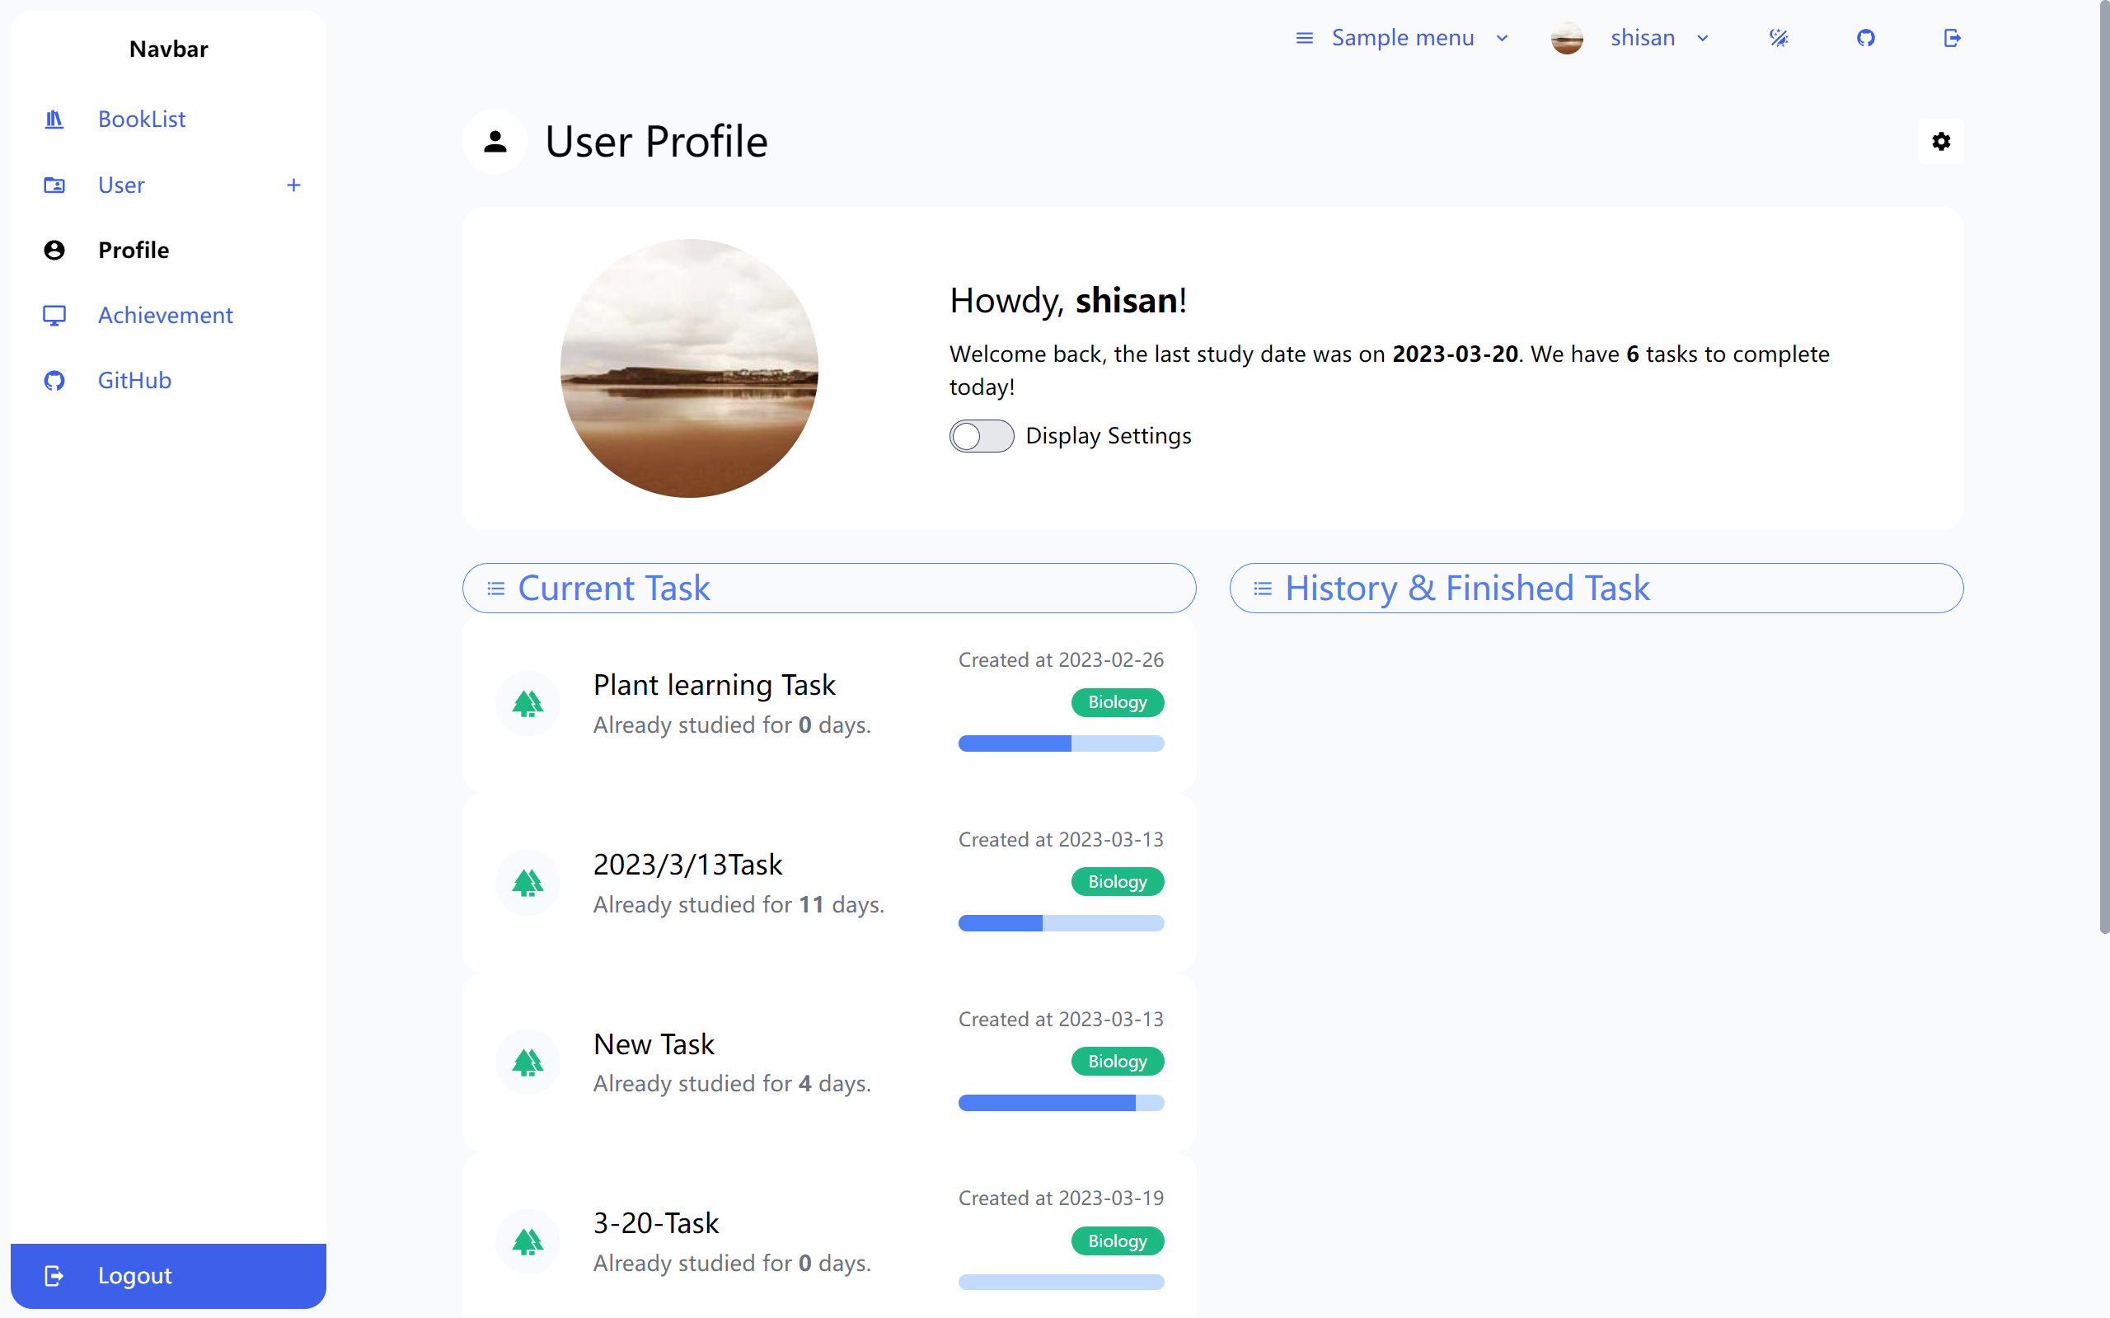

Figure 22 Light Mode

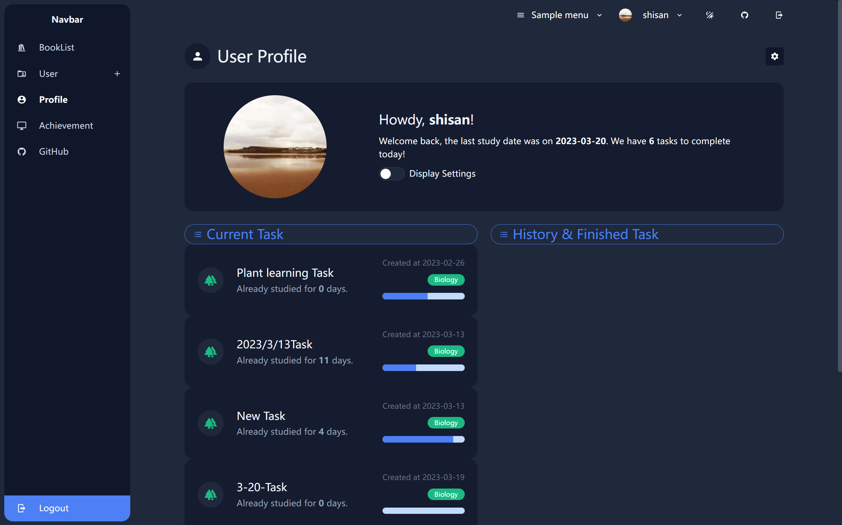

Figure 23 Dark Mode

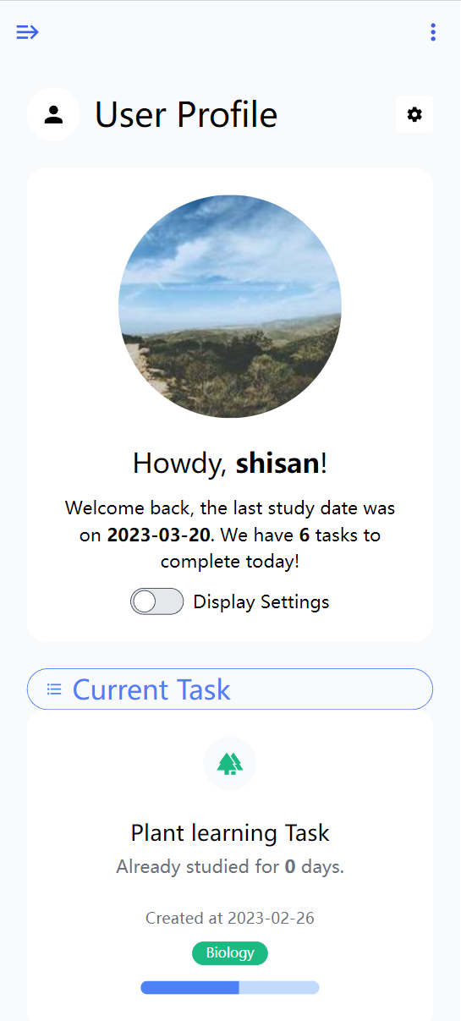

Figure 24 Mobile Phone Screen Interface

## Project Outcome

### Account Registration

Each user has a unique registered email as a user ID and a password. The website offers a user-friendly and efficient Account Registration feature.

Below is an outline of the Account Registration feature's key components and functionality.

1. Accessible Registration Form: Users can easily locate and access the registration form, which is prominently displayed on our website's homepage or within the login page. The form is designed to be intuitive and visually appealing.

2. Required Information: To create an account, users will be prompted to provide essential information such as their name, email address, and a unique username. Additional optional fields such as "Age" and "Gender" may be available to collect user data to enhance user personalization.

3. Password Creation: Users will be asked to create a secure password, adhering to specified guidelines that ensure the security of their accounts. The guidelines may include a minimum character count, a combination of uppercase and lowercase letters, numbers, and special characters.

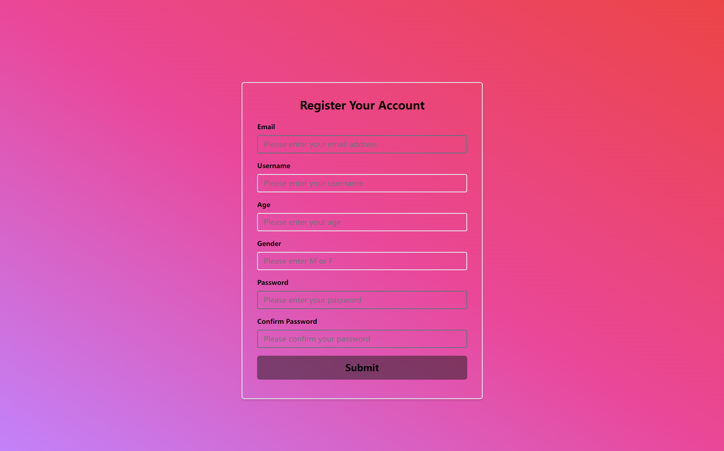

Figure 25 Registration Interface

The website provides a secure and user-friendly Account Login feature, enabling users to access their personal accounts and fully utilize the website's various services, features, and customized content. The login process is designed to be efficient and straightforward, ensuring that users can quickly access their accounts without unnecessary delays.

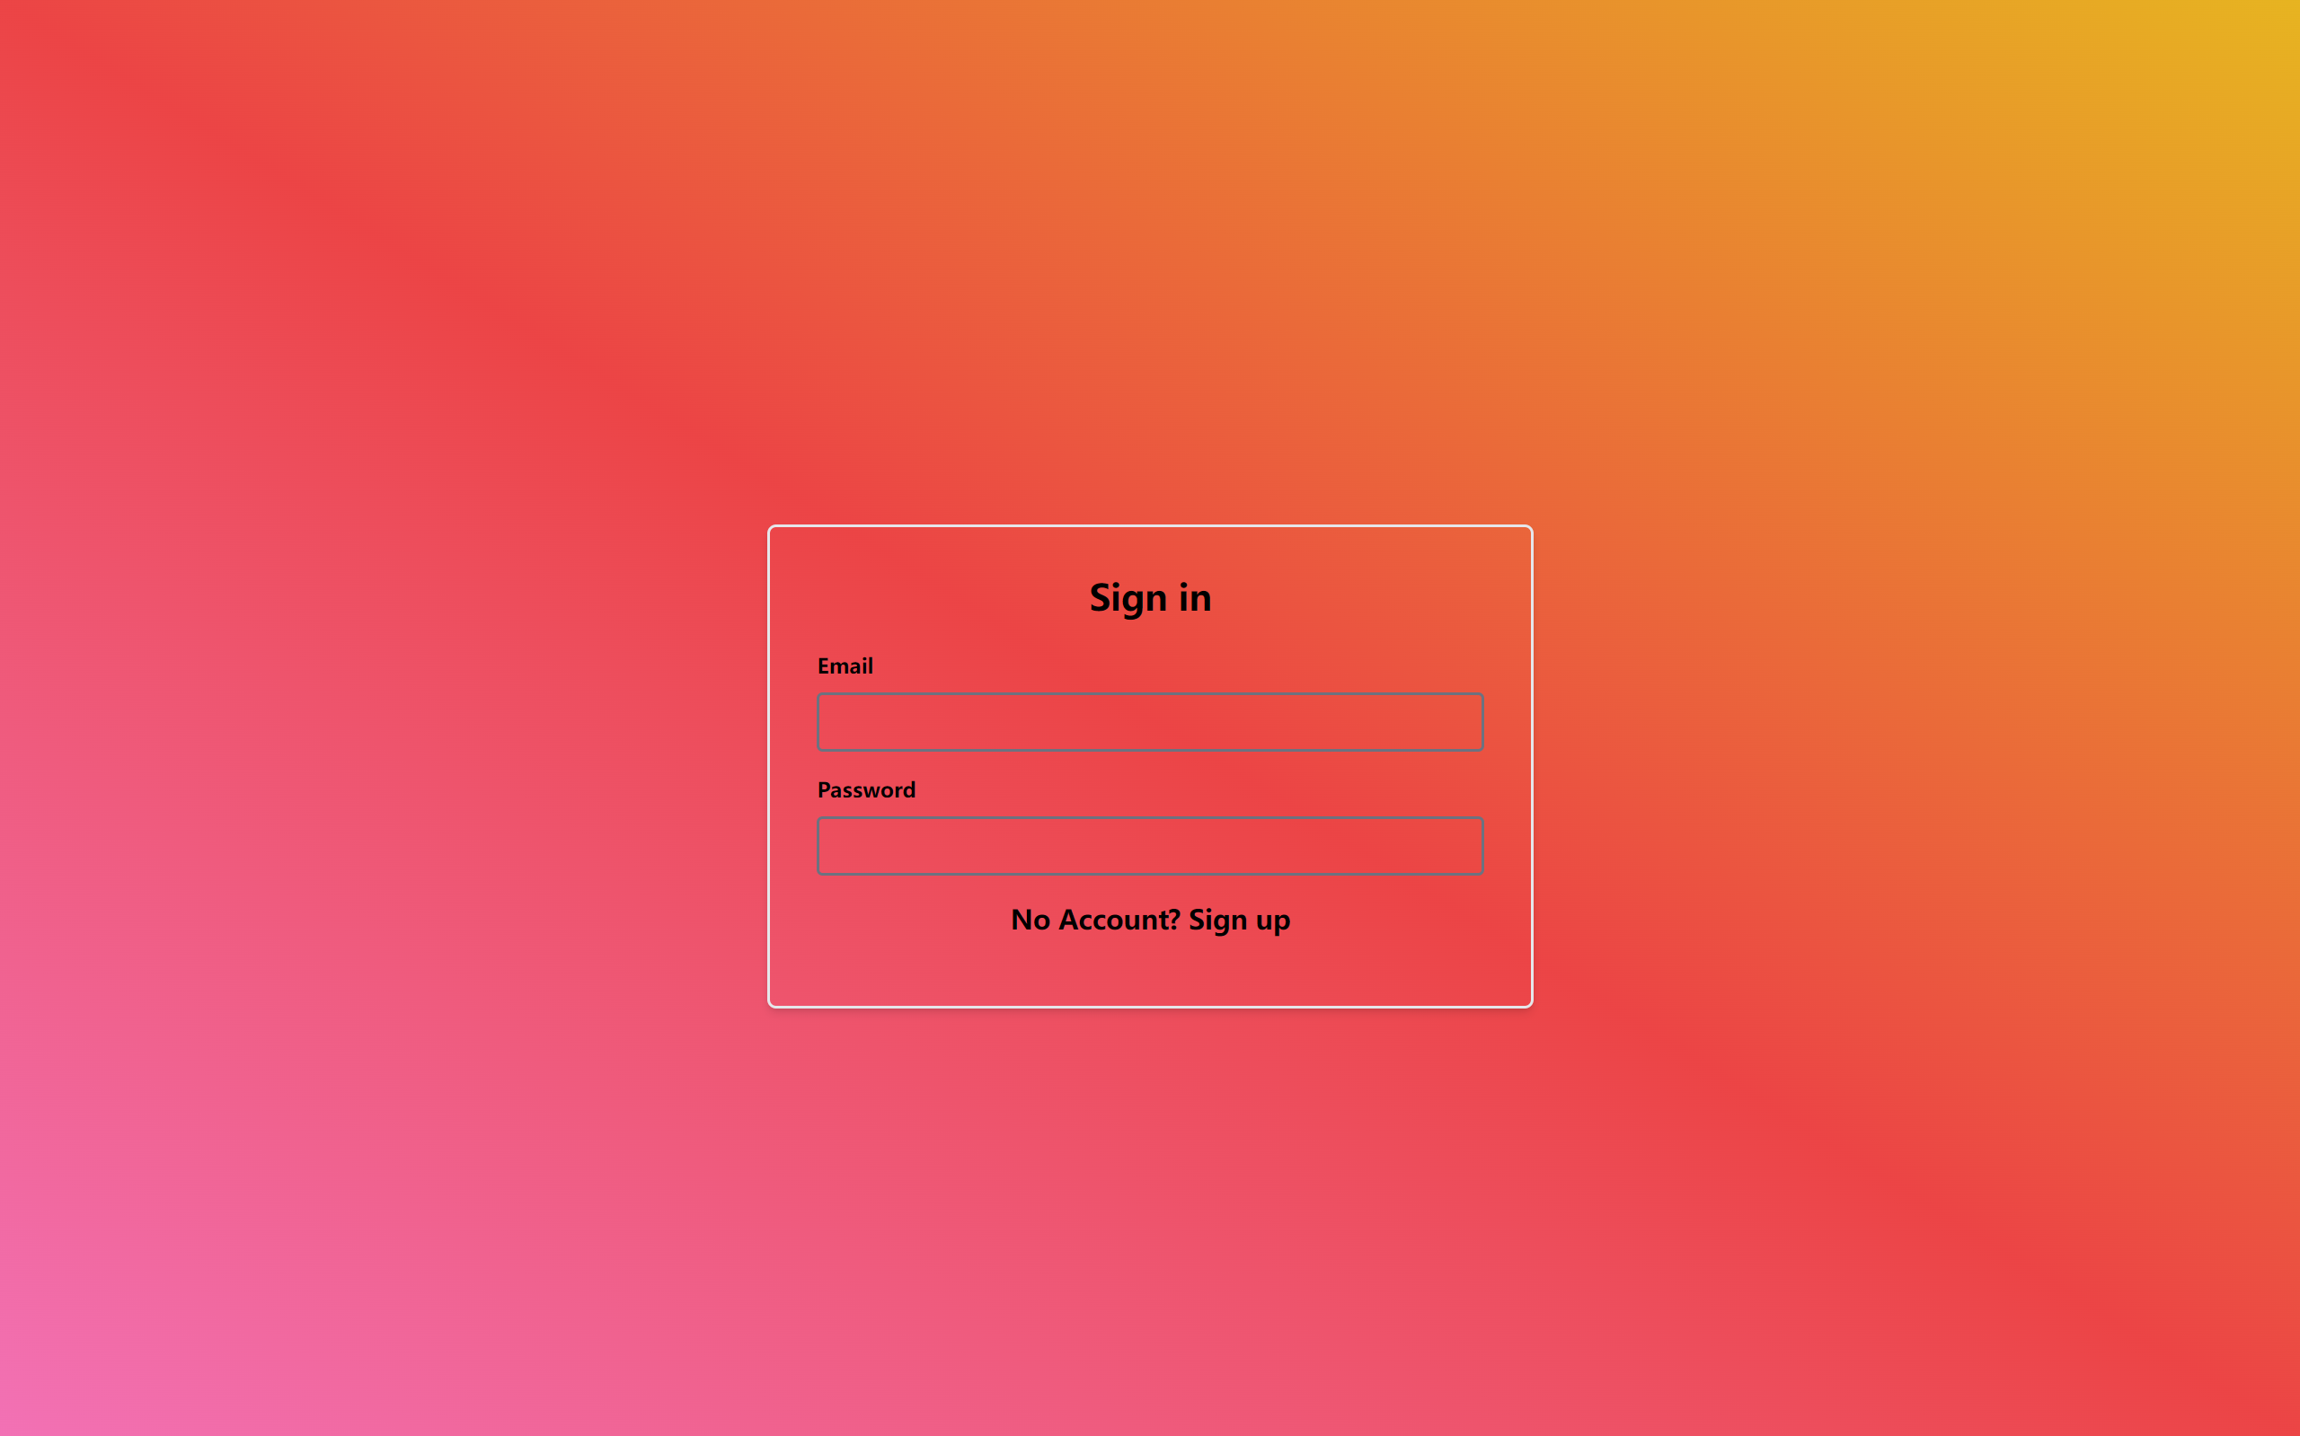

Figure 26 Login Interface

The website considers the possibility that users may enter incorrect or unsuitable information. To address this, multiple warning messages appear beneath each input field, accompanied by clear guidance to help users adhere to the basic requirements more effectively. After accurately entering the necessary information, users can successfully register and log in to their accounts.

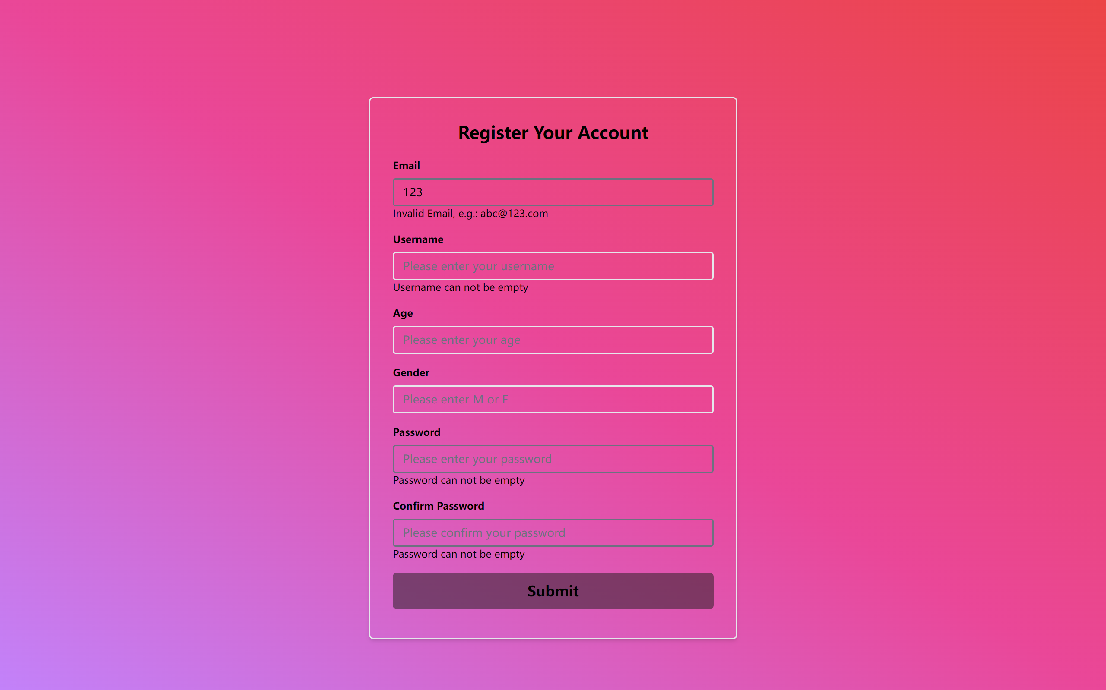

Figure 27 Error Alert

### Navigation Bar

The website features a well-organized and user-friendly navigation bar (Navbar) designed to facilitate seamless access to the various sections, services, and features available on the site. The Navbar ensures that users can easily navigate and find the content they are looking for without difficulty. Here is an overview of the Navbar's key components and functionality.

1. Responsive Design: The Navbar is designed to be fully responsive, ensuring a consistent and optimized user experience across various devices, including desktops, tablets, and smartphones. The Navbar will automatically adjust its layout and elements based on the screen size and orientation.

2. Intuitive Layout: The Navbar's layout is organized in a clear and logical manner, grouping related sections and features together for easy access. This user-centric design enables users to quickly locate the information they need.

3. Dropdown Menus: To further enhance usability and reduce clutter, the Navbar may include dropdown menus that expand when the menu item “User” is clicked, revealing additional subcategories or pages related to a specific section.

### Book List

The website incorporates a comprehensive and user-friendly Book List feature, designed to enable users to effortlessly discover, explore, and manage their desired books from a vast collection. The Book List feature provides users with an intuitive interface. Here's an overview of the key components and functionality of the Book List feature.

1. Book Display: The books are presented in an organized and visually appealing manner, featuring cover images, titles, authors, and a brief description or summary.

2. Book Details: By clicking on a book, users can access a dedicated book detail page that offers extensive information about the book. Users have the option to browse and read eBooks using two distinct methods: a PDF reader and an image viewer. This flexibility caters to diverse user preferences and ensures a comfortable reading experience.

3. User Interactions: The Book List feature allows users to interact with the books by adding them to their personal studying lists.

The Book List page showcases a collection of encyclopedias and exercise books specifically curated for children's learning and use. Currently, the page features three encyclopedias and three exercise books.



Figure 28 Book List

The PDF reader enables users to read eBooks in PDF file format while offering various interactive features, such as page zooming, rapid page navigation, and file downloading.



Figure 29 PDF reader

The Photo Reader displays each page of a book as an image, providing an enhanced reading experience for the user. Upon clicking a thumbnail, the image is displayed in full screen, offering basic interactive functions such as image navigation, image rotation, and image downloading.

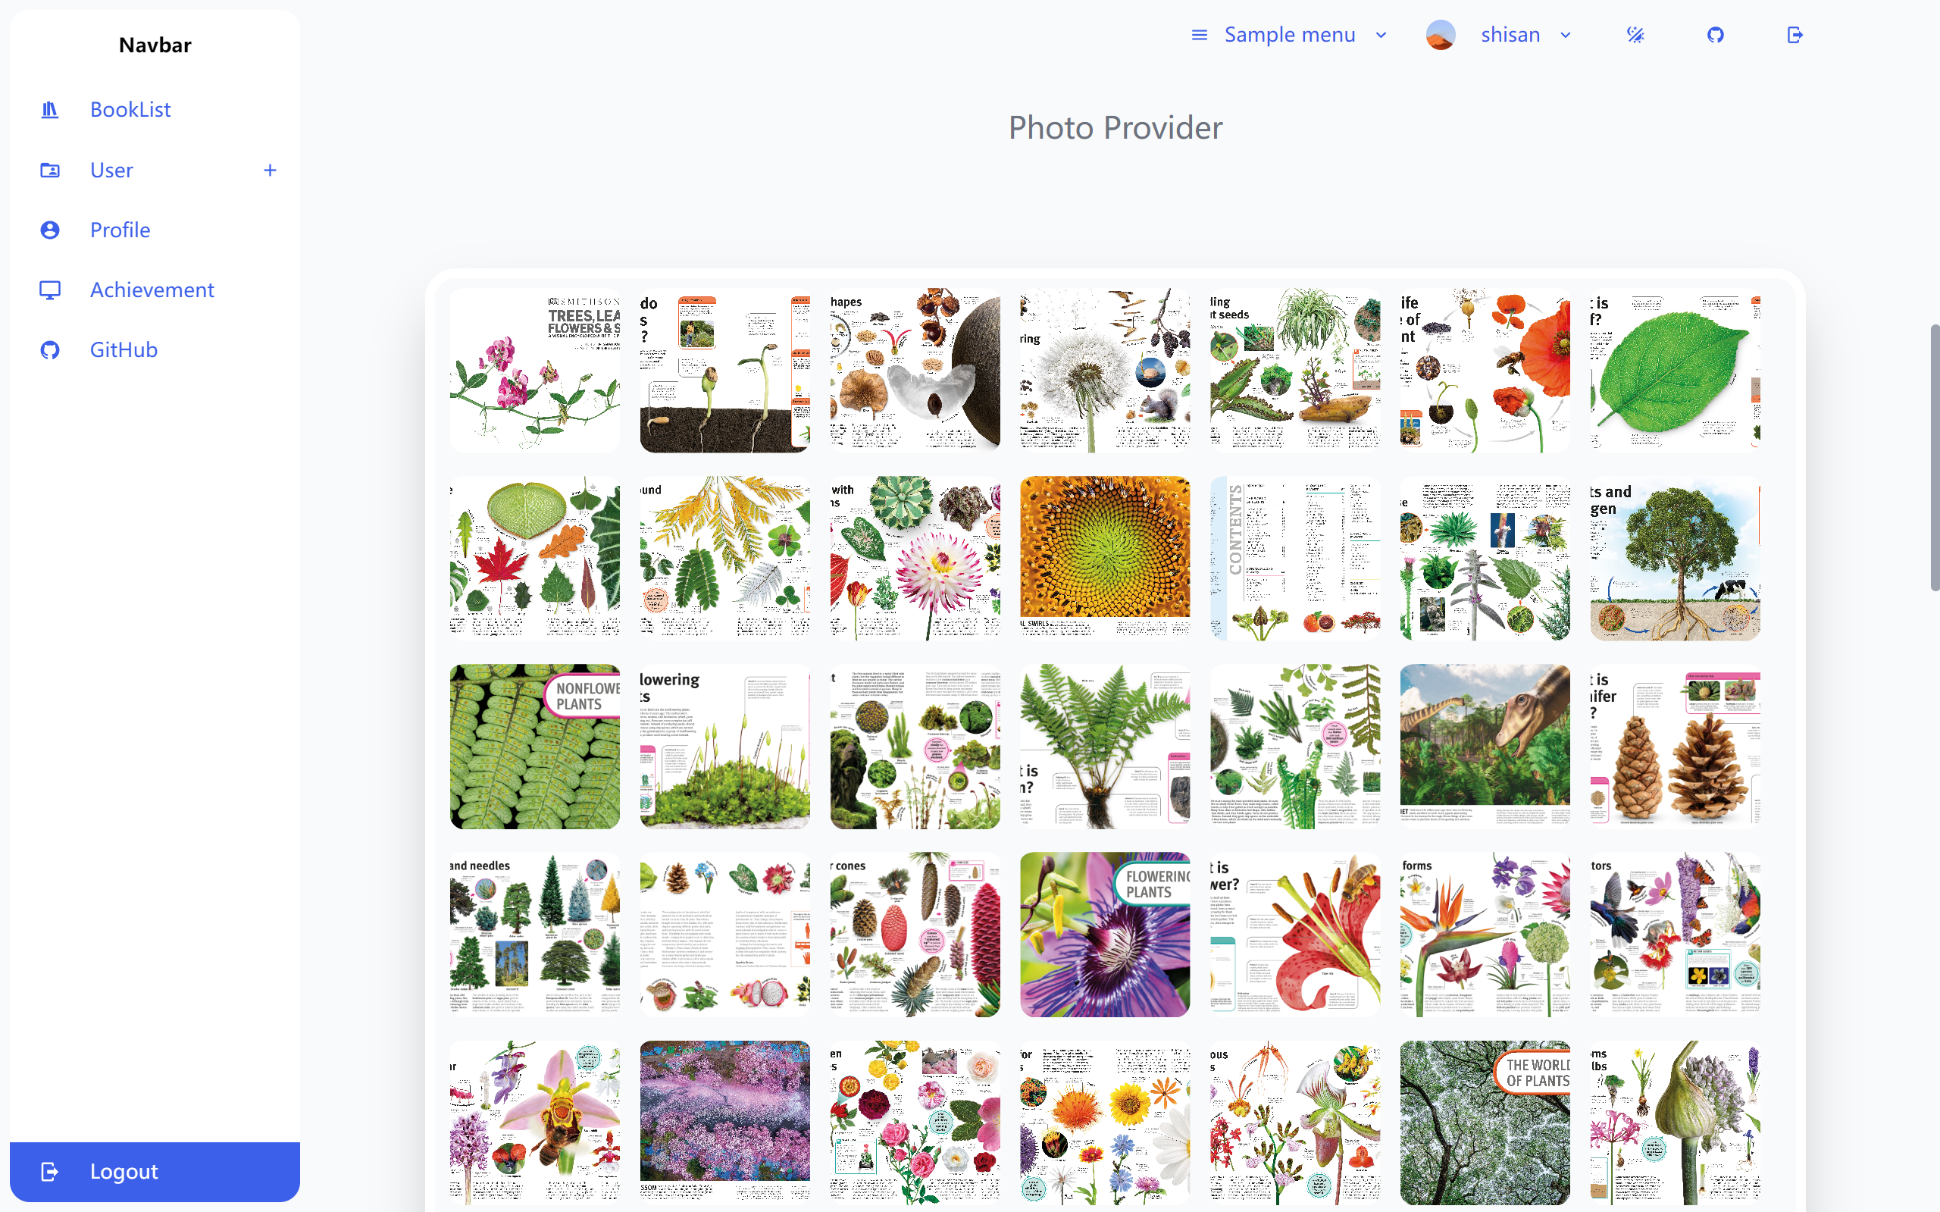

Figure 30 Photo reader(thumbnail)

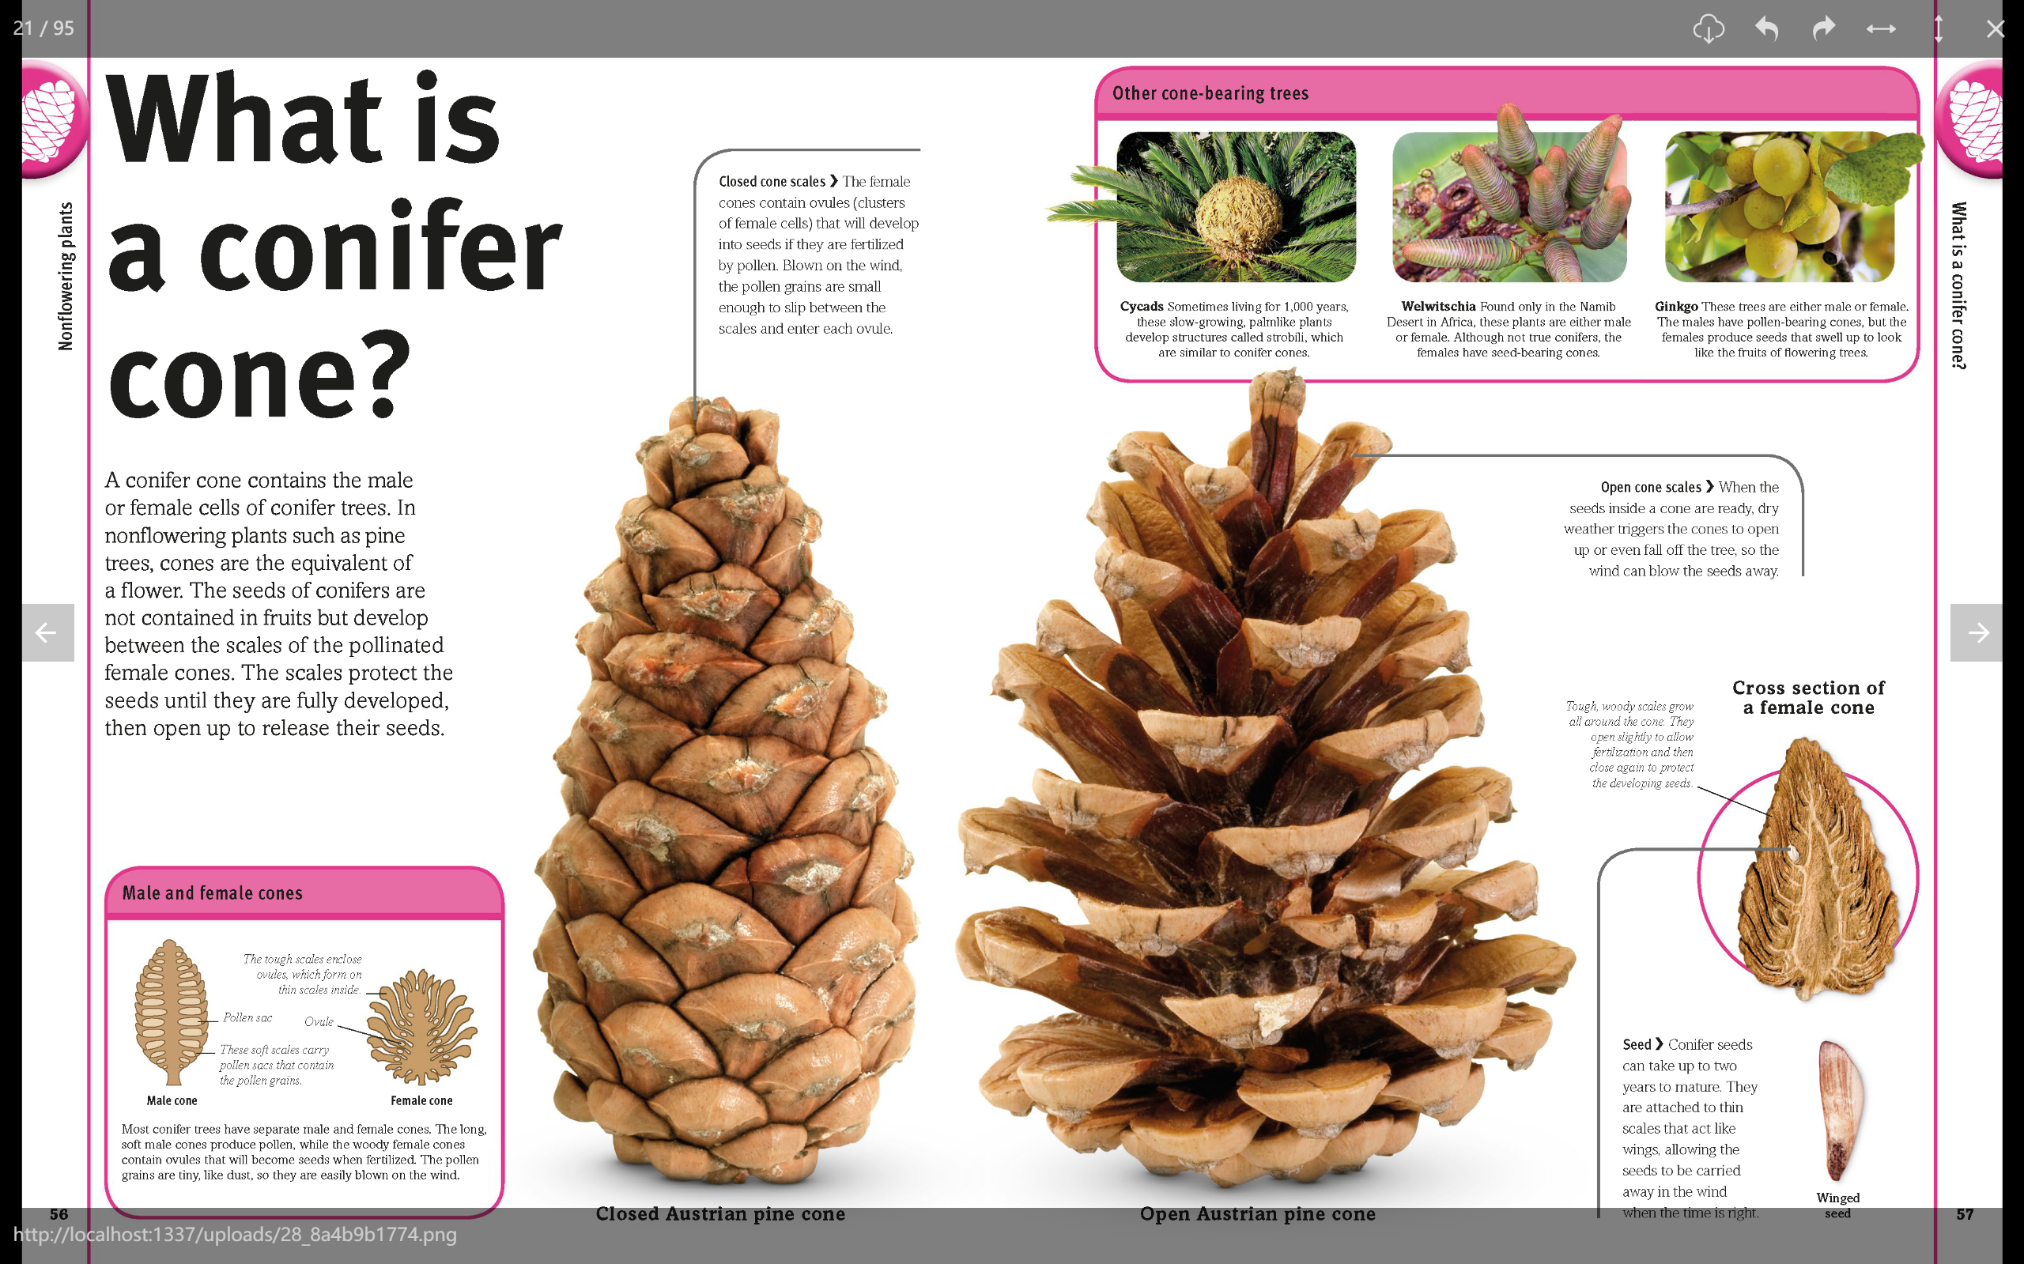

Figure 31 Photo reader(detail)

It's worth mentioning that, in order to meet the needs of mobile users, Photo Reader also adopts a responsive design. In mobile mode, users can click on the image thumbnail to enter the detailed image interface, where they can freely enlarge the image to make the text and pictures in the book easier to read.

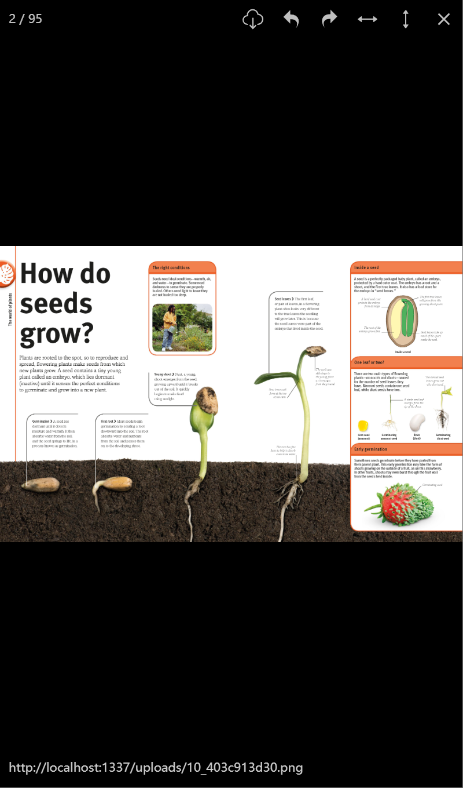

Figure 32 Photo reader (mobile)

At the bottom of the book detail page, users will find a form that allows them to create a personalized study plan. The form includes a default duration (15 days) and a due date for the task. Each book comes with a set of supplementary exercises for users to practice and consolidate the knowledge they have learned. In the user-created study plan, the user's learning goal is to correctly answer all the exercises and master the related knowledge.



Figure 33 Study Task Form (Empty form)

After completing the form, the user can click the "Create" button to generate a new study task. Once successfully created, an alert appears on the web page, informing the user that the plan has been successfully established and redirecting them to the profile screen, which displays all of the user's plans.



Figure 34 Study Plan Form (After entering information)

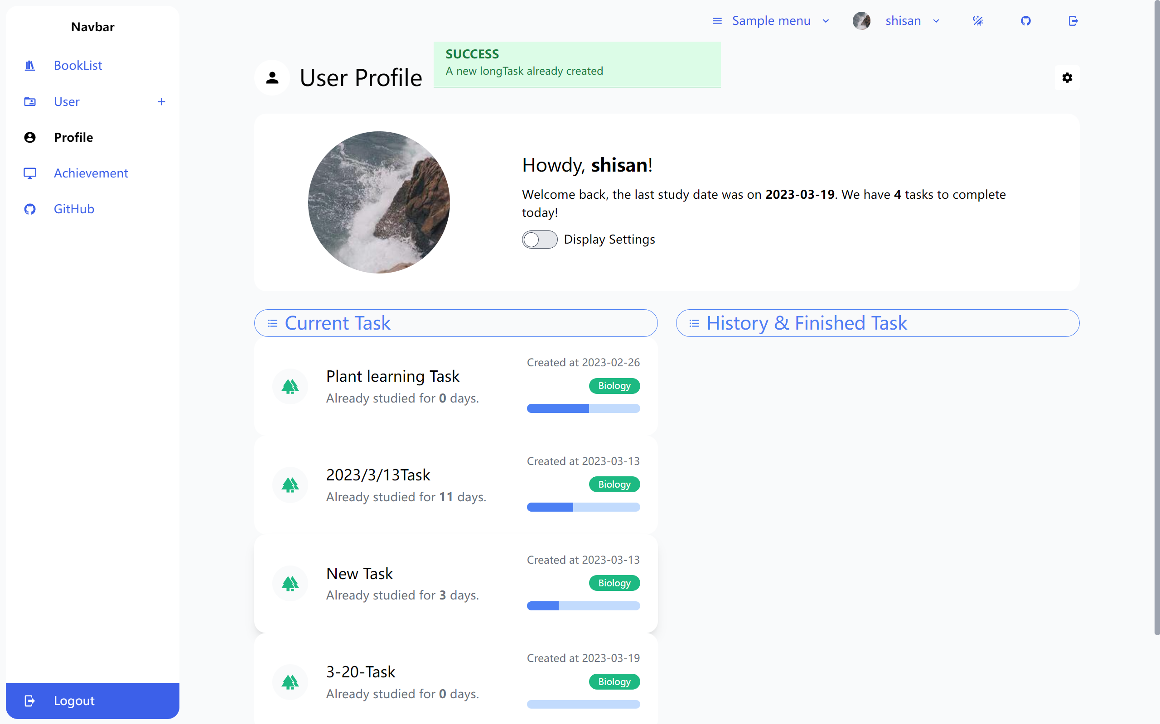

Figure 35 Successful task creation

### User Profile

The website offers a comprehensive User Profile feature, designed to provide users with a personalized and organized space for managing their account, preferences, and activities. Here is an overview of the key components and functionality of the User Profile feature:

1. Personal Information: The user profile displays basic personal information, such as the user's name, profile picture, and a brief biography. Users can edit and update this information as needed, such as name, age, and daily workload. The daily workload refers to the default number of questions included in the user's daily practice.

2. Account Settings: Users can access and modify their account settings, including password management.

3. Study Tasks List: Users can view their study plans and track progress to help stay organized and focused on their learning goals.

Users can update their personal information and change their password by completing two forms when they click on the Settings button.

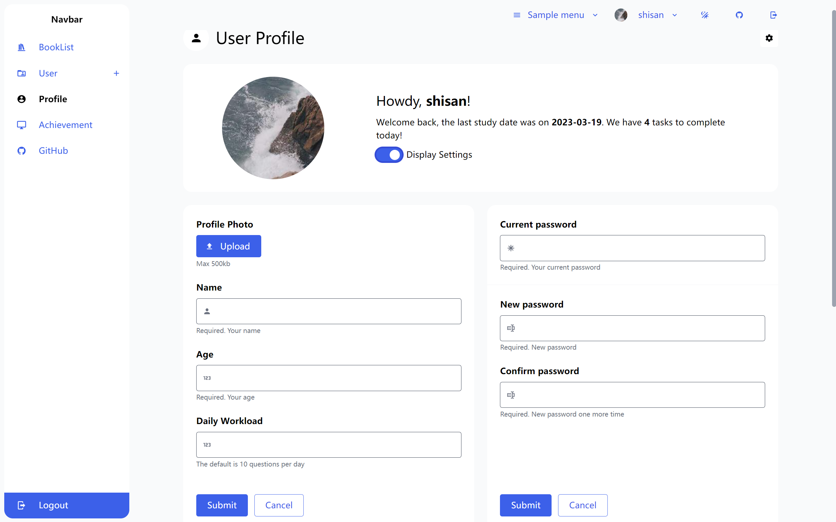

Figure 36 Amend personal information form && Reset password

The Task List keeps track of all tasks, including both ongoing and past tasks. Each task bar displays basic information about the task and the current progress of the learning.

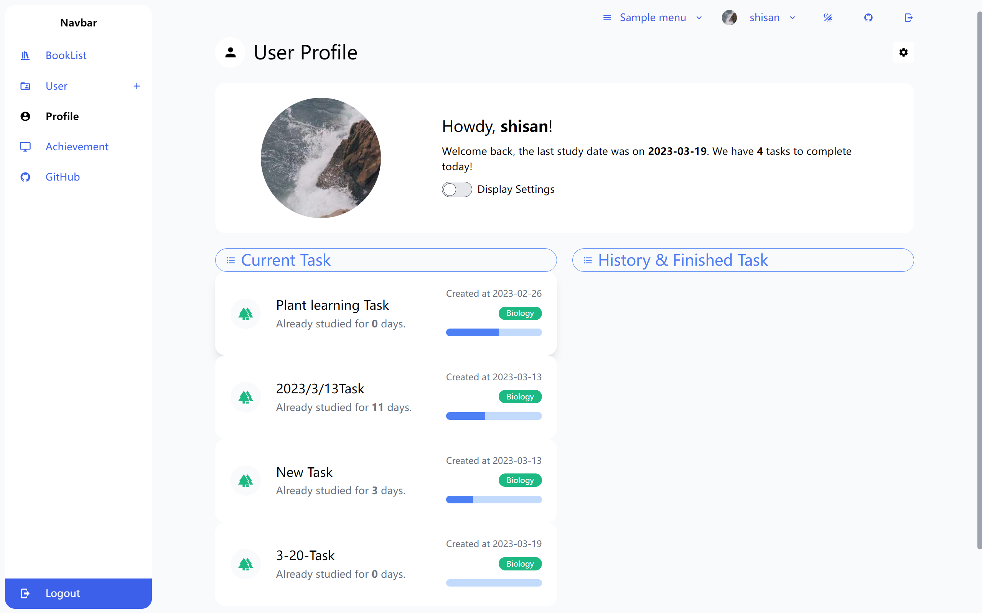

Figure 37 Task tracking list

### Exercise List

When a user completes a learning task in the Task Tracking List, the system will navigate to the Exercise List page. Each study task contains multiple exercise records. The Exercise List feature provides users with a collection of educational exercises to practice and reinforce their learning.

Users can browse through the exercise list, select an exercise, and complete it at their own pace. Here's a description of the key components of this feature:

1. Exercise List Page: A dedicated page that displays all available exercises, showing some basic information about each exercise, such as task name, accuracy rate, and the number of questions.

2. Progress Tracking: Users can track their progress through the exercise list, with completed exercises marked as "Done" and incomplete exercises saved for later. This allows users to easily pick up where they left off and monitor their learning progress.

3. Exercise Details: When users select an exercise, they are taken to a detailed view of the exercise, including instructions, the number of questions, and an estimated completion time. Users can start the exercise by clicking on a "Blue eyes" button.

4. Add and Delete: Users can add a new daily exercise by filling in the form with the exercise name, the number of questions, and the start date in the specified order. Additionally, users can delete an exercise by clicking on the red button.

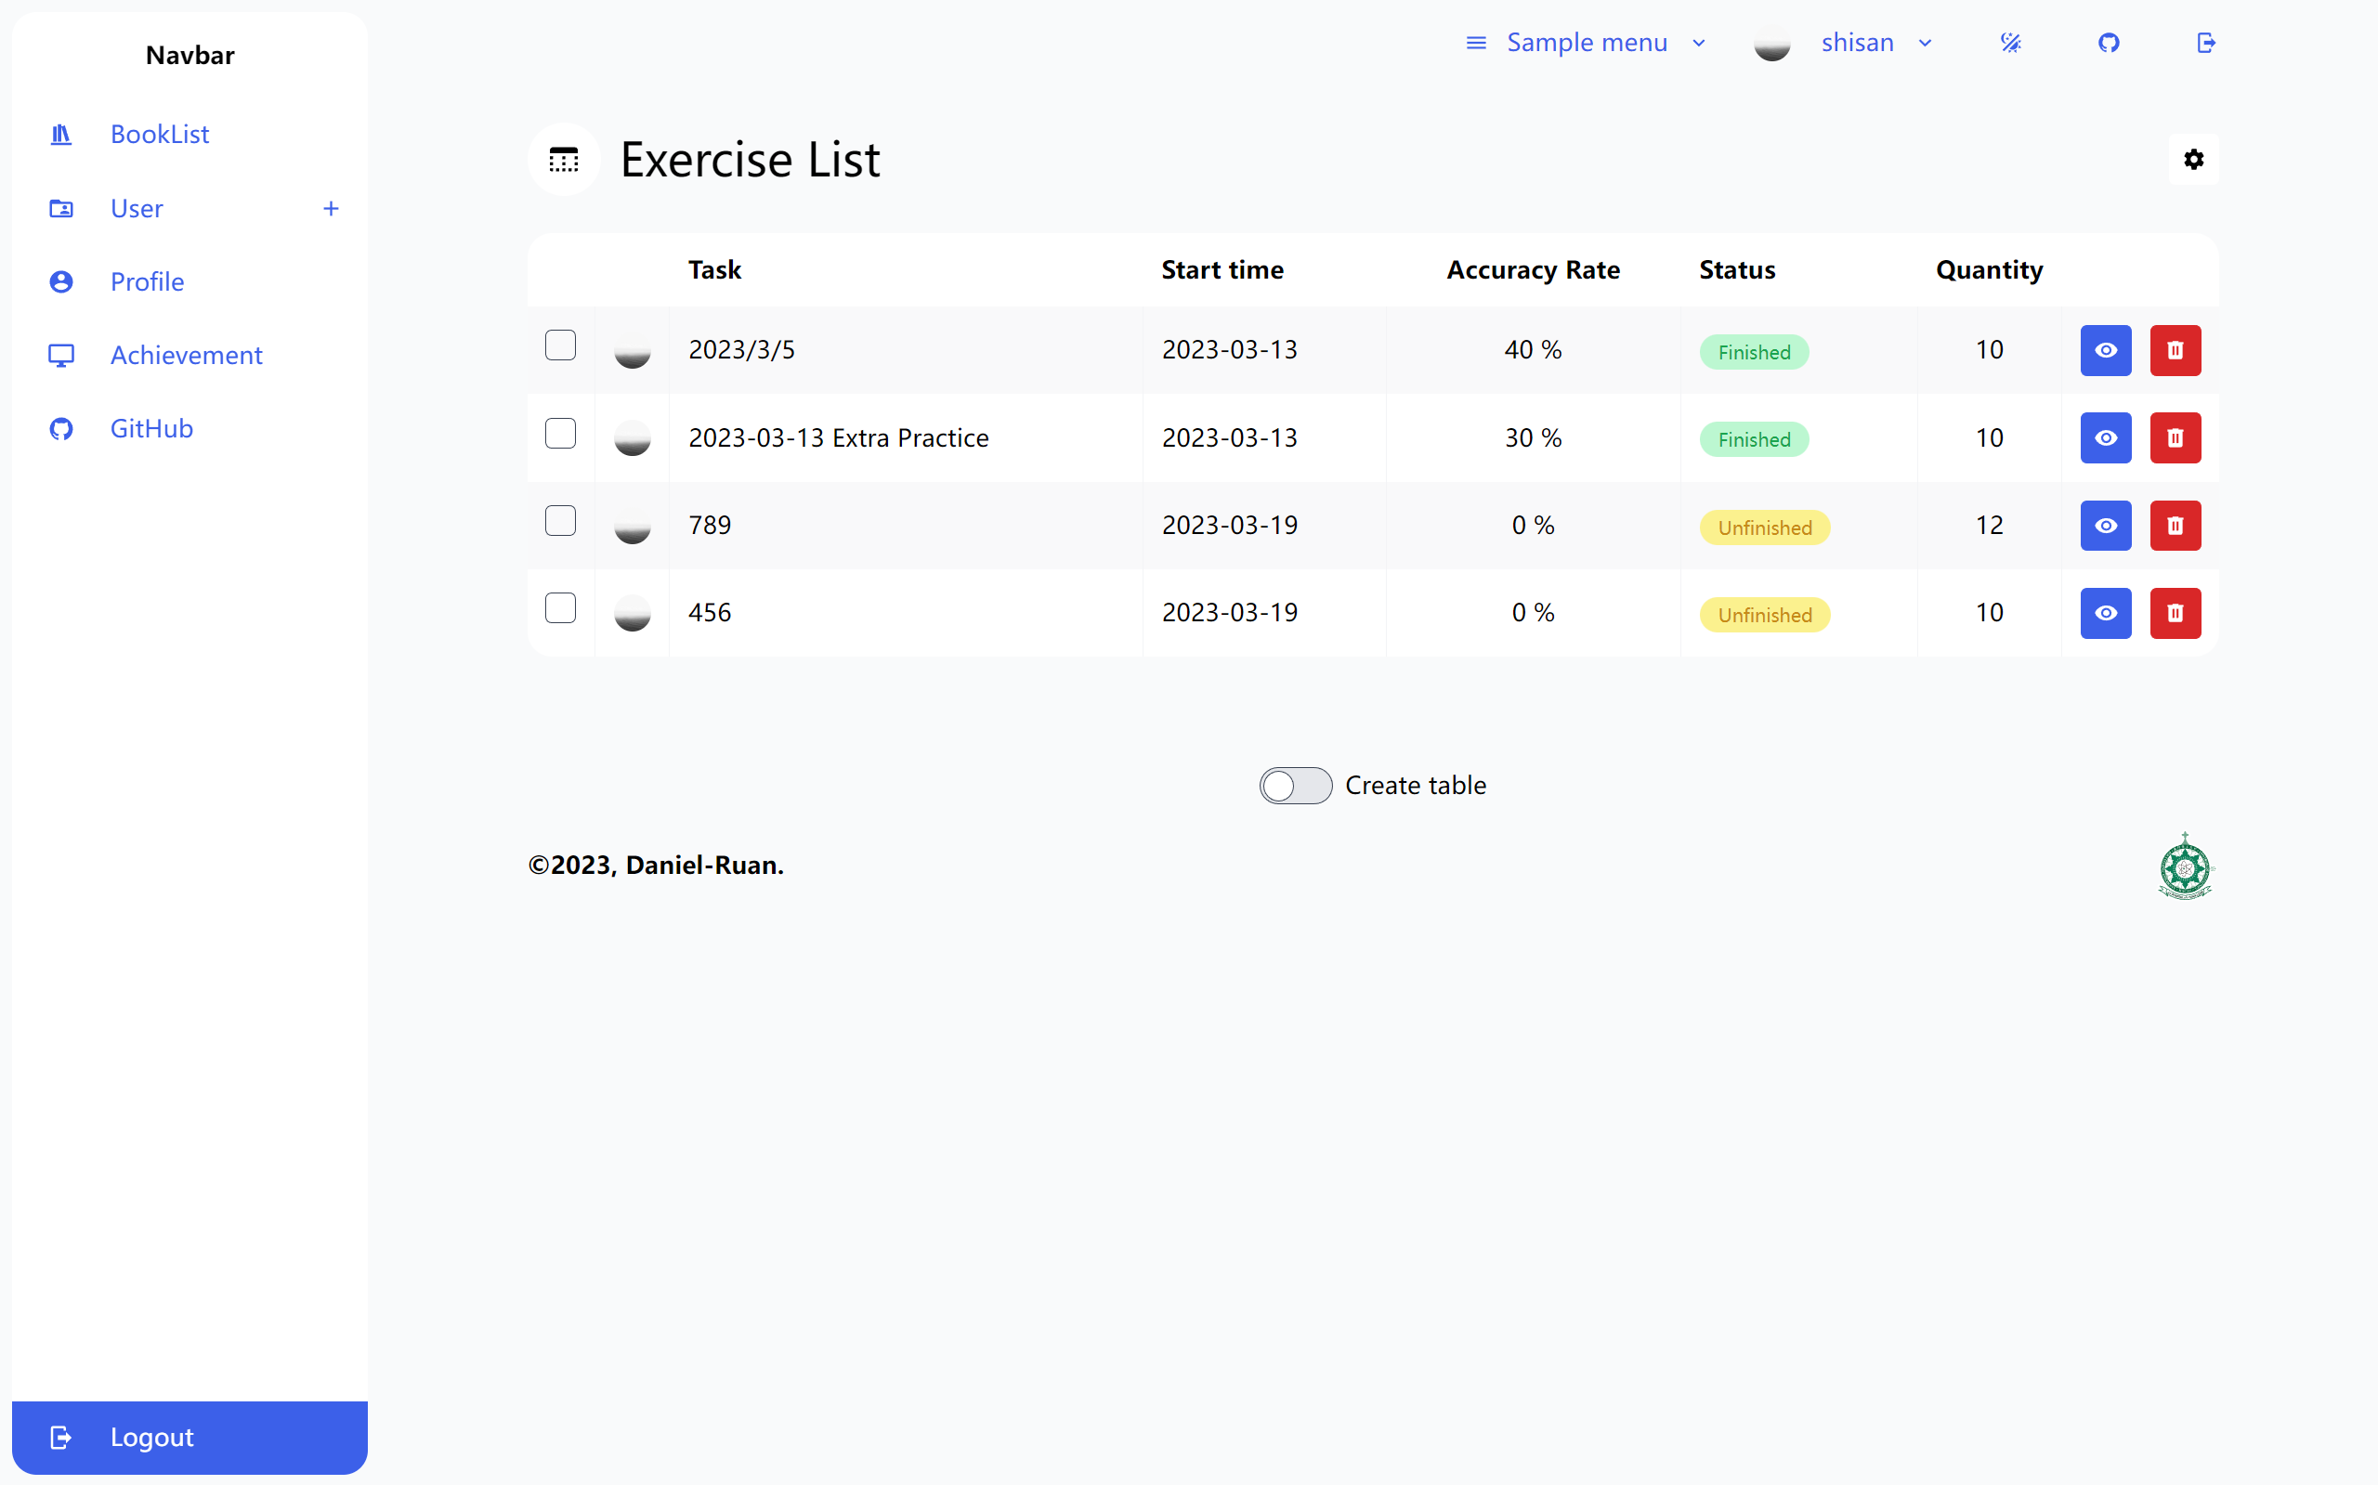

Figure 38 Exercise record table

If the study task has just been created, users must click on the 'Create Question Deck' button to initialize the task. After a brief waiting period, they can begin creating their first exercise. Simultaneously, the 'Create Question Deck' button will be replaced with the 'Create Daily Task' button.

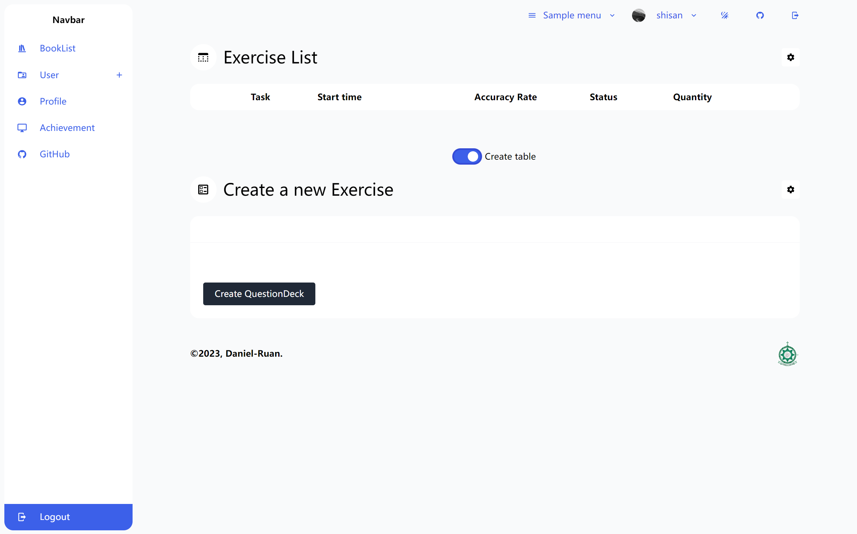

Figure 39 Create question decks

After the user fills in the form and clicks the button below, a new exercise task is created, and a success message appears.

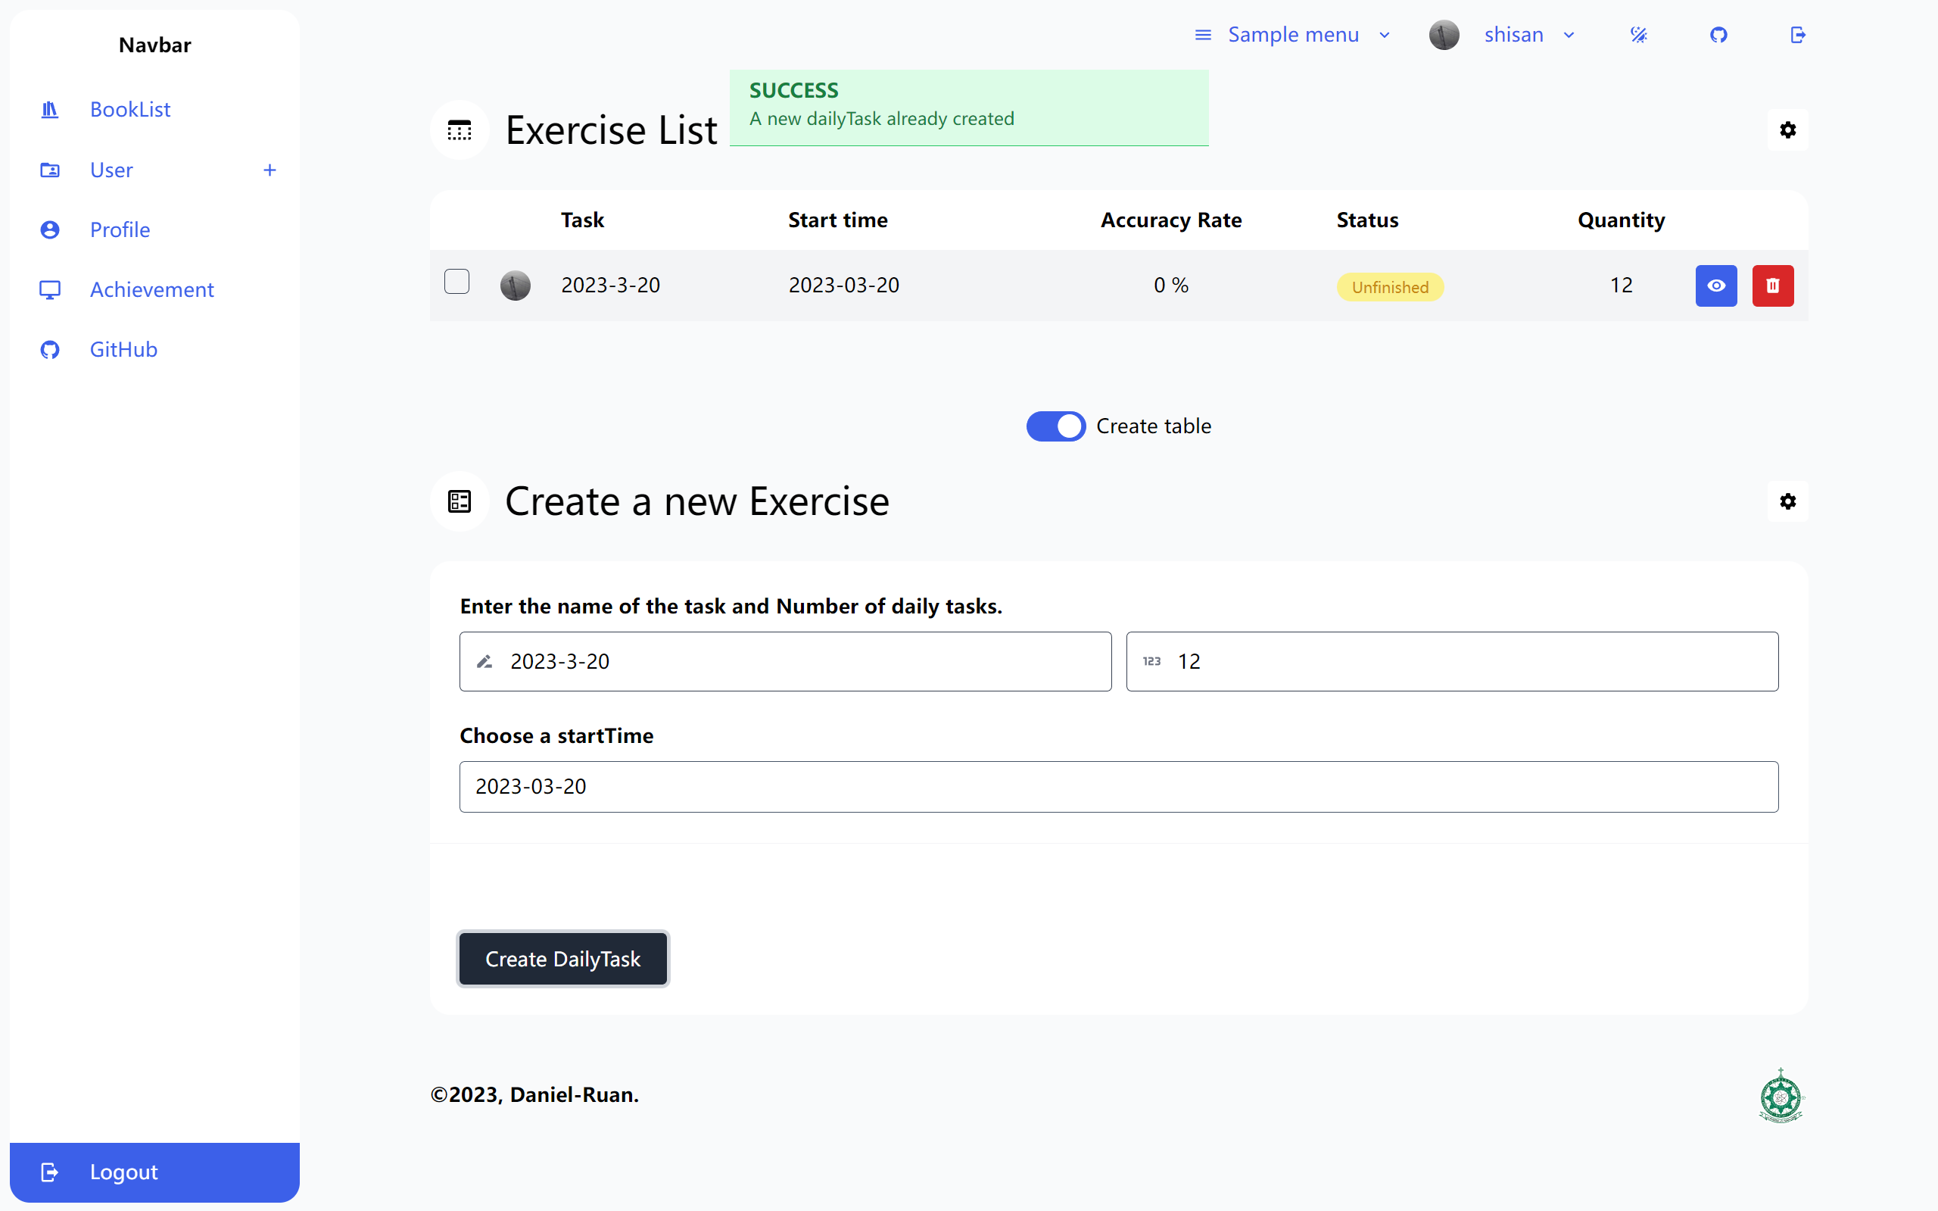

Figure 40 Successful creation of new exercise task

### Question List

When users click on the blue button from the previous screen, they are redirected to the Question List page. This relatively simple page displays basic information about each question that users need to answer next:

1. Thumbnails: The page consists of several thumbnails representing different topics, each showing some basic information about the topic.

2. Pagination: To prevent overcrowding, the author has added a paginator. Users can quickly navigate to different sub-pages using the red button at the bottom of the page.

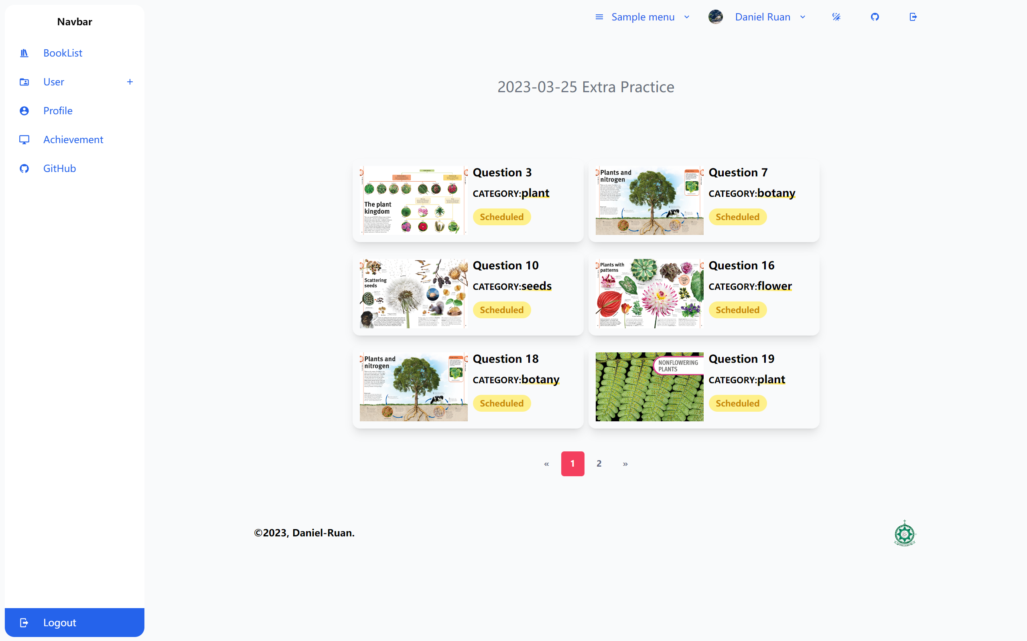

Figure 41 Exercise List

### Multiple choice question

The multiple choice question feature offers users an interactive and engaging way to test their knowledge and learn about various subjects. This feature comprises a collection of questions, each with multiple answer options, and only one of them is correct. Here is a description of the key components of this feature:

1. Question Display: Users are presented with a question and a list of answer options. The questions may cover various topics and difficulty levels.

2. User Interaction: Users can select one of the available answer options by clicking or tapping on it.

3. Answer Submission: After selecting an answer, users can submit their response by clicking a button or performing another action. Once submitted, the answer cannot be changed.

4. Instant Feedback: Users receive immediate feedback on their submitted answer. Correct answers are typically highlighted, while incorrect answers are marked. Explanations or additional information may be provided to help users understand the correct answer.

5. Performance Statistics: Users can view their performance statistics, such as accuracy, and the number of questions answered. This data can be used to identify strengths and weaknesses, helping users tailor their learning experience to their individual needs.

The Multiple Choice Question feature enhances the learning experience by offering an interactive and engaging way for users to test their knowledge and improve their understanding of various subjects.

The page is divided into two sections: the topic's question number and the single-choice form. The form comprises the question, the options, and the submit button.

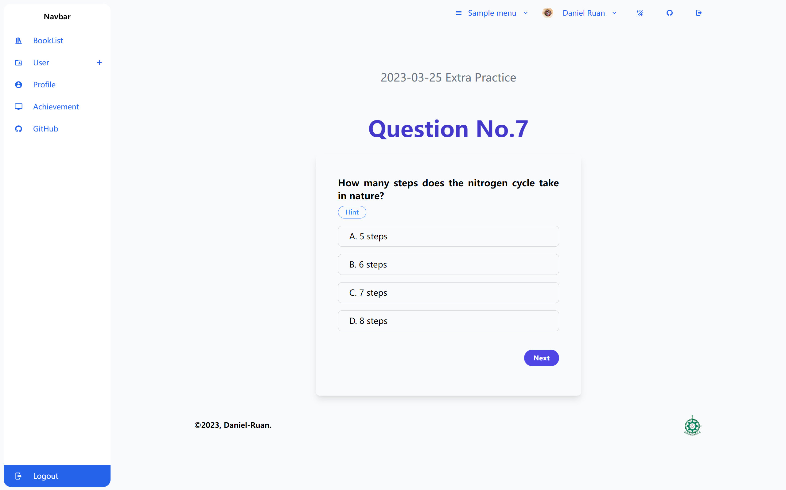

Figure 42 Multiple Choice Question

If users select an incorrect option, their choice is marked in red, and the correct answer option is highlighted in green.

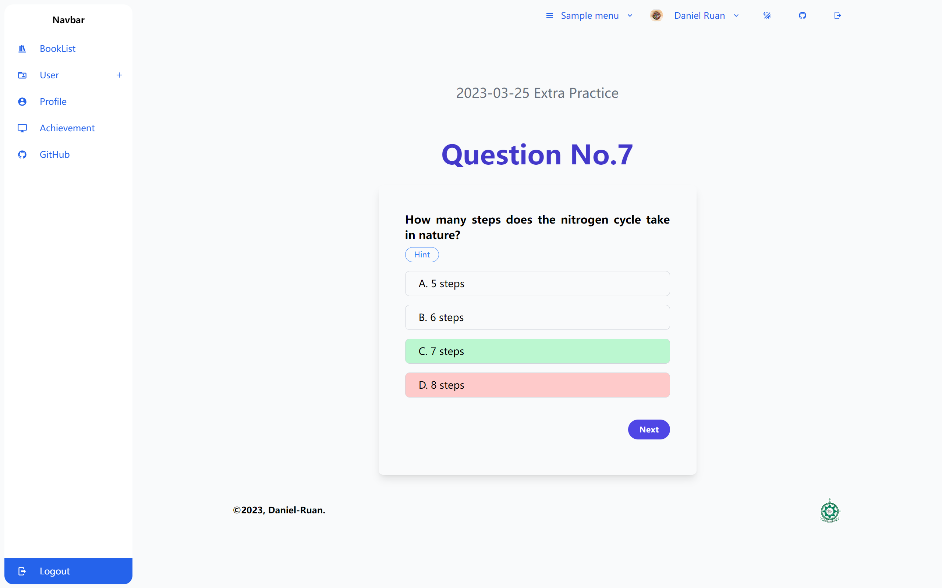

Figure 43 Multiple Choice Question (wrong answer)

If users select the correct option, the correct answer option is highlighted in green, and they are prompted that they have chosen the right option.

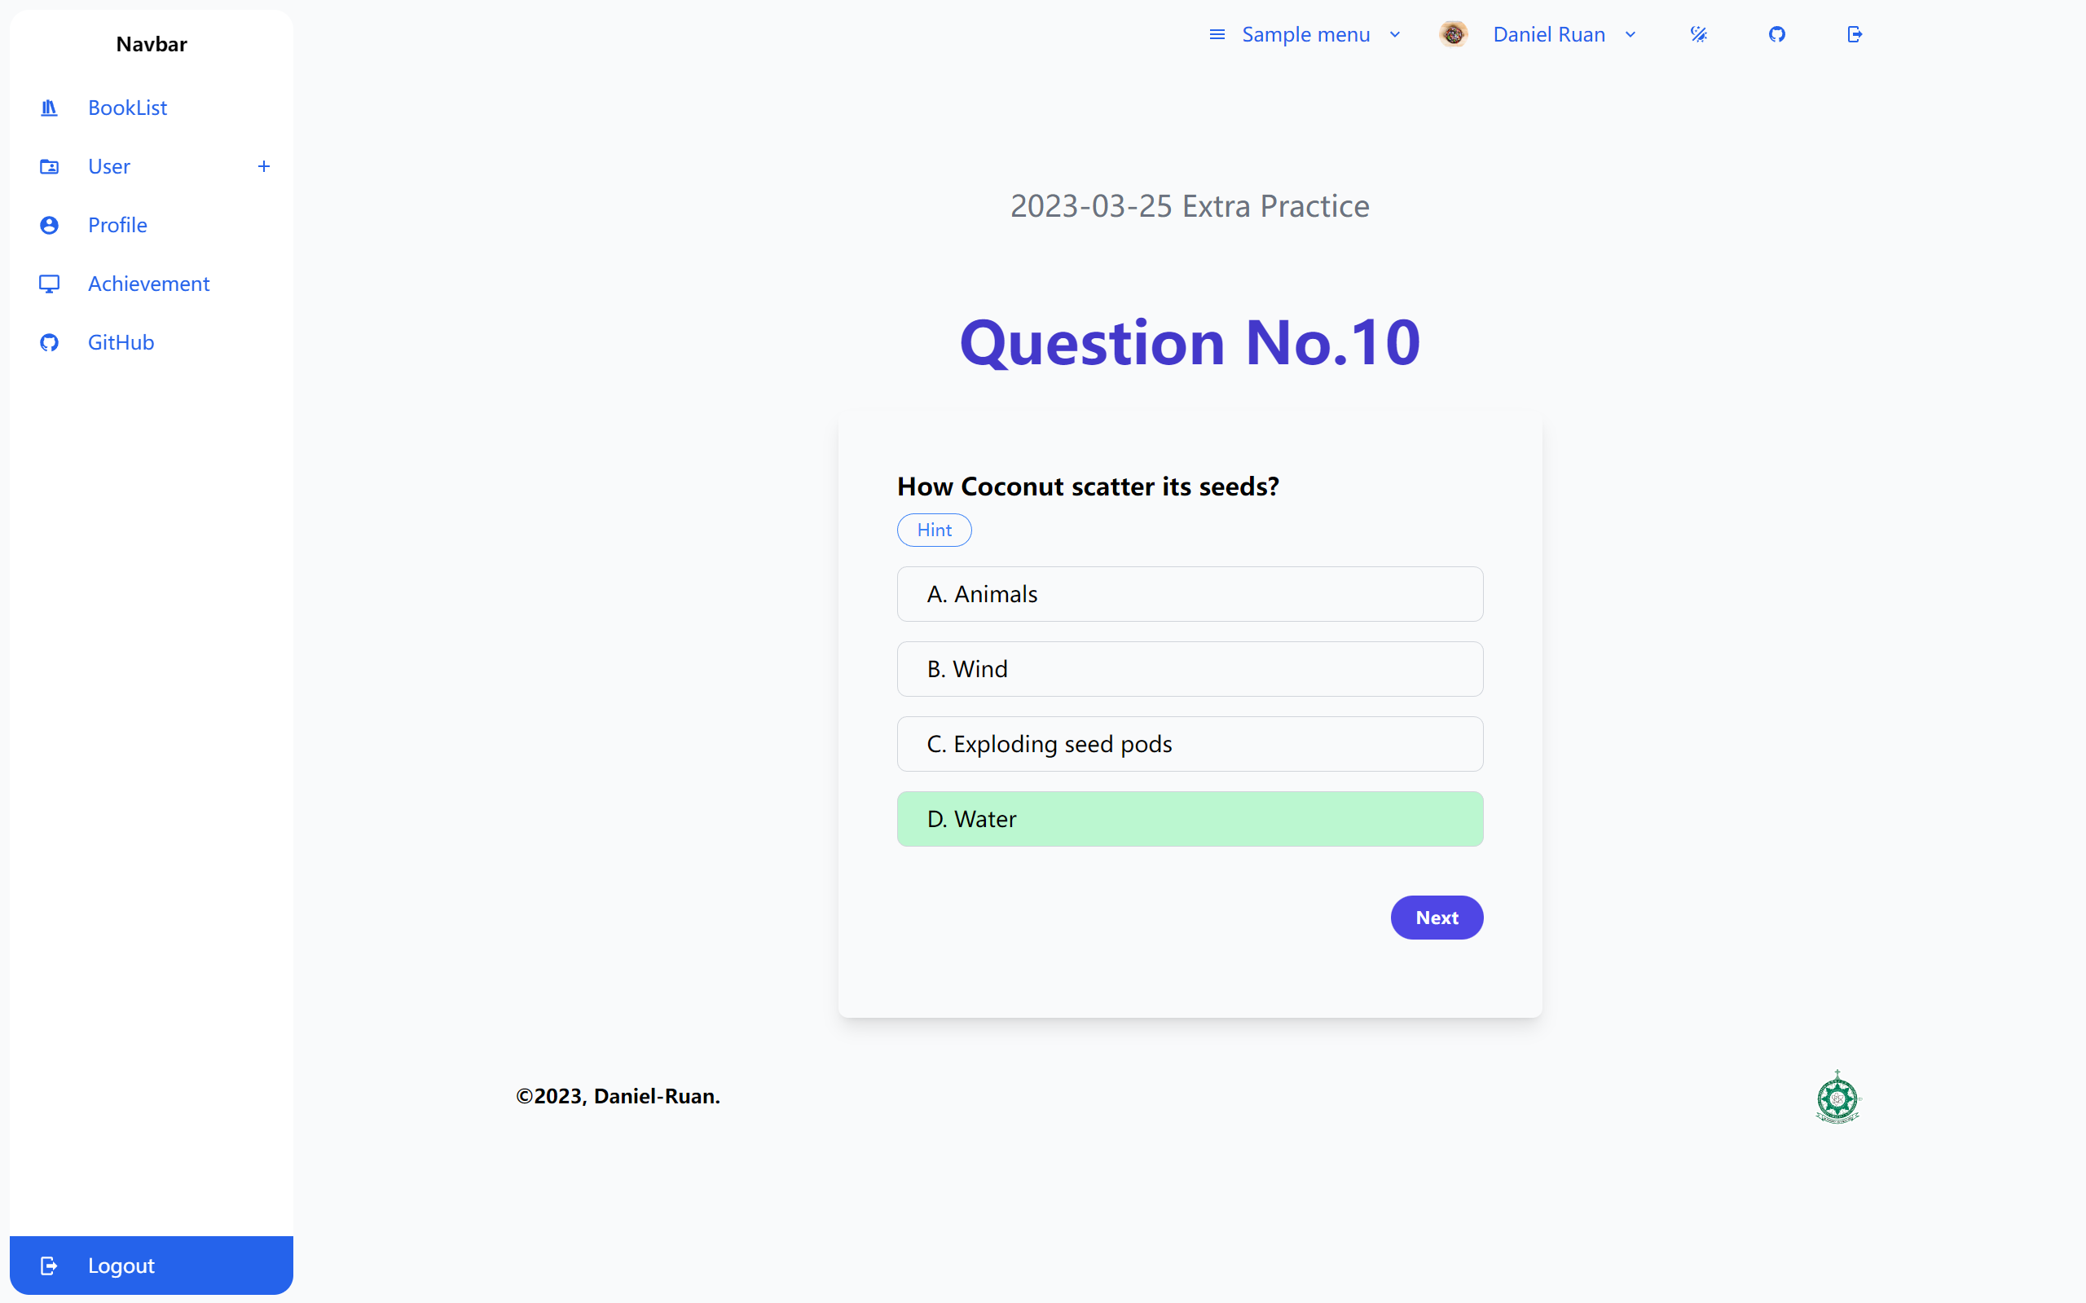

Figure 44 Multiple Choice Question (true answer)

After answering the question, users can click the "next" button to submit their response. If the answer is correct, the question deck status increases by one level, up to a maximum of five levels. If the answer is incorrect, the question deck status returns to level one. Once the system records the results, a successful submission message appears for the user, and they are redirected to the next question.

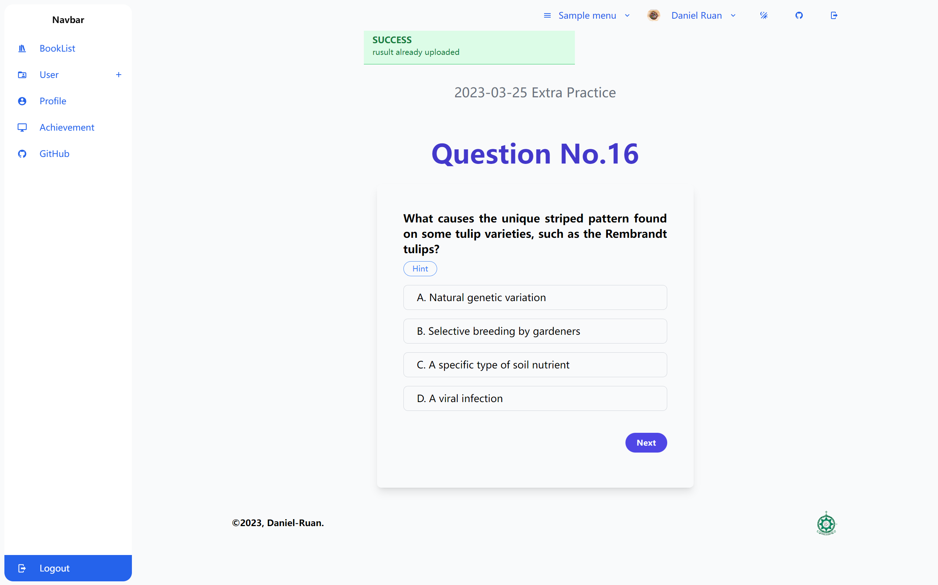

Figure 45 Successful Submission Alert

When users encounter difficulties during the problem-solving process, they can hover their mouse over the "Hint" button to obtain information related to the question. If users want to read more related information, they can click on the hint content, and the system will open a new window and navigate to the corresponding Wikipedia page with the relevant information.

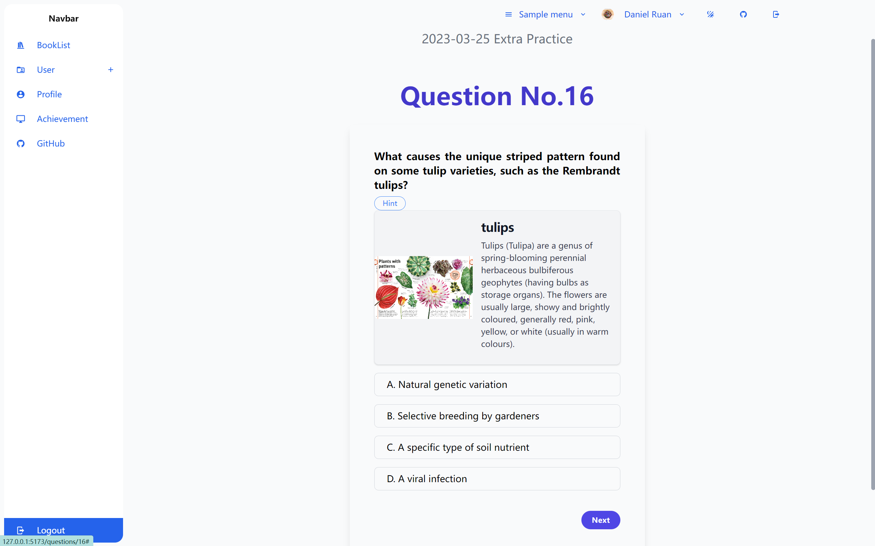

Figure 46 Question hints

After users complete all the exercise questions, a results summary appears, displaying the number of correct and incorrect questions. At the same time, two buttons appear: the 'Upload Result' button submits the information for this exercise, updating the exercise status and the percentage correct. The 'Learn More' button triggers a prompt box, and if users select "Confirm," it not only updates the information but also automatically creates a new exercise closely related to the previous one, allowing users to reinforce and expand their knowledge. Finally, the page automatically navigates to the relevant screen.

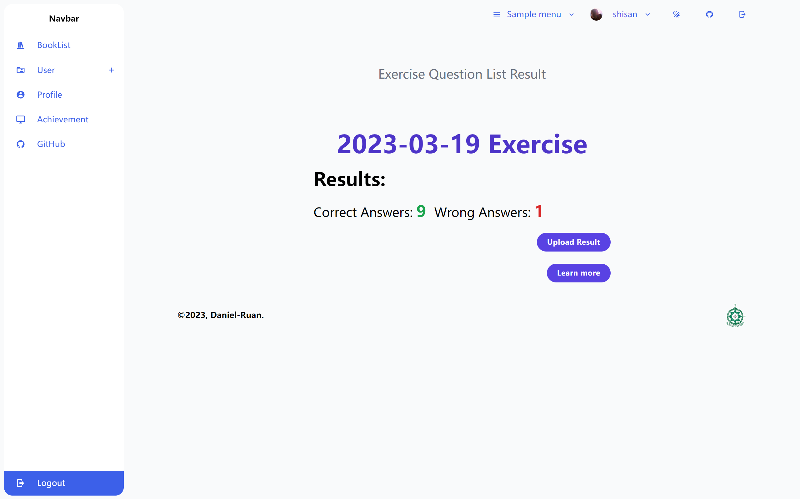

Figure 47 Presentation of results

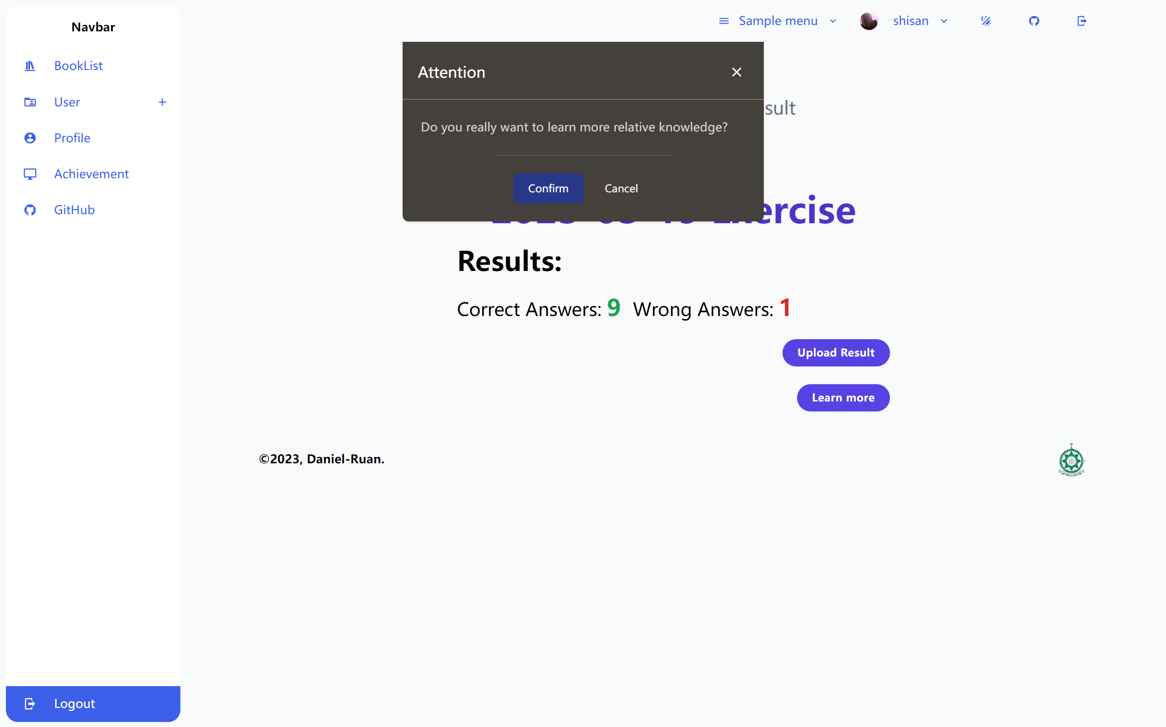

Figure 48 Reconfirm

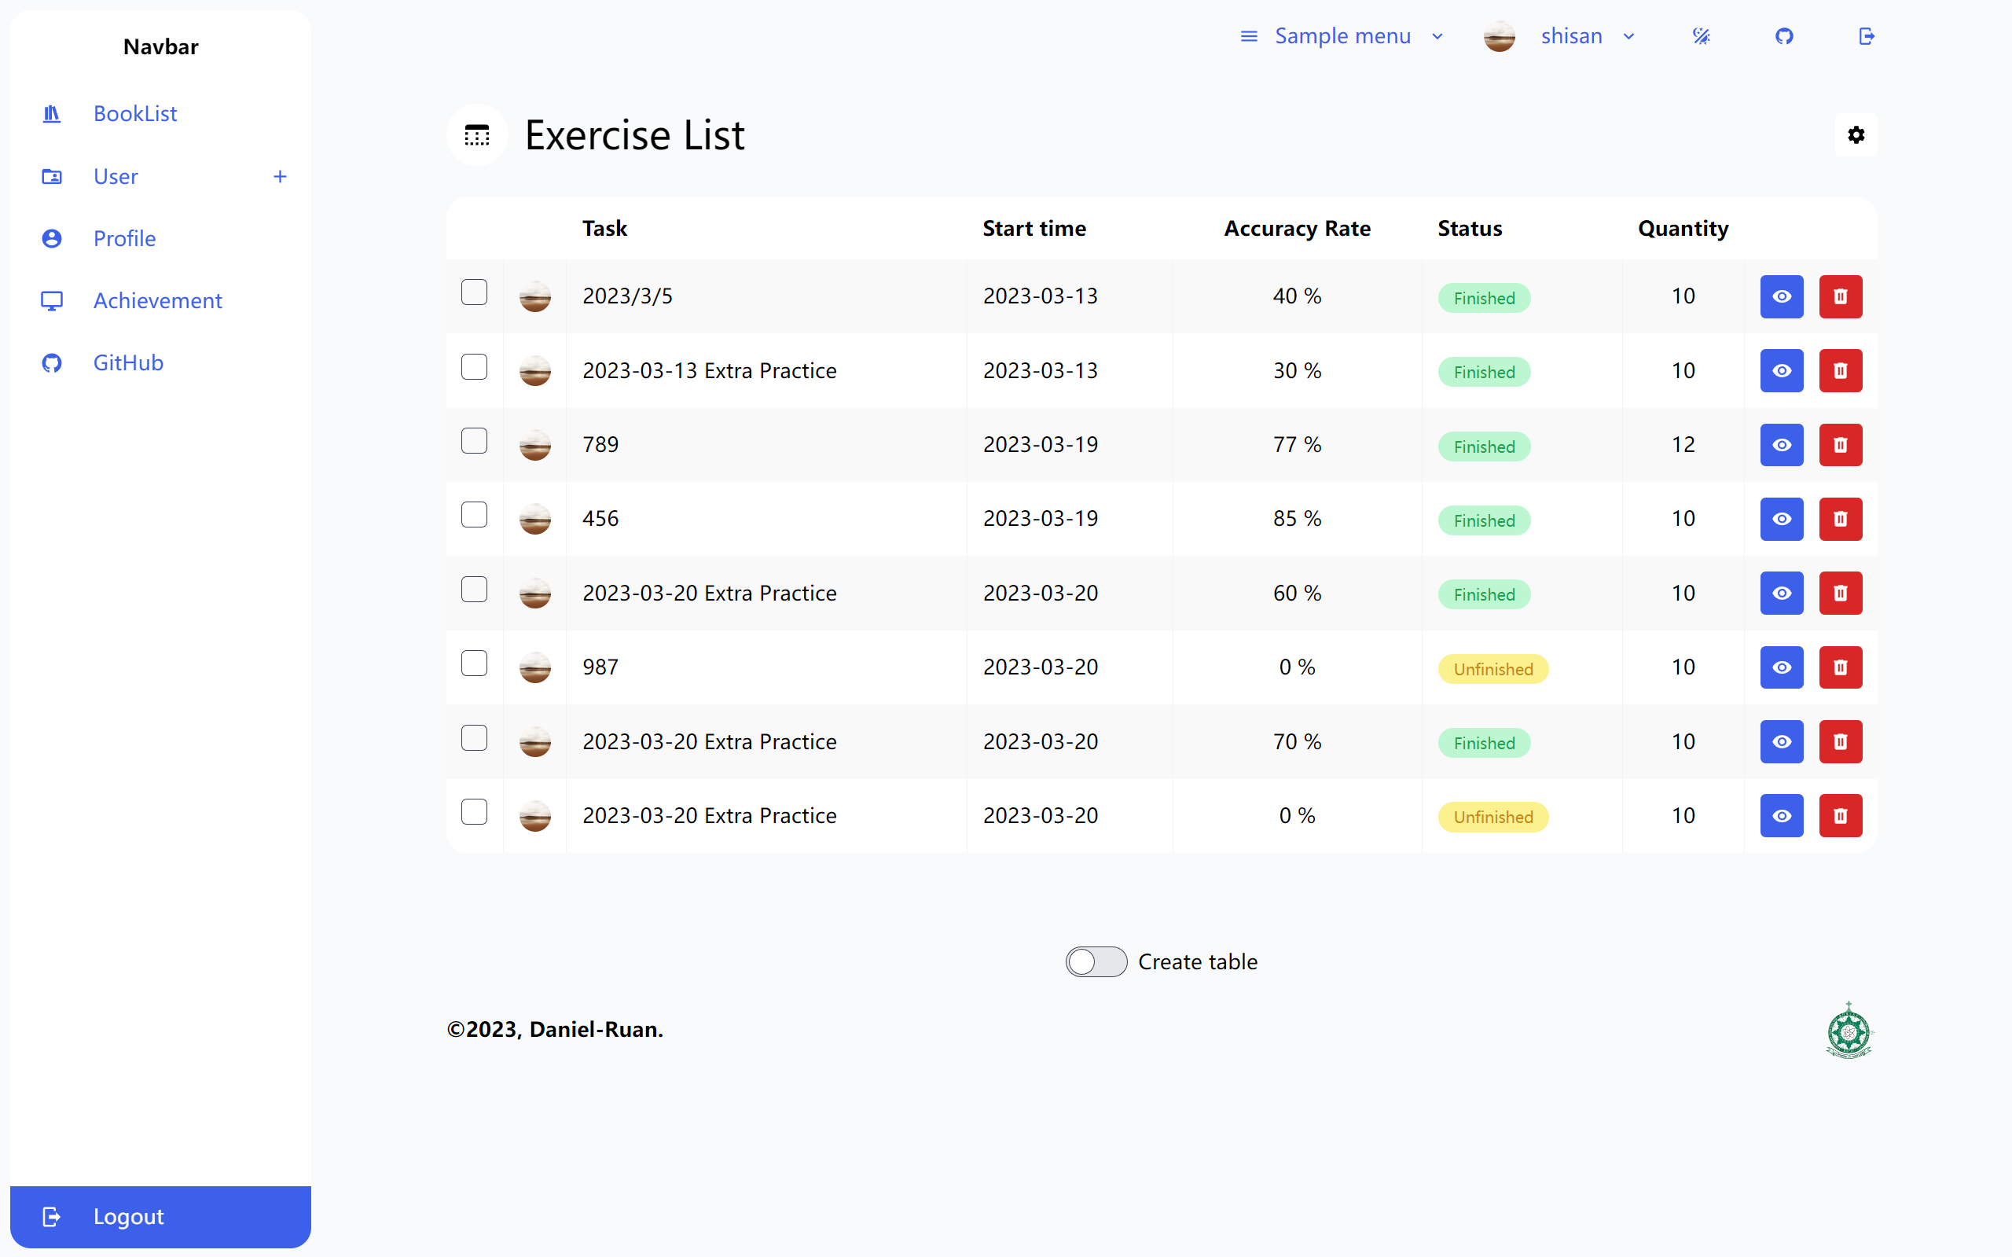

Figure 49 After the page jump

### User Achievement Showcase

The User Achievement Showcase feature is designed to highlight and celebrate users' accomplishments within the platform. This feature allows users to track their progress, showcase their achievements, and motivate themselves to continue learning. Key components of the User Achievement Showcase feature include:

1. Progress Overview: Users can view their overall progress within the platform, including the number of completed tasks, mastered topics, and accuracy rates for various exercises.

2. Graphical display: The graphs will show the correct percentage of each study task for the last 7 times and will be shown as a line graph in the graph.

The User Achievement Showcase feature enhances the learning experience by providing users with a way to track their progress, celebrate their accomplishments, and stay motivated throughout their learning journey.

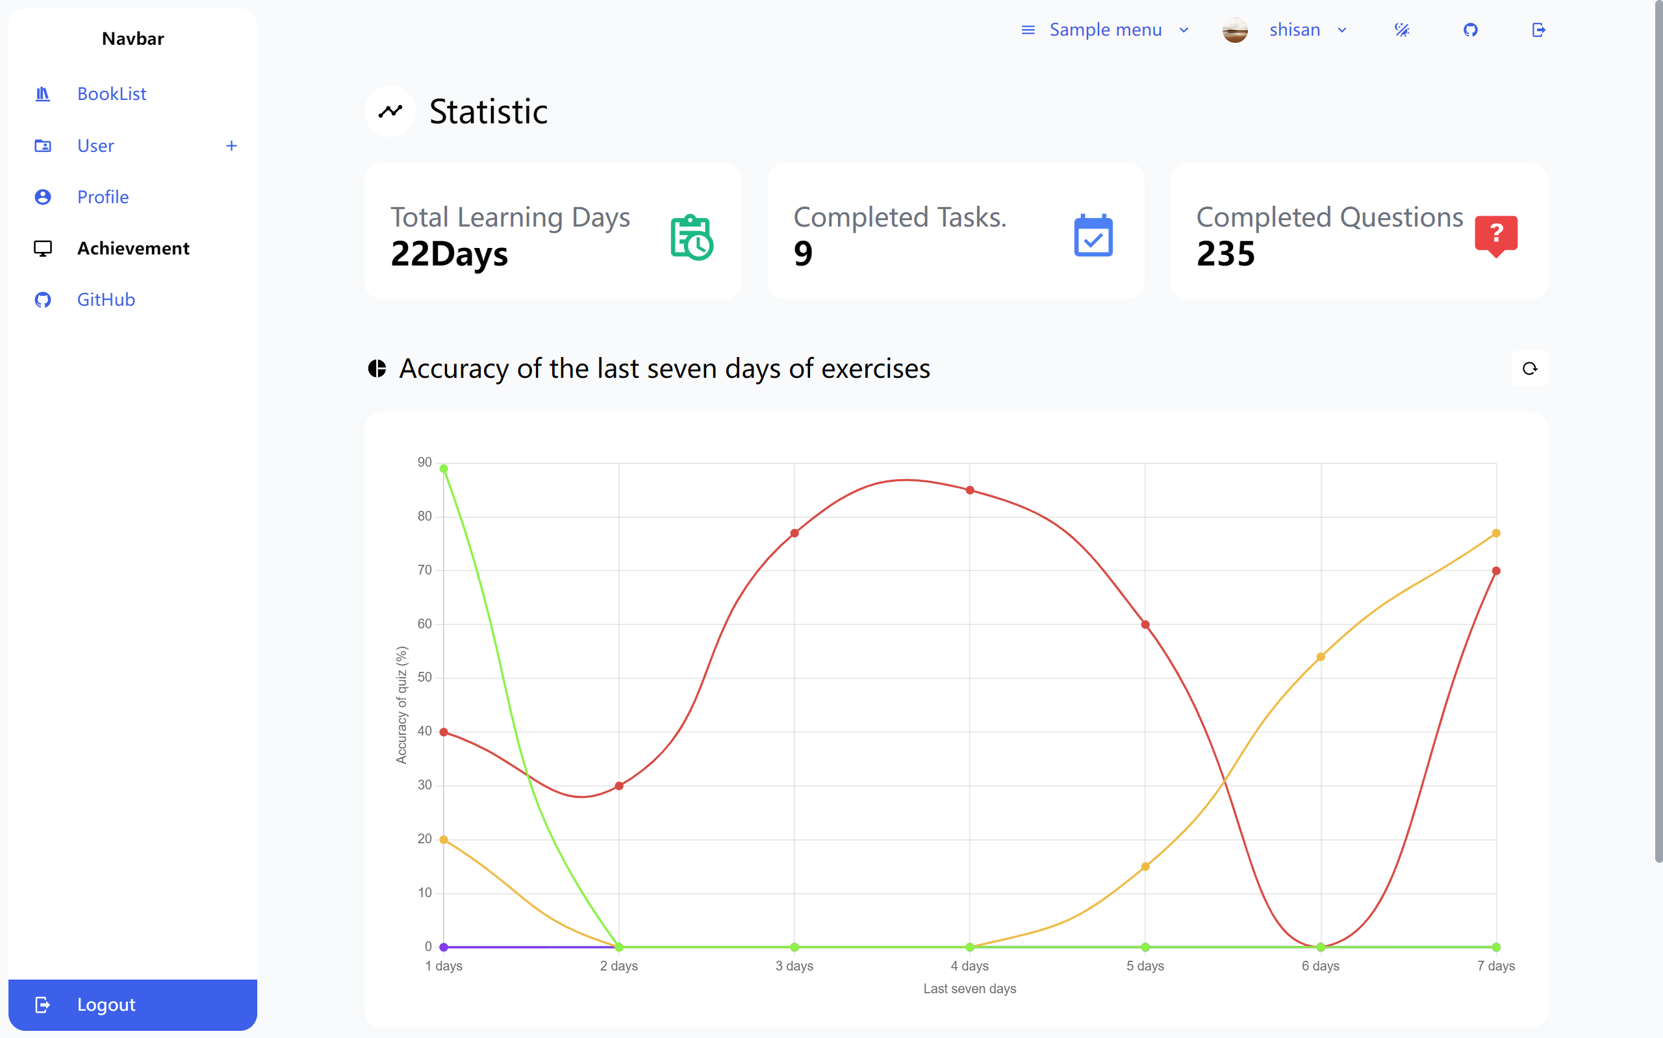

Figure 50 User Achievement Showcase

## Testing & Evaluation

In this section, the author will introduce the testing process and evaluate the final test results of this project. As the entire development process was carried out independently and without a professional testing team, the software testing for this project was completed by the author himself. Therefore, there are significant limitations to the testing process.

The author adopted a development and testing approach in parallel, testing each unit after completion. During the testing process, many bugs were discovered and resolved one by one. After the entire web application was developed, the author conducted multiple rounds of system testing. After passing the system testing, the author decided to proceed with the final user testing.

### User Acceptance Testing

Due to the author not having access to his own server, the project could not be deployed on a server, which brought many difficulties for user testing. Currently, ordinary people who want to use this project must download the source code from GitHub and install it on their local computer. The author tried to invite many friends and relatives, hoping to have their children serve as test subjects for the project. However, due to the complexity of the software installation process, all attempts ended in failure. In the end, the author volunteered himself for the user testing and conducted a one-month testing activity.

The author chose "Trees, Leaves, Flowers, and Seeds: A Visual Encyclopaedia of the Plant Kingdom" as the primary learning target for this testing activity. As the author's native language is Chinese, the encyclopaedia is entirely in English. Although the author had a basic understanding of biology through previous high school education, this book was very unfamiliar to me, and he had no knowledge of many concepts presented in the book. Therefore, the author believes that choosing this book as the main learning target for the testing activity was very appropriate.

In order to verify whether this project can promote learning and achieve better learning outcomes, the author decided to conduct a controlled experiment divided into experimental and control groups. The experimental group used the spaced learning system to study, while the control group did not use this system and used conventional learning methods instead. The author selected 50 different questions from different chapters of the book, totalling 100 questions, and placed them separately in the experimental and control groups.

First, the author spent 2 weeks conducting the control group test. The author spent 90 minutes studying every weekend, learning 25 questions per week, for a total of three hours and 50 questions. A quiz was conducted on the last day of the second week, covering the 50 questions studied in the two weeks. The quiz results are as follows:

|  |  |  |  |  |  |  |  |  |  |  |  |  |  |  |  |  |  |  |  |  |  |  |  |  |
| --- | --- | --- | --- | --- | --- | --- | --- | --- | --- | --- | --- | --- | --- | --- | --- | --- | --- | --- | --- | --- | --- | --- | --- | --- |
| 1 | 2 | 3 | 4 | 5 | 6 | 7 | 8 | 9 | 10 | 11 | 12 | 13 | 14 | 15 | 16 | 17 | 18 | 19 | 20 | 21 | 22 | 23 | 24 | 25 |
| T | F | T | F | T | F | T | T | F | F | F | T | F | T | T | F | F | F | T | F | F | F | F | T | T |
| 26 | 27 | 28 | 29 | 30 | 31 | 32 | 33 | 34 | 35 | 36 | 37 | 38 | 39 | 40 | 41 | 42 | 43 | 44 | 45 | 46 | 47 | 48 | 49 | 50 |
| T | T | T | F | T | T | T | T | T | T | F | F | T | T | T | T | T | F | T | T | T | F | T | T | T |

Table 5 Quiz results after learning with conventional methods

From the table, it can be seen that the overall accuracy rate is 62%. The test-taker answered 14 questions incorrectly in the first 25 questions and 5 questions incorrectly in the last 25 questions. This indicates that the test-taker had already forgotten most of the content learned in the previous week during the second week's quiz.

In the following two weeks, the author began testing the experimental group. The author consistently used the spaced learning system of this project to study for 10 to 15 minutes every day, spending a total of less than 3 hours learning 50 questions. On the last day of the test, a quiz was conducted, covering the 50 questions studied in the two weeks. The test results are as follows:

|  |  |  |  |  |  |  |  |  |  |  |  |  |  |  |  |  |  |  |  |  |  |  |  |  |
| --- | --- | --- | --- | --- | --- | --- | --- | --- | --- | --- | --- | --- | --- | --- | --- | --- | --- | --- | --- | --- | --- | --- | --- | --- |
| 1 | 2 | 3 | 4 | 5 | 6 | 7 | 8 | 9 | 10 | 11 | 12 | 13 | 14 | 15 | 16 | 17 | 18 | 19 | 20 | 21 | 22 | 23 | 24 | 25 |
| T | T | T | T | T | T | T | F | T | T | T | F | T | T | T | T | T | T | T | T | T | T | T | T | F |
| 26 | 27 | 28 | 29 | 30 | 31 | 32 | 33 | 34 | 35 | 36 | 37 | 38 | 39 | 40 | 41 | 42 | 43 | 44 | 45 | 46 | 47 | 48 | 49 | 50 |
| F | T | F | T | T | T | T | T | T | T | T | F | T | T | T | T | F | F | T | T | T | T | F | T | T |

Table 6 Quiz results after using spaced practice

From the table, it can be seen that the overall accuracy rate is 82%. The test-taker answered 3 questions incorrectly in the first 25 questions and 6 questions incorrectly in the last 25 questions. This indicates that after using the project for spaced learning, the knowledge learned in the first week was well retained.

User testing and controlled experiment results have demonstrated that when allocating the same amount of time to learn the same content, utilizing this project as a learning tool can effectively minimize students' forgetfulness during the learning process and boost their performance in the final tests. These conclusions signify that the project achieves the objectives discussed in this final year project.

### Limitations

In this section, the author will briefly discuss some of the shortcomings and limitations encountered during the research and development process of this project. Firstly, one issue in this study is that although the Markov model was used to simulate the memory and forgetting processes during learning, it is merely a mathematical theoretical model rather than an actual physiological study. The human memory system is very complex, and to date, despite the significant efforts and progress made by scientists, the complete understanding of human memory mechanisms remains elusive. Due to objective reasons, the author had to simplify the process in the research of the spaced practice algorithm, so there is still much room for improvement in the spaced learning algorithm used in this project.

In terms of project implementation, the software services and review algorithms of this project still have a considerable gap compared to the leading players in the online children's learning field, such as Duolingo. Although Duolingo specializes in children's language learning, which is different from the subject of this study, its successful experience can still be referenced and applied to this project.

Lastly, this project has not undergone professional software testing, and there may be potential bugs in the development and implementation. Additionally, due to the limitations of objective conditions, the author was unable to find real-world age-appropriate children to serve as volunteers for professional user testing. As a result, it is not possible to obtain genuine children's user testing to prove the software's superiority.

# Conclusion and Further Work

The project began with research on human memory preservation, reviewing numerous papers and research reports on human memory theories and spaced learning algorithms. Next, the project focused on carefully designing the data structure and modifying the original Leitner System spaced practice algorithm, with the improved algorithm undergoing mathematical validation and theoretical assessment using Markov models. The project then utilized the popular Vue 3 JavaScript framework for code development, successfully implementing a Vue 3 web application that provides a digital platform for school children to learn scientific knowledge. It also combines efficient learning algorithms from spaced practice to create customized learning plans for each student. By incorporating personalized revision and adjusting review strategies, it reduces knowledge forgetfulness and thus increases learning efficiency. User testing and controlled experiment results demonstrated that the application of spaced practice algorithms in the project significantly improved learning outcomes and knowledge retention.

Although the project has largely met the primary objectives set out in the original project plan, there are still various limitations and areas for improvement, and the project could be enhanced in specific areas. For instance, in the future, by combining advanced technologies such as reinforcement learning, the existing Leitner System spaced practice algorithm can be optimized and upgraded, providing students with the best possible learning plans. Additionally, actively collecting more student feedback data during the learning process is an important aspect of future work. Having more dimensions of learning data means a more accurate assessment of student performance during the learning process, and combining this feedback data with algorithms can help achieve dynamic adjustments and personalized learning plans for students.

References

1. Carpenter, S. K, Cepeda, N. J., Rohrer, D., Kang, S. H. K., and Pashler, H. Using spacing to enhance diverse forms of learning: Review of recent research and implications for instruction. Educational Psychology Review, 24, 369-378, 2012.
2. Aurelien Nioche∗, Pierre-Alexandre Murena, Carlos de la Torre-Ortiz, and Antti Oulasvirta. Improving Artificial Teachers by Considering How People Learn and Forget. IUI '21: 26th International Conference on Intelligent User Interfaces, 445–453, April 2021.
3. Keith B. Lyle, Campbell R. Bego, Patricia A. S. Ralston, and Jason C. Immekus. Spaced Retrieval Practice Imposes Desirable Difficulty in Calculus Learning. Educational Psychology Review, 34, 1799–1812, 2022.
4. Ebbinghaus H. Memory: a contribution to experimental psychology. Ann Neurosci. 2013 Oct;20(4):155-6. doi: 10.5214/ans.0972.7531.200408. PMID: 25206041; PMCID: PMC4117135.
5. Smolen, Paul & Zhang, Yili & Byrne, John. The right time to learn: Mechanisms and optimization of spaced learning. Nature Reviews Neuroscience. 17. 77-88. 10.1038/nrn.2015.18, 2016.
6. Rubin, David C.; Hinton, Sean; Wenzel, Amy. "The precise time course of retention". Journal of Experimental Psychology: Learning, Memory, and Cognition. 25 (5): 1161–1176. doi:10.1037/0278-7393.25.5.1161. hdl:10161/10146.2, 1999.
7. S. Reddy, I. Labutov, S. Banerjee, and T. Joachims. Unbounded human learning: Optimal scheduling for spaced repetition. In Proc. ACM SIGKDD International Conference on Knowledge Discovery and Data Mining, page 1815–1824, August 2016.3
8. Carpenter, Shana & Wiseheart, Melody & Rohrer, Doug & Kang, Sean & Pashler, Harold. Using Spacing to Enhance Diverse Forms of Learning: Review of Recent Research and Implications for Instruction. Educational Psychology Review. 24. 369–378. 10.1007/s10648-012-9205-z, 2012.
9. Nicholas J. Cepeda, Harold Pashler, Edward Vul, and John T. Wixted. Distributed Practice in Verbal Recall Tasks: A Review and Quantitative Synthesis. Psychological Bulletin Copyright 2006 by the American Psychological Association 2006, Vol. 132, No. 3, 354–380 DOI: 10.1037/0033-2909.132.3.354.
10. Toppino, T. C., & Gerbier, E. About practice: Repetition, spacing, and abstraction. In B. H. Ross (Ed.), The psychology of learning and motivation (pp. 113–189). Elsevier Academic Press, 2014.
11. Dempster, F. N. The spacing effect: A case study in the failure to apply the results of psychological research. *American Psychologist, 43*(8), 627–634, 1988. 3
12. Goossens, N. A. M. C., Camp, G., Verkoeijen, P. P. J. L., Tabbers, H. K., Bouwmeester, S., and Zwaan, R. A. Distributed Practice and Retrieval Practice in Primary School Vocabulary Learning: A Multi-classroom Study. Appl. Cognit. Psychol., 30: 700– 712. doi: 10.1002/acp.3245, 2016.3
13. Sobel, H.S., Cepeda, N.J. and Kapler, I.V. Spacing effects in real-world classroom vocabulary learning. Appl. Cognit. Psychol., 25: 763-767, 2011.3
14. Childers, J. B., & Tomasello, M. Two-year-olds learn novel nouns, verbs, and conventional actions from massed or distributed exposures. *Developmental Psychology, 38*(6), 967–978, 2002.
15. Fritz JM, Cleland JA, Childs JD. Subgrouping patients with low back pain: evolution of a classification approach to physical therapy. J Orthop Sports Phys Ther. 2007 Jun;37(6):290-302. doi: 10.2519/jospt.2007.2498. Erratum in: J Orthop Sports Phys Ther. 2007 Dec;37(12):769. PMID: 17612355.3
16. Rovee-Collier, C. Dissociations in infant memory: Rethinking the development of implicit and explicit memory. *Psychological Review, 104*(3), 467–498, 1997.
17. Carolyn Rovee-Collier, Sharon Evancio, Linda A. Earley. The time window hypothesis: Spacing effects, Infant Behavior and Development, Volume 18, Issue 1, 1995, Pages 69-78, ISSN 0163-6383.
18. Folarin, B. A. The effect of spacing category members on children's memory. *The Journal of Psychology: Interdisciplinary and Applied, 114*(2), 167–177, 1983.
19. Lauren J. Cuddy & Larry L. Jacoby. When Forgetting Helps Memory: An Analysis of Repetition Effects. JOURNAL OF VERBAL LEARNING AND VERBAL BEHAVIOR 21, 451-467, 1982.
20. Hintzman, D. L. Theoretical implications of the spacing effect. In R. L. Solso (Ed.), Theories in cognitive psychology: The Loyola Symposium. Lawrence Erlbaum, 1974.
21. Glenberg, A. M. Component-levels theory of the effects of spacing of repetitions on recall and recognition. *Memory & Cognition, 7*(2), 95–112, 1979.
22. Greene, J. C., Caracelli, V. J., & Graham, W. F. Toward a Conceptual Framework for Mixed-Method Evaluation Designs. *Educational Evaluation and Policy Analysis*, *11*(3), 255–274, 1989.
23. Landauer, T. K. Reinforcement as consolidation. *Psychological Review, 76*(1), 82–96, 1969.
24. Thios, S. J., & D'Agostino, P. R. Effects of repetition as a function of study-phase retrieval. Journal of Verbal Learning & Verbal Behavior, 15(5), 529–536, 1976.
25. Anderson, E. W., et al. Customer Satisfaction, Market Share, and Profitability: Findingsfrom Sweden, Journal of Marketing, Vol. 58, July, 53-66, 1994.
26. Bjork, Robert. Retrieval as a Memory Modifier: An interpretation of negative recency & related phenomena. Information Processing and Cognition: The Loyola Symposium, 1975.
27. Delaney, Peter & Verkoeijen, Peter & Spirgel, Arie. Chapter 3 - Spacing and Testing Effects: A Deeply Critical, Lengthy, and At Times Discursive Review of the Literature. Psychology of Learning and Motivation. 53. 63-147. 10.1016/S0079-7421(10)53003-2, 2010.
28. Rea, C. P., & Modigliani, V. The spacing effect in 4- to 9-year-old children. *Memory & Cognition, 15*(5), 436–443, 1987.
29. Gluckman, Maxie & Vlach, Haley & Sandhofer, Catherine. Spacing Simultaneously Promotes Multiple Forms of Learning in Children's Science Curriculum. Applied Cognitive Psychology. 28. 10.1002/acp.2997, 2014.
30. Smith, T.A., & Kimball, D.R. Learning from feedback: Spacing and the delay-retention effect. *Journal of experimental psychology. Learning, memory, and cognition, 36 1*, 80-95, 2010.
31. Ren ZH, Gao JP, Li LG, Cai XL, Huang W, Chao DY, Zhu MZ, Wang ZY, Luan S, Lin HX. A rice quantitative trait locus for salt tolerance encodes a sodium transporter. Nat Genet. 2005 Oct;37(10):1141-6. doi: 10.1038/ng1643. Epub 2005 Sep 11. Erratum in: Nat Genet. 2010 Nov;33(11):2000. PMID: 16155566.
32. Narasimhan P, Wood J, Macintyre CR, Mathai D. Risk factors for tuberculosis. Pulm Med. 2013;2013:828939. doi: 10.1155/2013/828939. Epub 2013 Feb 12. PMID: 23476764; PMCID: PMC3583136.
33. Mervis, C. B., & Bertrand, J. Acquisition of the Novel Name-Nameless Category (N3C) principle. *Child Development, 65*(6), 1646–1662, 1994.
34. Balota, D. A., & Chumbley, J. I. Where are the effects of frequency in visual word recognition tasks? Right where we said they werep Comment on Monsell, Doyle, and Haggard (1989). *Journal of Experimental Psychology: General, 119*(2), 231–237, 1990.
35. Toppino, T. C., & DiGeorge, W. The spacing effect in free recall emerges with development. *Memory & Cognition, 12*(2), 118–122, 1984.
36. Vlach HA, Johnson SP. Memory constraints on infants' cross-situational statistical learning. Cognition. 2013 Jun;127(3):375-82. doi: 10.1016/j.cognition.2013.02.015. Epub 2013 Mar 29. PMID: 23545387; PMCID: PMC4099971.
37. James W. The Principles of Psychology. Vol. 1. New York: Henry Holt. pp. 403–404, 1890.
38. Nidhi Sinha, Swasti Arora, Priyanka Srivastava, Raymond M. Klein, What networks of attention are affected by depression? A meta-analysis of studies that used the attention network test, Journal of Affective Disorders Reports, Volume 8, 2022, 100302, ISSN 2666-9153.
39. Giovannoli J, Martella D, Casagrande M. Assessing the Three Attentional Networks and Vigilance in the Adolescence Stages. Brain Sci. 2021 Apr 16;11(4):503. doi: 10.3390/brainsci11040503. PMID: 33923437; PMCID: PMC8073862.
40. H. Ebbinghaus. Über das Gedächtnis. Wissenschaftl. Buchgesell. trans Ruger HA, Bussenius CE (1913) [Memory: A Contribution to Experimental Psychology] (Columbia Univ Teachers College, New York), 1885.
41. J. Karpicke and A. Bauernschmidt. Spaced retrieval: Absolute spacing enhances learning regardless of relative spacing. Journal of experimental psychology. Learning, memory, and cognition, 37:1250–7, 2011.
42. E. Mettler, C. Massey, and P. Kellman. A comparison of adaptive and fixed schedules of practice. Journal of experimental psychology. General, 145, 2016.
43. S. Leitner. So lernt man lernen: angewandte Lernpsychologie - ein Weg zum Erfolg. Herder, 7th edition, 1972.
44. Behzad Tabibian, Utkarsh Upadhyay, Abir De, and Manuel Gomez-Rodriguez. Enhancing human learning via spaced repetition optimization. January 22, 2019.
45. Anouk Beursgens. A Markov process analysis of and a proposal for adjustments to the Leitner system, February, 2022.
46. Deng, Francis; Gluckstein, Jeffrey A.; Larsen, Douglas P. "Student-directed retrieval practice is a predictor of medical licensing examination performance". Perspectives on Medical Education. 4 (6): 308–313. doi:10.1007/s40037-015-0220-x. ISSN 2212-277X. PMC 4673073. PMID 26498443, December 2015.
47. ELA and Literacy Criteria, Grades 3‒5; ELA Curricula, Grades 6‒12, National Governors Association Center for Best Practices, Council of Chief State School Officers, 2 May 2012. David Coleman and Susan Pimentel, Revised Publishers’ Criteria for the Common Core State Standards in English Language Arts and Literacy, Grades 3‒12, 2 May 2012.
48. Zulkiply N, Burt JS. The exemplar interleaving effect in inductive learning: moderation by the difficulty of category discriminations. Mem Cognit. 2013 Jan;41(1):16-27. doi: 10.3758/s13421-012-0238-9. PMID: 22886736, January 2013
49. Smolen Paul, Zhang Yili, Byrne John. The right time to learn: Mechanisms and optimization of spaced learning. Nature Reviews Neuroscience. 17. 77-88. 10.1038/nrn, 2016
50. Cepeda NJ, Pashler H, Vul E, Wixted JT, Rohrer D. Distributed practice in verbal recall tasks: A review and quantitative synthesis. Psychol Bull. 132(3):354-80. doi: 10.1037/0033-2909.132.3.354. PMID: 16719566, May 2006
51. Burr Settles and Brendan Meeder. A Trainable Spaced Repetition Model for Language Learning. In *Proceedings of the 54th Annual Meeting of the Association for Computational Linguistics (Volume 1: Long Papers),* pages 1848–1858, Berlin, Germany. Association for Computational Linguistics, 2016.
52. Beursgens, A.E. A Markov process analysis of and a proposal for adjustments to the Leitner system, 2022

Appendix A. Project Management

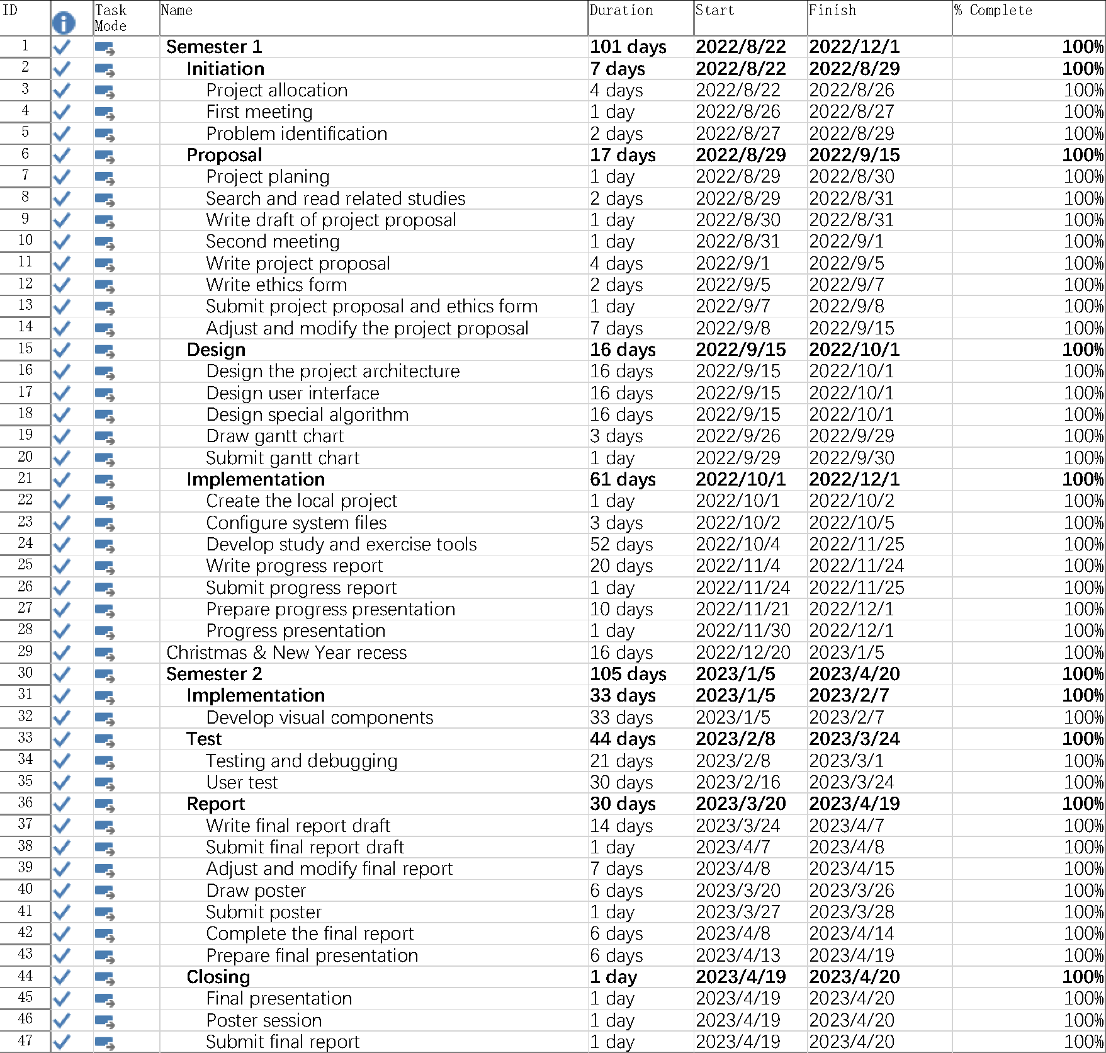

Table 7 Program plan

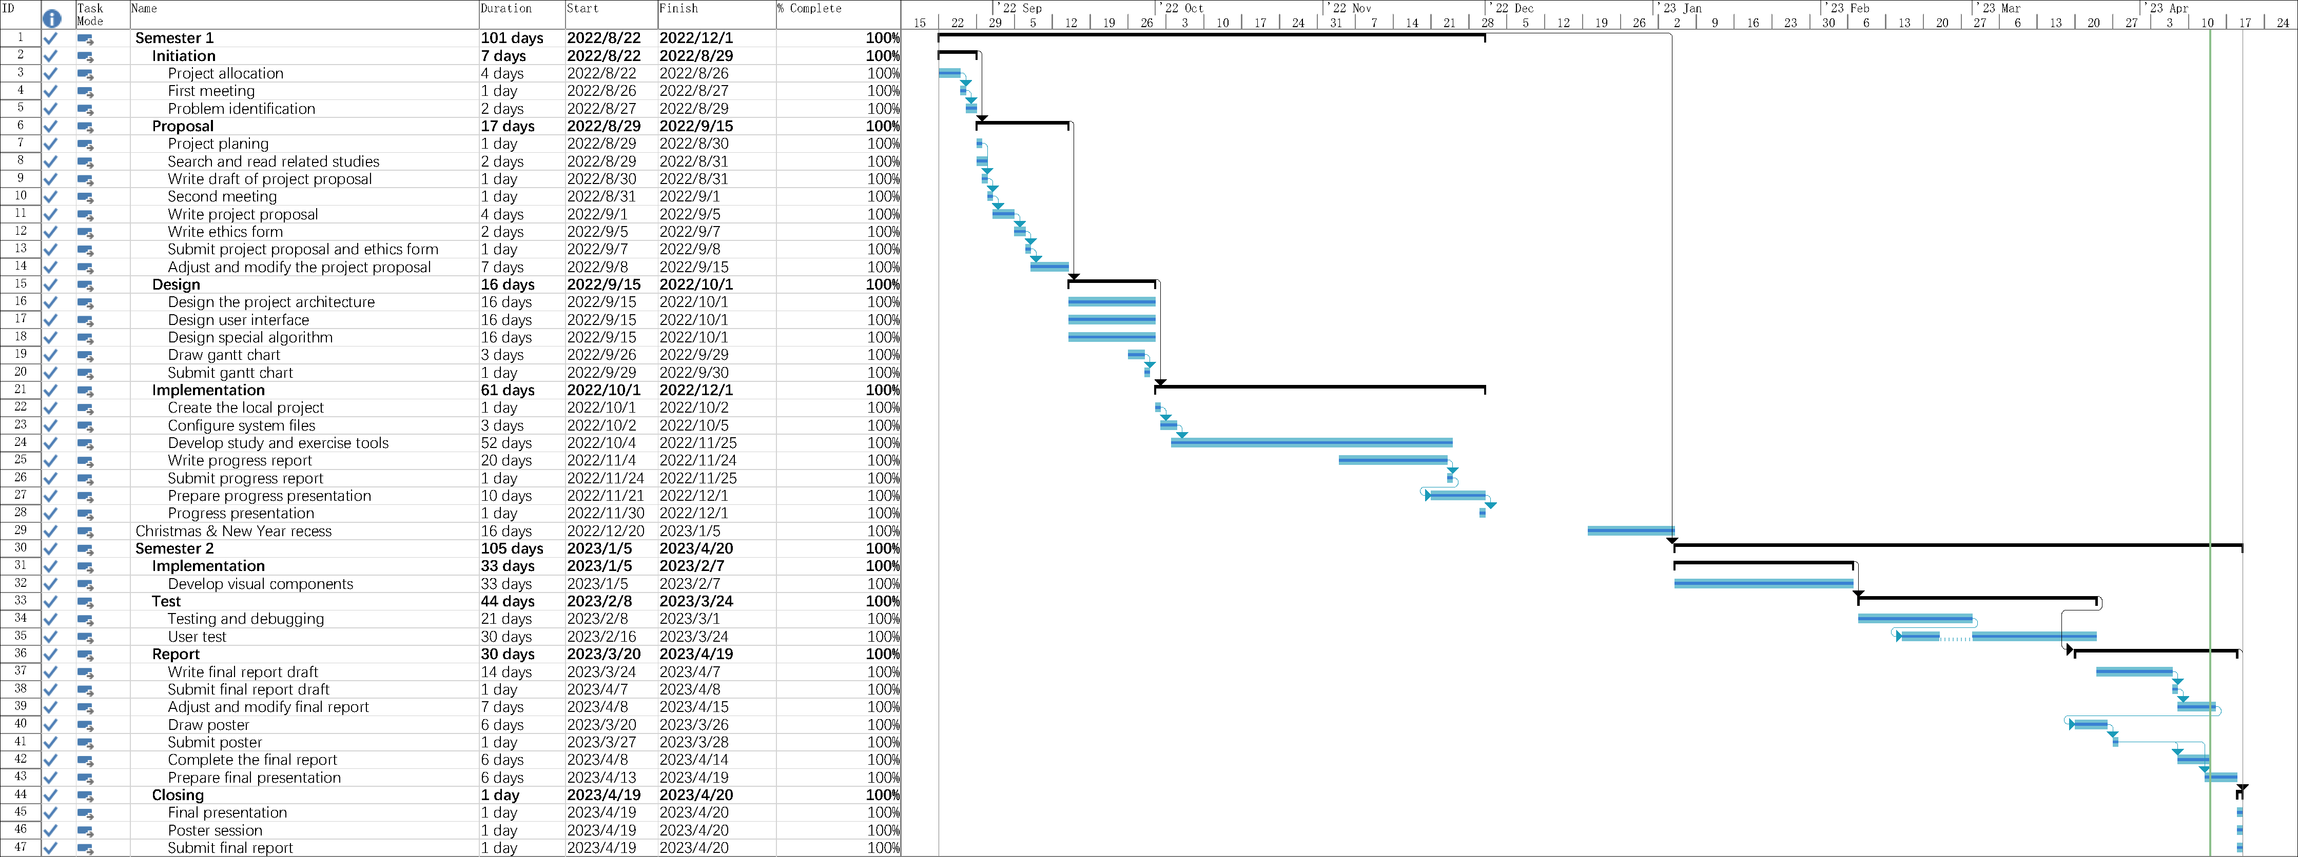

Figure 51 Gantt chart

Appendix B. Reflection

Throughout my final year project, I embarked on a journey of personal growth and learning. As the first person in this narrative, I delved deep into Vue3 front-end development and acquired a wealth of knowledge in this area. I also learned to use TypeScript and adopted new naming conventions and other cutting-edge technologies.

During the development process, I encountered numerous setbacks and challenges. There were times when I felt overwhelmed and unsure of my ability to overcome these obstacles. However, with perseverance and determination, I managed to find solutions to each issue, allowing me to make steady progress on my project.

I am incredibly proud of the fact that I was able to complete this final year project at the Macau University of Science and Technology. This experience has not only enhanced my technical skills but also instilled in me the importance of resilience and the ability to adapt in the face of adversity. Looking back on my journey, I am grateful for the opportunities and challenges that have shaped my growth and development as a student and an individual.